GIST Oryong Art Hall Invitational ‘Science-Sapiens’ Exhibition in conjunction with Gwangju Design Biennale

- ‘Science-Sapiens’ invitational exhibition held at GIST Oryong Art Hall until October 31 with the theme of conceptual art and science explained by scientists

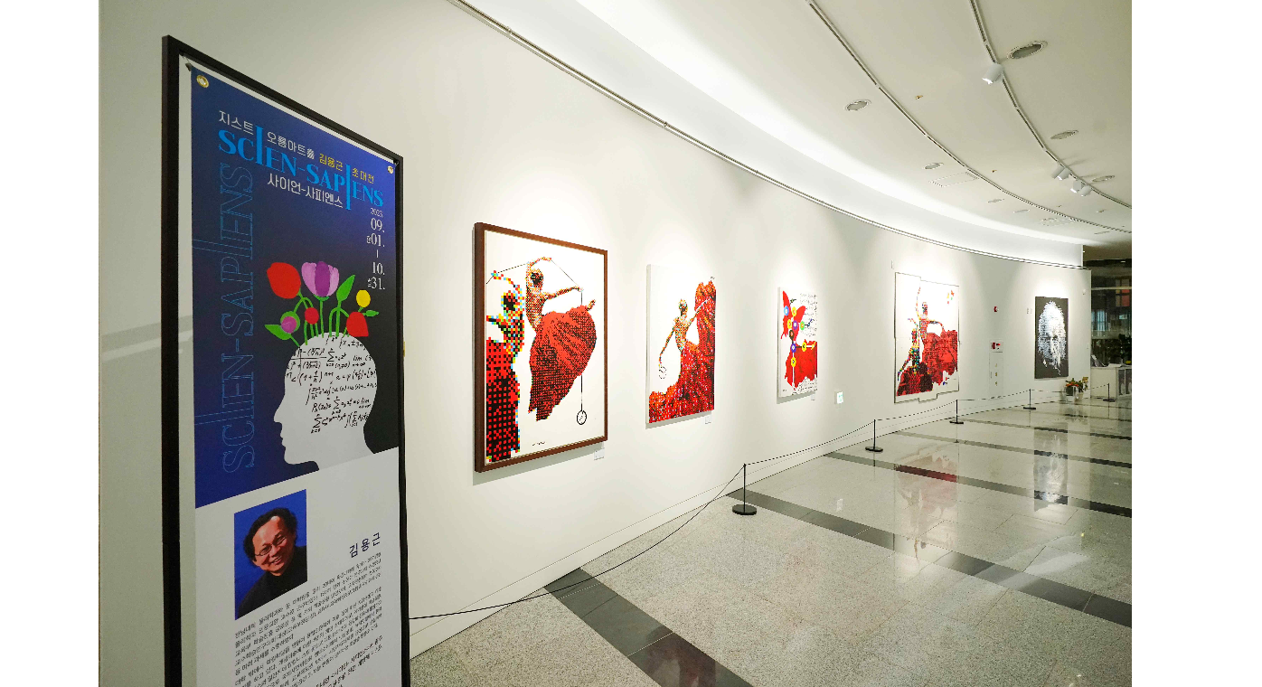▲ Panoramic view of the ‘Science-Sapiens’ invitation exhibition on display at Oryong Art Hall

The 5th invitational exhibition ‘Science-Sapiens’, currently on display at the Gwangju Institute of Science and Technology (GIST, President Kichul Lim) Oryong Art Hall, will be held in conjunction with the 10th Gwangju Design Biennale’s official event.

The Gwangju Design Biennale is held through programs such as main exhibitions (theme exhibitions), special exhibitions, design spots, and international academic events., and ‘Science-Sapiens’ was selected as a design spot (special exhibition and linked/commemorative exhibition) and participated in the Biennale event.

This exhibition is an opportunity to reflect on the modern civilization created by humans using science as a means and tool. A total of 46 paintings will be presented to the public on themes such as human alienation caused by science and technology, environmental pollution, and climate change.

Artist Yong-geun Kim, who is featured in this invitational exhibition, has worked as a professor of physics and humanities at Donggang University for over 30 years and has been at the forefront of the movement to integrate the fields of science and art, including as an art columnist. He is actively working as a scientist and artist, having held eight solo exhibitions of conceptual art.

Artist Yong-geun Kim said, "I am very happy to be able to present science-themed works at GIST, a world-class science and technology research university that is celebrating its 30th anniversary this year. I hope that this early competition will be a unique opportunity to overcome the barriers between science and art and create positive interactions."

Oryong Art Hall has held a total of 5 events from the end of last year to this ‘Science-Sapiens’ exhibition in order to provide a venue for strengthening exchange and cooperation with the local community for GIST, which has grown due to the interest of local residents. By holding an invitational exhibition, it provides an open space for cultural enjoyment for both internal and external visitors.

Meanwhile, the Gwangju Design Biennale, hosted by Gwangju Metropolitan City and hosted by the Gwangju Design Promotion Agency, will be held from September 7 (Thursday) to November 7 (Tuesday) under the theme of ‘MEET DESIGN’.

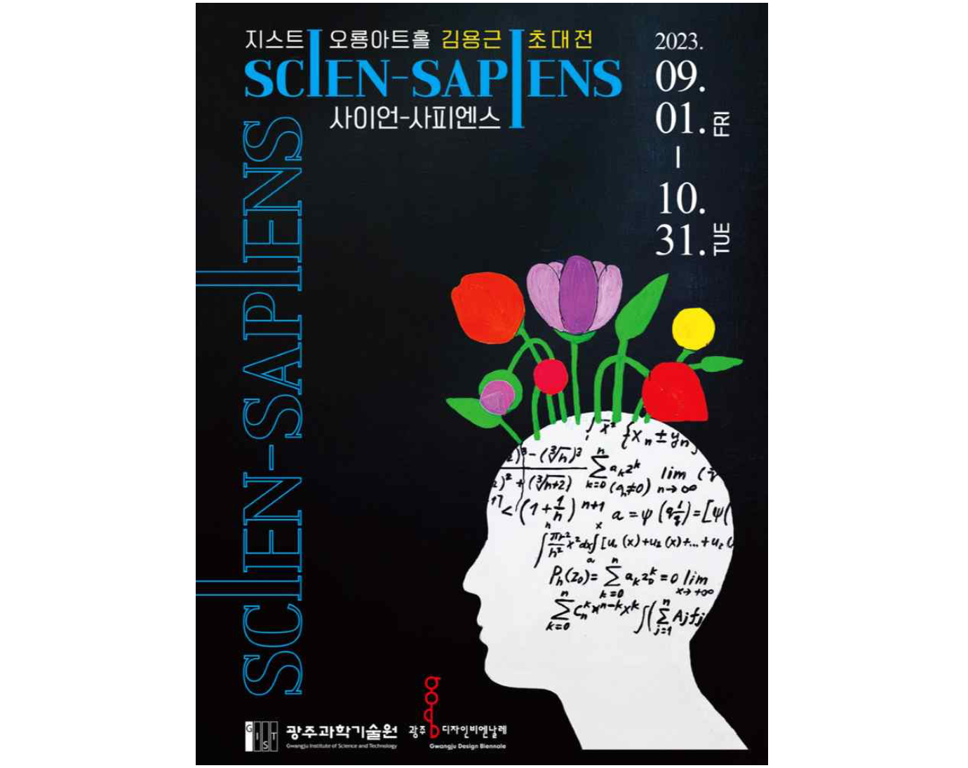▲ Poster for Oryong Art Hall’s 5th invitational exhibition ‘Science-Sapiens’



