Development of a 'Haptic Band' that allows people to feel the rhythm with your skin... Introduced at a barrier-free concert

- On the 26th (Sat), a synesthesia convergence performance was held where people can feel the rhythm and melody of music with your skin (tactile sense) and enjoy sign language performances visually with the ‘Haptic Band’ developed by a GIST research team
- Preparing a venue for festivals that can be enjoyed by both deaf, disabled and non-disabled visitors

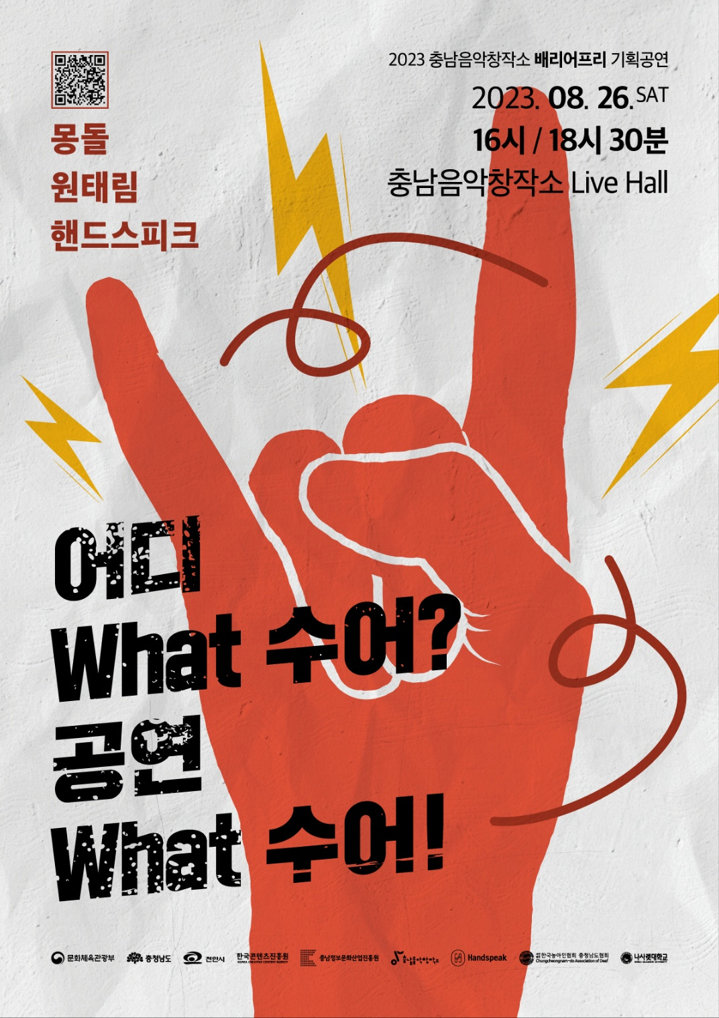
▲ Barrier-free planning performance ‘What is it? What a performance!’ event poster

A Gwangju Institute of Science and Technology (GIST, President Kichul Lim) research team has developed a ‘haptic band’ that allows people to feel the rhythm and melody of music with your skin, and will show it at a barrier-free special performance on the 26th (Sat).

<What is it? What a performance!> has been held every year since 2021 as a project to produce a performance that everyone can enjoy together through collaboration between deaf and non-disabled artists and overcome cultural alienation.

This year, artists belonging to the preparatory social enterprise ‘Handspeak’ and local musicians discovered by the Chungnam Music Creation Center will perform together on stage in collaboration with music and sign language. In particular, this performance is expected to be a special performance of synesthesia convergence where you can not only feel the rhythm of the music, but also enjoy the sign language performance visually.

'Team GIST (Research Director: Professor Jin Hyuk Hong)' of GIST's School of Integrated Technology is 'developing realistic music and dance visualization technology for the hearing-impaired to enjoy music' (host organization: GIST, joint research institute: CK Co., Ltd.) Materials Lab, Korea Advanced Institute of Science and Technology (KAIST), Sejong University, Hands Peak Co., Ltd.) and decided to support the 'Haptic Band', which is the result of the project, so that visitors can enjoy a special performance.

This research project will be conducted from June 2021 to the end of December this year (2 years and 7 months). In this performance, 8 applicants will wear haptic bands and watch the performance in order to verify the prototype for usability.

▲ An example of wearing a ‘haptic band’, which is the result of a research project in which ‘team GIST (Research Director: Professor Jin Hyuk Hong)’ of the School of Integrated Technology at GIST participated as a host institution

The haptic band detects the music (sound) of the external performance and measures the envelope follower (lowest note analysis), transient (rhythm beginning), BPM (music tempo), etc. It is a device that analyzes elements and converts them into haptic strength and frequency.

To more abundantly deliver the sense of rhythm delivered by sign language performances, it is being used as a tool to support the appreciation of performances by performing sound analysis-vibration conversion centered on rhythm.

Professor Jin Hyuk Hong said, "This performance is significant not only in that it supports people to experience music through senses other than hearing but also in that they participate in the music genre of ‘deaf culture’ that expresses the atmosphere, lyrics, and rhythm of music through sign language. Through the haptic band, it is expected that 'hearing' without hearing impairment and 'deaf' with hearing impairment can enjoy together, and it will be a rare opportunity to receive feedback from the deaf audience."

As a follow-up research plan, they are currently participating as a joint research institute in the <Institute of Information & Communications Technology Planning & Evaluation (IITP) development of multi-sensory music experience system and educational solution for the hearing impaired> hosted by ETRI and will be expanding it to music education contents for the hearing impaired.

This performance will be held in the afternoon of August 26th at the Live Hall of the Chungnam Music Creation Center through the process of song selection, sign language translation/supervision, practice, etc. It is held twice, at 4:00pm and 6:30pm. Anyone can make a reservation through the QR code on the poster or the advance reservation link, and all seats are free.

(Pre-registration link: https://answer.moaform.com/answers/MxDAQG)

