GIST held graduation ceremony for the second half of 2023

- Graduation Ceremony held on the 18th (Fri) at GIST Oryong Hall... A total of 191 students were awarded degrees
- Graudating 59 doctoral students... Published an average of 5 papers in SCI-level academic journals during the school year

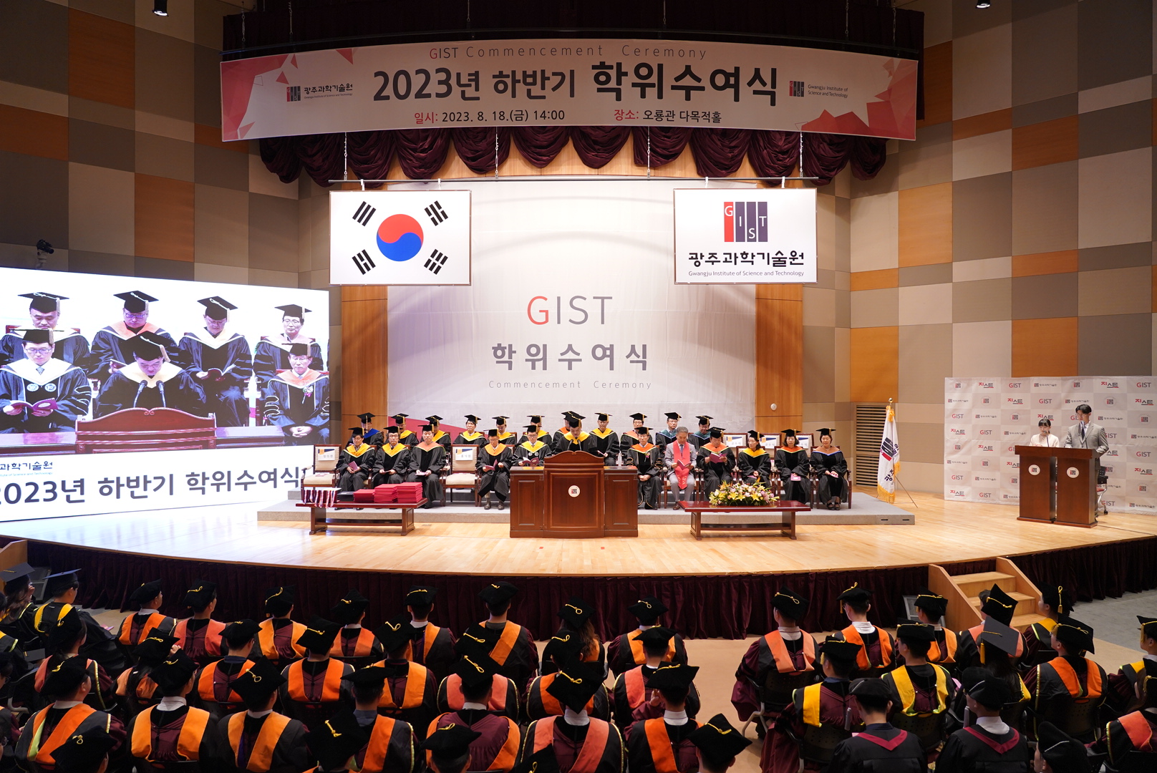
▲ On August 18 (Friday) at 2:00 PM, GIST held the ‘2023 Commencement Ceremony’ at the Oryong Hall, which was attended by key officials, outstanding degree recipients, and graduate representatives.

GIST (Gwangju Institute of Science and Technology, President Kichul Lim) held a graduation ceremony for the second half of 2023, inviting degree recipients, parents, and domestic and foreign guests at GIST Oryong Hall Auditorium at 2:00 pm on Friday, August 18.

At the graduation ceremony, a total of 191 students were awarded degrees, including 59 doctoral students, 91 master's students, and 41 bachelor students.

It was found that 59 doctoral students receiving their degrees this time published an average of about 5 papers per person in SCI-level academic journals during their school years.

Among the Ph.D. graduates, Dr. Wonhee Jeong (Advisor: Professor Unjong Yu) of the Department of Physics and Photon Science conducted research on statistical mechanics, phase transition, evolutionary dynamics, and complex system networks and published in renowned international journals (「Chaos, Solitons & Fractals」, etc.). He has achieved outstanding research results, such as publishing six SCI-level papers as the first author, was recognized for this, and was awarded the Excellent Research Award.

Dr. Wonhee Jeong's research results drew attention as they were expected to contribute to solving social dilemmas and understanding real social networks.

In particular, bachelor's degree recipients Jin-kyu Lee of the School of Mechanical Engineering, received the Future Talent Award* at this graduation ceremony, received the Excellent Thesis Award along with the Mirae Award, and was also selected as the highest-ranking graduate and won the ‘three crowns’.

* Future Talent Award: Awarded to graduates who meet GIST College’s educational goal of 3C1P (cultivating problem-solving students with creativity, communication, and cooperation).

President Kichul Lim said, "We sincerely congratulate the precious fruits achieved through hard work over the past few years and support the new challenge of 191 graduates. With the spirit of 'If there is no road, I will make a road,' I hope that they will grow into a talented people who can innovate Korea’s science and technology world."

Celebrating its 30th anniversary this year, GIST produced a total of 7,725 high-quality science and technology personnel, including 1,780 PhDs, 4,819 master's and 1,126 bachelor's, since its establishment in 1993 through this graduation ceremony.



