2023 ‘Open GIST Science Lab’ held

- Participation of 59 students recommended by 33 high schools in the region... Goal of preparing future scientists
- Listening to special lectures by majors and participating in experiments... Fruitful programs received favorable responses from participants

▲ After the <Open GIST Science Lab> event, 59 high school students from the Honam region and admissions team members are taking a group photo together.

GIST (Gwangju Institute of Science and Technology, President Kichul Lim) held the ‘Open GIST Science Lab’ and invited high school students interested in science and technology.

This event is a science and technology talent training program designed to help students experience GIST's excellent curriculum and explore their careers by inviting second-year high school students in the Honam region to listen to special lectures by majors and provide opportunities to directly participate in experiments.

This year, 59 students recommended as outstanding science talents from each school participated in the event held on July 27th in GIST COllege Building C.

The event started with the introduction of GIST (College) and admissions guide followed by explanations of various global talent development programs (Summer Semester, SAP, etc.) and infinite challenge programs that give opportunities for free exploration. In addition, as GIST students vividly conveyed their reviews of their participation in the program, it received a great response from high school students.

In addition, teams were assigned to 7 groups according to the desired majors of the participants, and experiments were conducted safely under the guidance of the experiment instructors and assistants.

Afterwards, the participants had a chance to communicate with GIST students about their curiosity about college life, and, as a result of the post-event survey, more than 94% of them responded that they were “satisfied.”

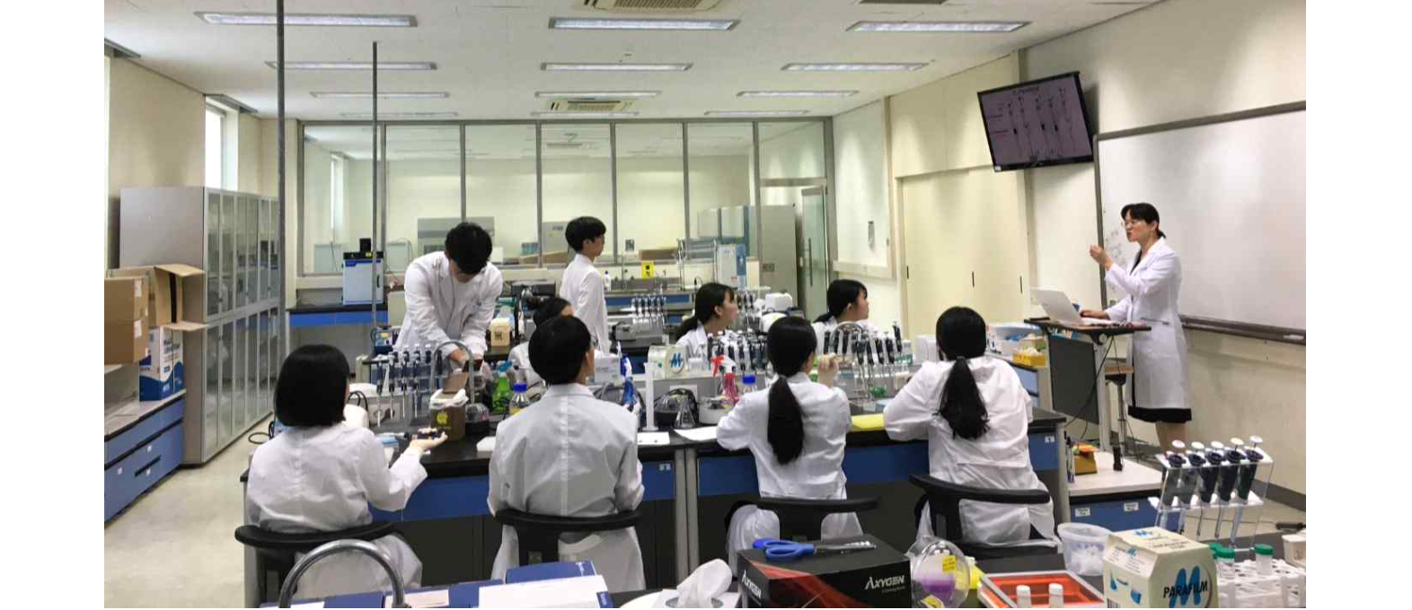▲ Participants are preparing for an experiment while listening to the explanation of the experiment instructor (assistant) during the experiment time for each major.

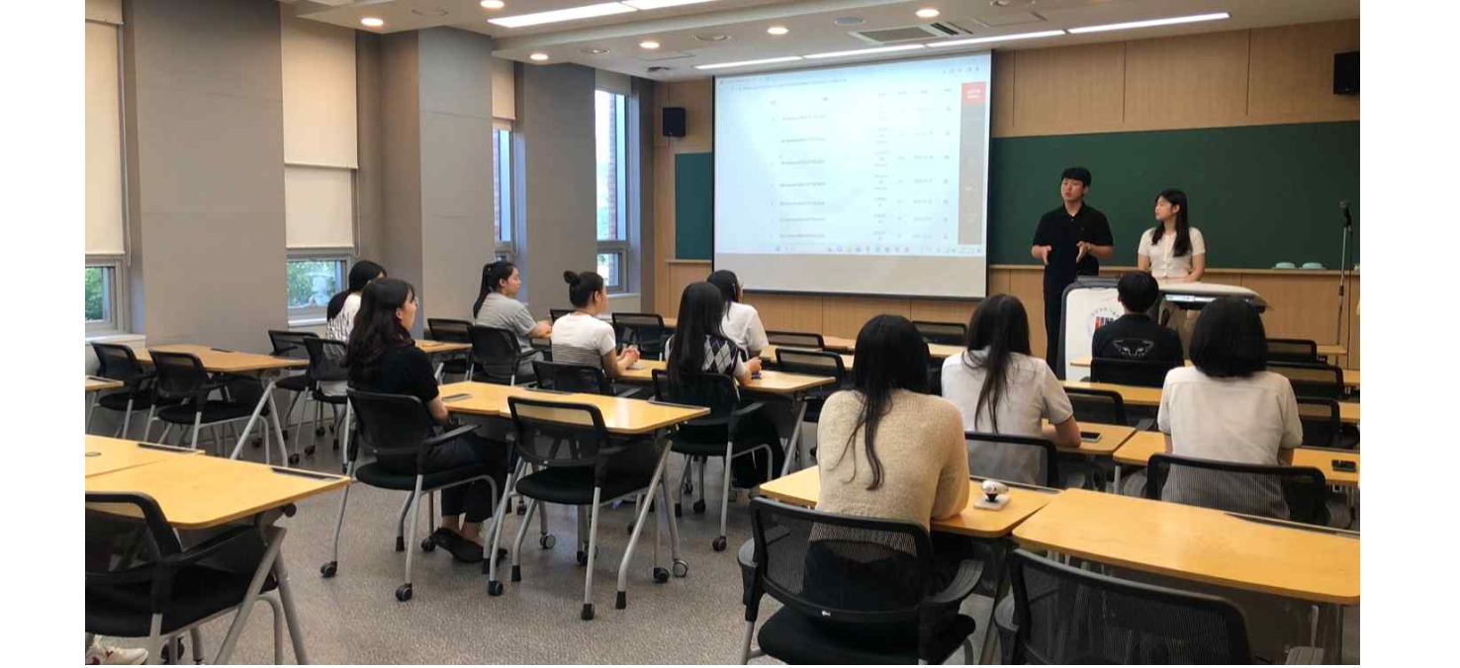▲ Participants are having time to ask questions about college life with GIST students.

One of the participants said, "I was able to improve my understanding of my major by directly participating in experiments that can only be done at universities. Not only did I get information about GIST College, but I also experienced my desired major, which was a great help in my career exploration."

Student Affairs and Admissions Dean Mi-Ryoung Song said, "We want to provide opportunities to experience GIST's excellent curriculum and environment to many high school students across the country who dream of becoming future scientists by gradually expanding the number of participants in the future."

In addition to the ‘Open GIST Science Lab’, the GIST admissions team is actively promoting various publicity activities such as ‘High School Admission Information Session’ and ‘Open GIST College’ to attract excellent scientific talent.



