GIST industry-university cooperation council 'hands-on' with local companies

- First step after inauguration as president... Invite business representatives from Gwangju and Jeonnam to open a forum for heated discussion
- Promise to play a pivotal role in revitalizing the local economy by creating new businesses and supporting bottleneck technologies

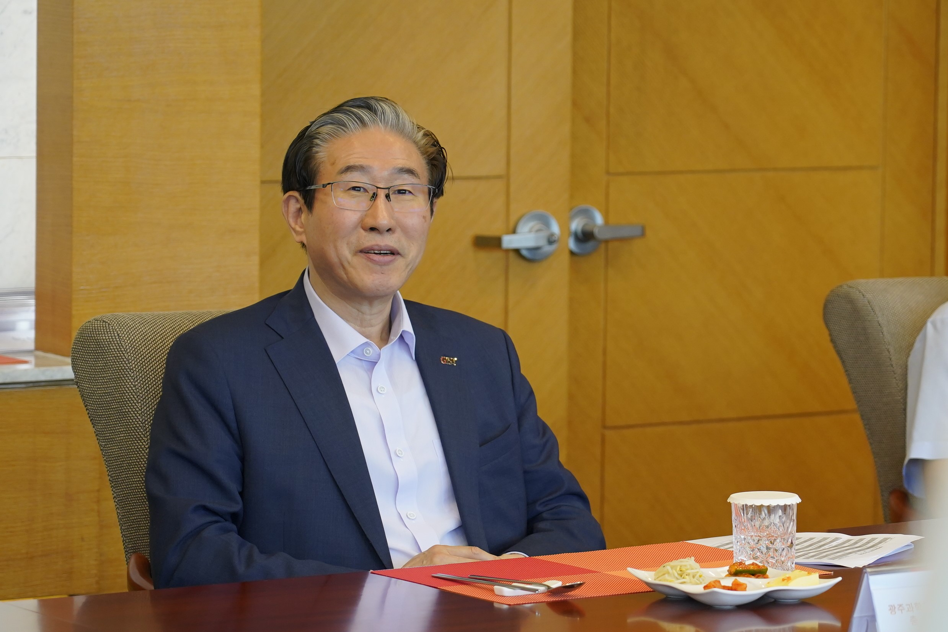▲ President Kichul Lim, who attended the meeting, said that he would actively promote industry-academia cooperation.

GIST (Gwangju Institute of Science and Technology) President Kichul Lim Gi-cheol invited business representatives from the Gwangju and Jeonnam regions to hold an ‘Industry-Academy Cooperation Consultative Body’ meeting. This was his first move since taking office on the 7th.

The event, which was held on the 19th (Wednesday) at the GIST Industry-University Cooperation Research Center, was attended by 10 company representatives, including President Lim, School of Mechanical Engineering Professor Sungho Jeong, and CEO Sang-ho Lee of Eugene System Co., Ltd. Chairman Na Ki-soo, who is in charge of the GIST Industry-Academic Development Committee and the Gwangju-Jeonnam Federation of Economic Organizations, also joined the event.

The Industry-University Cooperation Council was formed in April of last year to support companies in the Gwangju and Jeonnam regions by utilizing GIST's excellent research capabilities and infrastructure. About 20 GIST professors and representatives of 59 companies in Gwangju and Jeonnam are active.

For professional technical support, the ▴ Bio Division, ▴A I Division, and ▴ Department Manager Division are separately operated and a meeting is held once a month.

At this meeting, President Lim drew attention by expressing his strong will to support companies and contribute to the development of the local economy. In particular, the key issue was the need to bridge the realistic technological gap between universities and companies and to find areas that universities can support from the perspective of companies.

Next, GIST introduced promising technologies for commercialization that can create new businesses and proposed industry-academia joint research and development to solve the technical difficulties of companies. The representative of the company requested GIST's cooperation, saying that there are many difficulties in securing technology and personnel in the field.

The attendees had a heated discussion on future cooperation plans and concluded a meaningful time by promising to play a role for the development of the local industry.

President Kichul Kim said, "Numerous industrial-educational cooperation projects that have been discussed between universities and local companies so far have often ended up as bogus declarations. It is a priority for GIST and corporate representatives to put their heads together to envision and execute a business that can actually be realized."

In addition, he said, "We will establish a systematic support plan, such as establishing an ‘integrated support service platform’ that connects not only GIST but also local organizations."



