GIST 2023 Summer School on Lasers and Laser Applications held

- Lectures and experiments from laser basics to applications... Participants from 10 countries around the world
- Held every year since 2010... Reinforcing the international status of the only laser-specialized research center in Korea

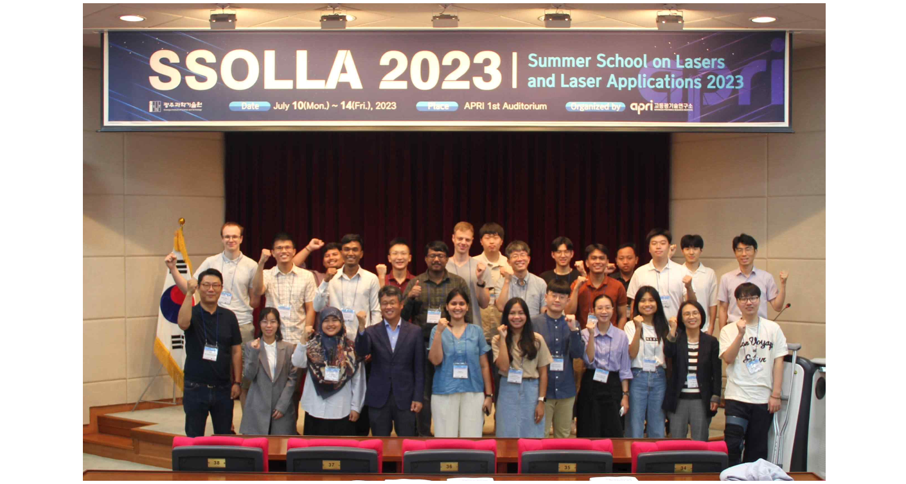▲ [Picture 1] Summer School on Lasers and Laser Applications participants are taking a group photo.

GIST (Gwangju Institute of Science and Technology, President Kichul Lim) Advanced Photonics Research Institute (APRI, Director Yeung Lak Lee) held the ‘Summer School on Lasers and Laser Applications (SSOLLA*) 2023’ for overseas students and researchers researching laser and optical technology.

* SSOLLA (Summer School On Lasers and Laser Applications)

This event, which has been held since 2010, is an international cooperation program in which students and researchers from all over the world come together, attend lectures on the basics and applications of lasers, and participate in optical experiments.

Due to the relaxation of the corona policy, this year, it was held as a face-to-face event for 5 days from the 10th to the 14th, and 22 students and researchers from 10 countries around the world, including Singapore, Vietnam, Cambodia, Malaysia, Czech Republic and Lithuania, participated.

At this event, GIST Advanced Photonics Research Institute Dr. Seong Ku Lee, Department of Biomedical Science and Engineering Professor Jae Gwan Kim, Department of Chemistry Professor Yoonsoo Pang, Chonnam National University Department of Physics Professor Lee Jung-Wook, and Department of Physics Education Professor Young-Ho Kang conducted lectures and experiments in the fields of optics and lasers.

The lecture consisted of ▴ fundamentals and applications of femtosecond (1/1,000 trillionth) lasers and fiber lasers, ▴ nonlinear optics, ▴ nano spectroscopy, ▴ biomedical optics, ▴ terahertz science and laser safety. The participants had a meaningful time attending lectures and touring the optics laboratory.

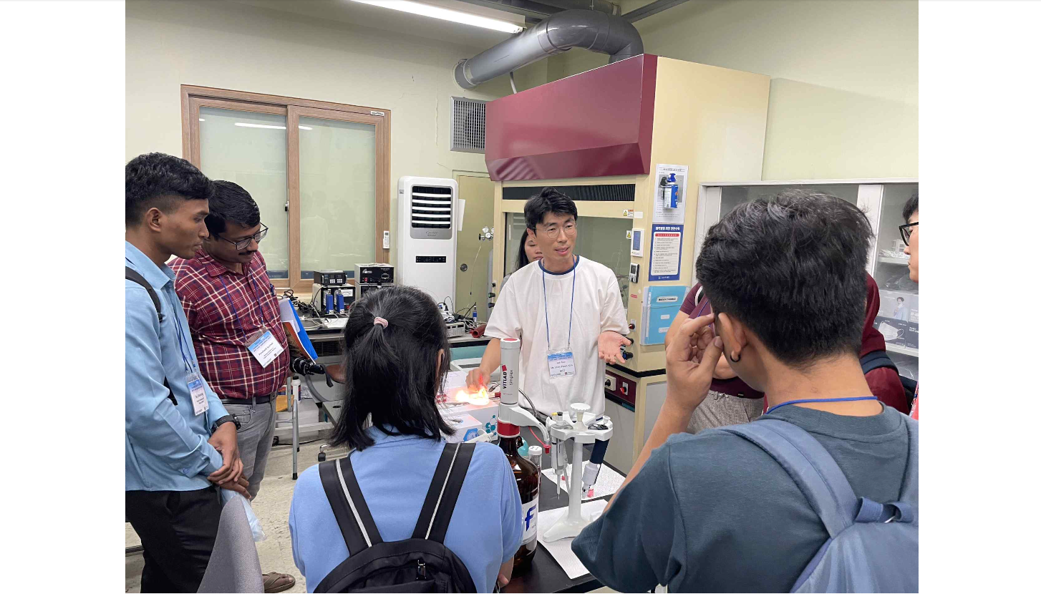[Picture 2] Advanced Photonics Research Institute Dr. Joon Heon Kim is explaining the contents of his research to participants visiting the nanoplasmonics laboratory.

Director Yeung Lak Lee said, "Since 2010, the Advanced Photonics Research Institute has held an international laser summer school event every year, actively exchanging research with overseas researchers in the field of laser optics and raising the status of domestic optical technology. We plan to contribute to the global laser field by expanding international exchange to the entire optical technology field in the future.

Meanwhile, the Advanced Photonics Research Institute, the only optical technology research center in Korea, which celebrated its 22nd anniversary this year, developed the world's first 20 femtosecond (1 femtosecond: 1,000 trillionth of a second) 4.2 petawatt (1 petawatt: 1,000 terawatt) ultra-powerful laser. Recently, it is expanding its research area to the field of defense technology using laser and optical technology.

