GIST invites Nobel laureate Dr. Tim Hunt to give a lecture in commemoration of its 30th anniversary

– 2001 Nobel Laureate in Physiology or Medicine Lecture... May 31st (Wed) 11:00 at Oryonggwan Dasan Hall

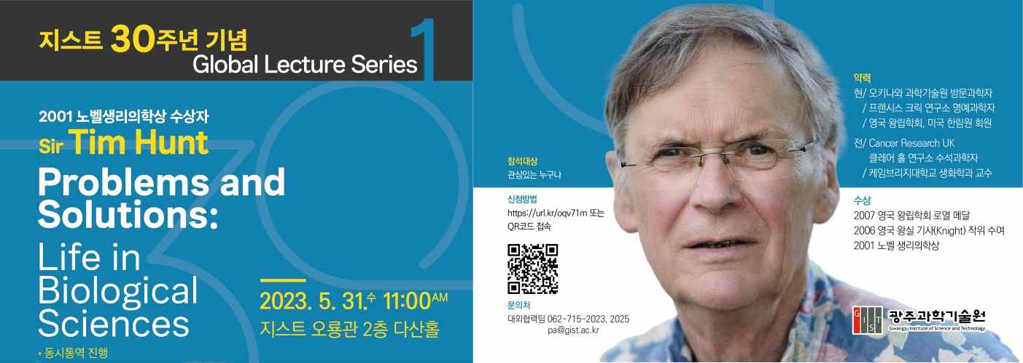
▲ 2001 Nobel Prize in Physiology or Medicine laureate ‘Tim Hunt’ lecture poster

Celebrating its 30th anniversary this year, GIST (Gwangju Institute of Science and Technology, Acting President Raekil Park) invites Dr. Tim Hunt, who won the 2001 Nobel Prize in Physiology or Medicine, to give a special lecture.

The lecture will be held on the 31st at 11:00 am at Dasan Hall on the 2nd floor of Oryong Hall under the theme of ‘Questions and Solutions: Life in Biological Sciences’.

The lecture, which is the first event to celebrate the 30th anniversary of GIST, is open to not only GIST members but also elementary, middle, and high school students who are interested in science, as well as citizens. Simultaneous interpretation will be provided, and application for participation can be made by using the QR code on the event poster. (https://url.kr/oqv71m)

British biochemist Tim Hunt won the 2001 Nobel Prize in Physiology or Medicine for his discovery of cyclins, proteins that regulate the cell cycle.

While studying sea urchins in the summer of 1982, Dr. Tim Hunt discovered cyclins, a protein that plays a key role in regulating cell division cycles and found that cyclins are periodically degraded in each cell division.

He was elected a member of the European Organization for Molecular Biology (EMBO) in 1978, serving as a member and board member and became a member of the Royal Society of England in 1991. He was elected a Fellow of the British Academy of Medicine in 1998 and a Fellow of the American Academy of Sciences in 1999.

Acting President Raekil Park said, "It is meaningful that the first event to commemorate the 30th anniversary of GIST began with a special lecture by Dr. Tim Hunt, a Nobel Laureate in Physiology or Medicine. It is hoped that this lecture will be used as an opportunity for future scientists to develop their dreams of winning the Nobel Prize."

Meanwhile, GIST is planning to hold various events such as cultural events with local residents, special guest lectures, and exhibitions to celebrate its 30th anniversary this year.



