GIST Academy held breakfast forum in May on “Using ChatGPT Smartly”

- <May Breakfast Forum> held on the 22nd (Mon)... Special lecture by Professor Yong Gu Lee

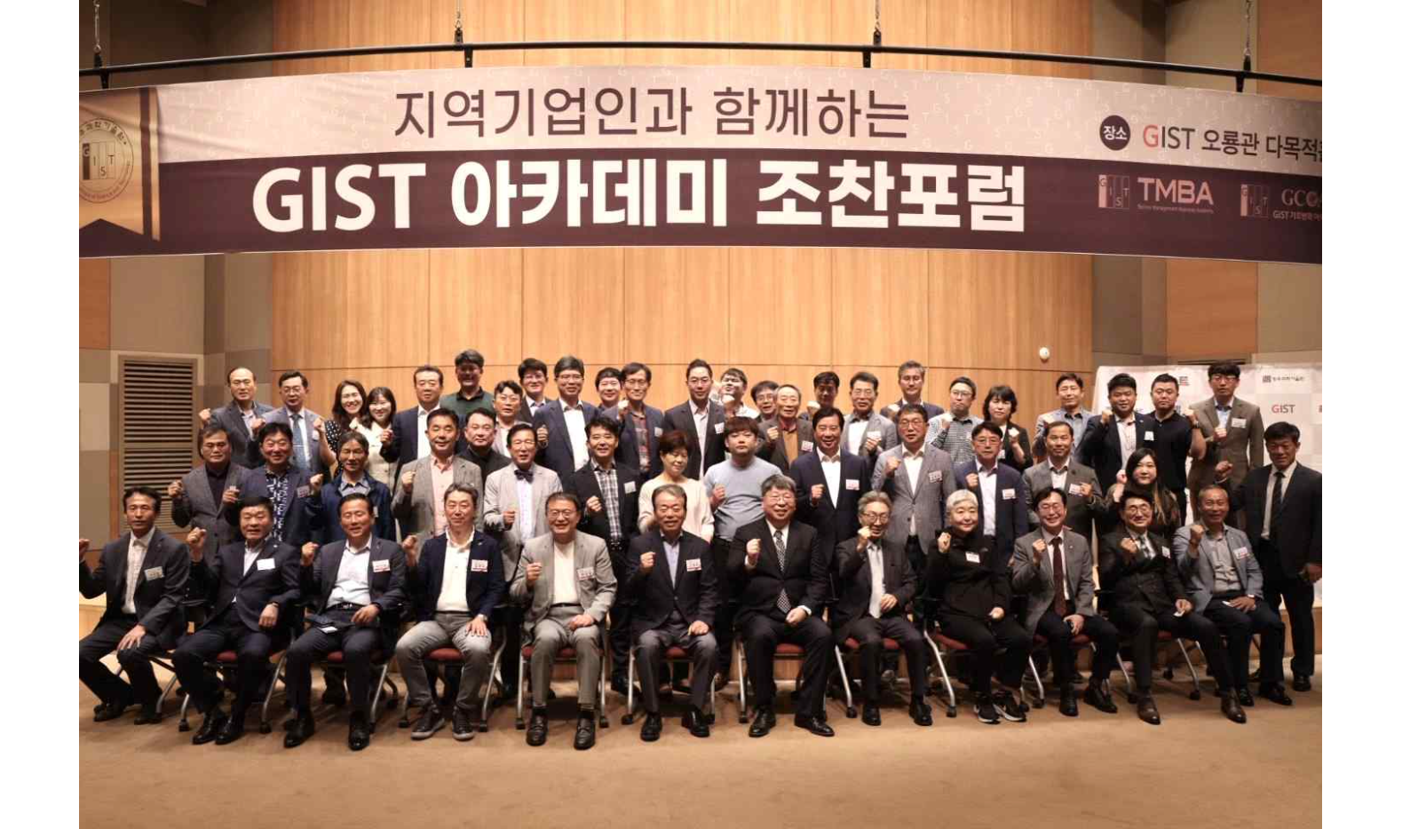▲ Commemorative photo of GIST Academy holding a breakfast forum in May at Oryong Hall

GIST (Gwangju Institute of Science and Technology, Acting President Raekil Park) Academy held a breakfast forum on the theme of 'Utilization of ChatGPT (Generative Pre-trained Transformer)' at Oryong Hall on May 22nd (Mon) with 60 representatives from Gwangju and Jeonnam region attending.

Prior to the lecture, GIST School of Mechanical Engineering Professor Yong Gu Lee, who was a speaker at the forum, explained the importance of ‘understanding language’ by showing examples of unmanned systems using kiosks or delivery apps when ordering food.

Professor Lee introduced ChatGPT, an artificial intelligence chatbot released by Open AI at the end of last year. ChatGPT is a generative AI that ‘pre-trains’ a large amount of data through machine learning and then ‘generates’ it into sentences. When a question is entered, based on the learned data, it is able to respond in sentences as if a person speaks, drawing great attention.

Tips for using ChatGPT well include ▴clear and specific instructions, ▴give the model time to think, and ▴develop repetitive prompts. In addition, Professor Lee showed the process of creating and using a simple UI with Python, drawing the interest of the attendees.

In particular, he concluded the lecture by emphasizing that the artificial intelligence industry is growing rapidly, saying that Microsoft had already invested $1 billion in Open AI in 2019 and reinvested in 2021.

The GIST Academy operates the Techno Management Business Academy (opened in 2010) and the Climate Change Academy (opened in 2016) as non-degree courses. The GIST Academy Breakfast Forum is held on the last Monday of every month, inviting experts from various fields as lecturers to alumni and executives of local companies.

GIST Academy supports executives in each field to deeply understand changes in the corporate environment and global management strategies through lectures by the best experts in Korea, form a wide human network, and contribute to the vitalization of the local economy and industry-university cooperation.

