AI Media Art Team, Team AI-GO, Daegu Arts Factory 'Dancing AI' exhibition

- GIST School of Integrated Technology Team Algo, following Seoul, participated in Daegu ‘AI-GO Land’ exhibition
- Exhibited until June... You can meet AI that changes language into gestures and communicates with dance

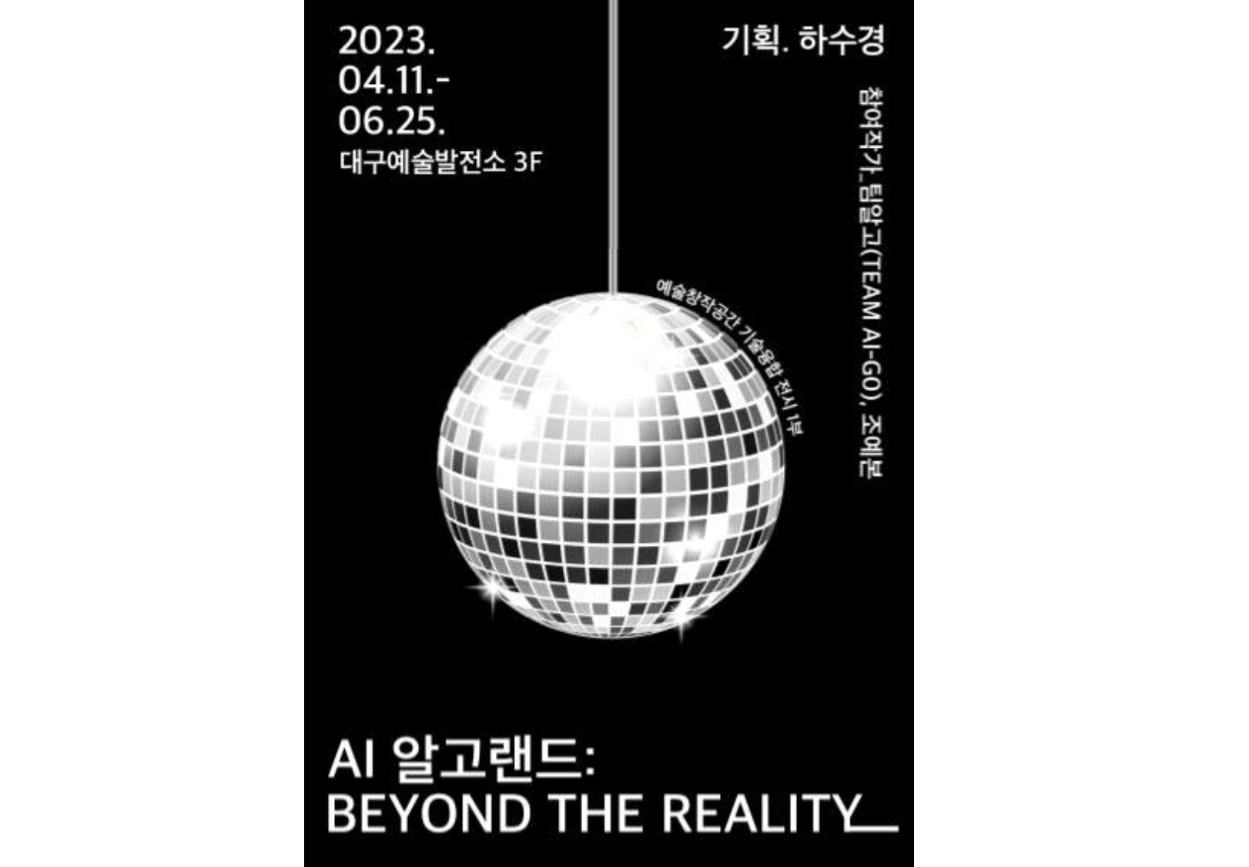▲ ‘Team AI-GO Land’ exhibition poster

‘Team AI-GO’, led by a GIST (Gwangju Institute of Science and Technology, Acting President Raekil Park) graduate student at the School of Integrated Technology, is exhibiting media art with AI technology that generates dance movements at the Daegu Arts Development Center.

Team AI-GO is an AI media art exhibition team started by a graduate student at the School of Integrated Technology, and it is exploring the meaning of AI and its coexistence in the art field from the perspective of researchers and artists in collaboration with sound art artist Ye-bon Cho.

‘AI-GO Land: Beyond The Reality’ is the first technology convergence exhibition of the Daegu Arts Factory, and Team AI-GO participated in the first and third parts of the three parts.

In the first part, <AI-GO Rhythm> has been on display since April. You can watch AI ‘AI-GO’ dance by transforming the public’s desires expressed in language into gestures.

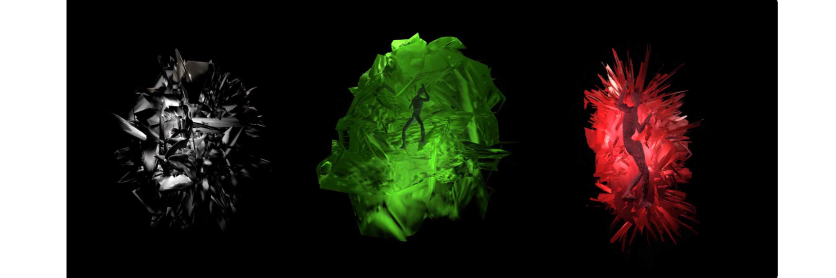▲ AI ‘Algo’ expresses the audience’s desire by changing it from language to dance in the work <Algorithm>.

In the third part, <Shall we dance?> will be exhibited from May 23rd (Tuesday). Visitors can gain a special experience of communicating with AI through the experience of communicating with AI ‘AI-GO’ through dance.

Team AI-GO was formed in June of last year with doctoral student Yujin Choi as the leader and with doctoral students Jaeyoung Moon and Taehwa Park participating. Although the research areas of the students were different, collaboration was possible thanks to the unique atmosphere of the School of Integrated Technology where ideas were exchanged freely. Active support from School of Integrated Technology, which emphasize convergence outside the laboratory, Professors Jin Hyuk Hong and Kyung-Joong Kim were also a source of strength.

Half a year after coming together, Team AI-GO presented <Algorithm> in the exhibition <Excessive Gestures: Awakening the Echo to Resonate?> sponsored by the Seoul Foundation for Arts and Culture. As the audience's attention was drawn to the attempt to combine AI and dance, it was evaluated as opening a new chapter for the role of AI in the art field.

Professors Jin Hyuk Hong said, "Students will experience convergence with various fields including art and grow into better researchers I hope people will have the opportunity to get creative ideas by experiencing exhibitions in Seoul, Daegu, and other places across the country outside of the laboratory."

Meanwhile, this exhibition not only suggests ways to stimulate and expand human senses using AI, but also raises the question of whether art created by AI can be understood as art, drawing much attention. It is free to view until June 25th.



