‘Ant-Man’ Professor Jae-chun Choi held a special lecture

- Invited on May 3rd (Wednesday)... Lecture held on the theme of <The world seen from Darwin's shoulders>

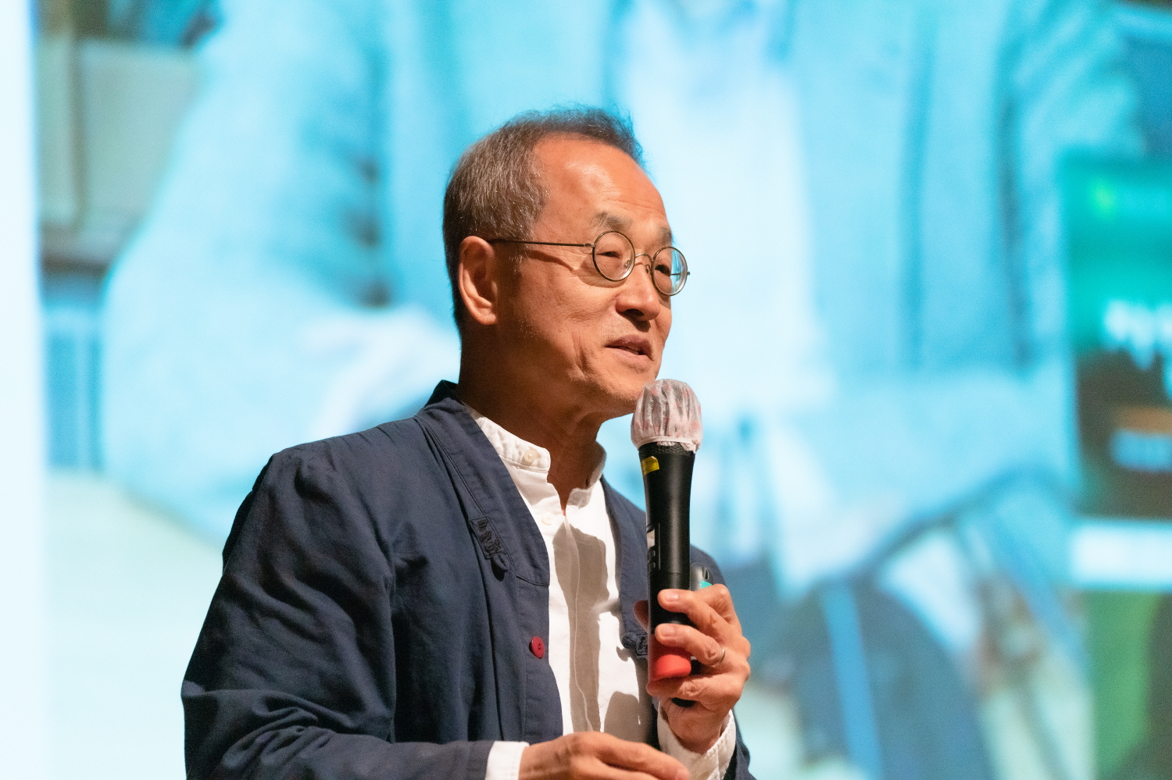▲ Professor Jae-chun Choi is giving a special guest lecture.

GIST (Gwangju Institute of Science and Technology, Acting President Raekil Park) invited Ewha Womans University Chaired Professor Jae-chun Choi (former Director of the National Institute of Ecology), an evolutionary biologist who has taken the lead in popularizing science, to give a special lecture on the theme of <The world seen from Darwin's shoulders>.

Professor Choi, nicknamed “Ant-Man” for his research on ants, is a researcher widely known to the public through his YouTube channel, “Choi Jae-cheon’s Amazon,” which has 520,000 subscribers. In Korea, which was a wasteland of evolutionary biology and ecology, he publicized the importance of evolutionary biology and biodiversity through vigorous writing activities such as 「Darwin's Apostles」, 「Darwinian Intelligence」, and 「Scientist's Library」, and was recognized for his contributions in 2015. In recognition of his contribution, he was awarded the Dongbaekjang of the National Order of Merit in 2015 and the Cheongam Education Award in 2023.

About 300 faculty members and students attended the special lecture hosted by the Section of Public Affairs and the Integrated Institute of Biomedical Research and supervised by the ‘Integrative Research Cluster for Space Biomedical Sciences (cluster head, Professor Steve K. Cho, School of Life Sciences)’. With the participation of local residents, it was held on May 3rd (Wednesday) in GIST Administration Building with great success.

In his lecture, Professor Choi explained the importance of Darwin's theory of evolution in an easy-to-understand manner and drew the audience's attention by suggesting ways to overcome the current financial crisis, academic crisis, and environmental crisis based on Darwin's theory of evolution.

In particular, applying the words of evolutionary biologist Dov Zansky, who said that nothing in biology can be understood without the theory of evolution, he emphasized that “nothing in life can be understood apart from the perspective of evolution” in modern society.

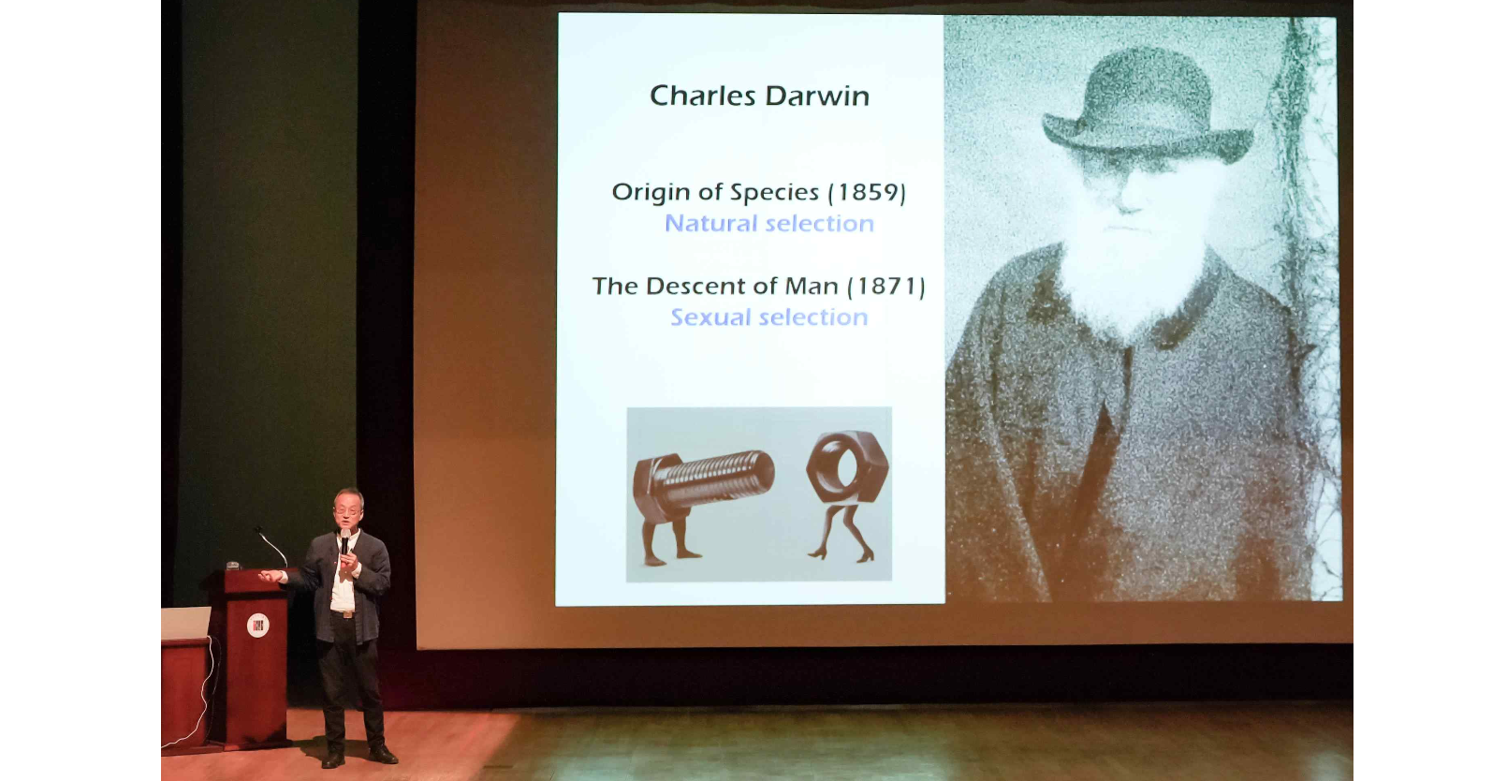▲ Professor Jae-chun Choi is explaining Darwin's theory of evolution.

After the lecture, a question-and-answer session was held, allowing participants to share various opinions and views with Professor Choi and expand their knowledge.

Professor Steve K. Cho, who prepared this special lecture, said, "I am deeply grateful to Professor Jae-chun Choi for his great help in helping GIST undergraduate and graduate students who are preparing for the future in various fields of study, regardless of their major, to develop and cultivate the knowledge to look at various phenomena of human society from the perspective of evolutionary biology as scientists."

Dean of Planning Zee Yong Park (concurrently serving as Dean of international and Public Affairs) said, "It is hoped that through this special guest lecture, GIST members and local residents could have a deeper understanding of Darwin and the theory of evolution. GIST will continue to lead the popularization of science and technology by providing lectures with local residents on a regular basis to arouse academic curiosity and provide opportunities to acquire various knowledge."



