GIST Aging-Friendly Industry Support Center is ‘spurring’ the fostering of local senior-friendly companies

- Recruitment of companies participating in the ‘2023 Senior-Friendly Customized Enterprise Support Project’ by the 19th (Wednesday) of this month

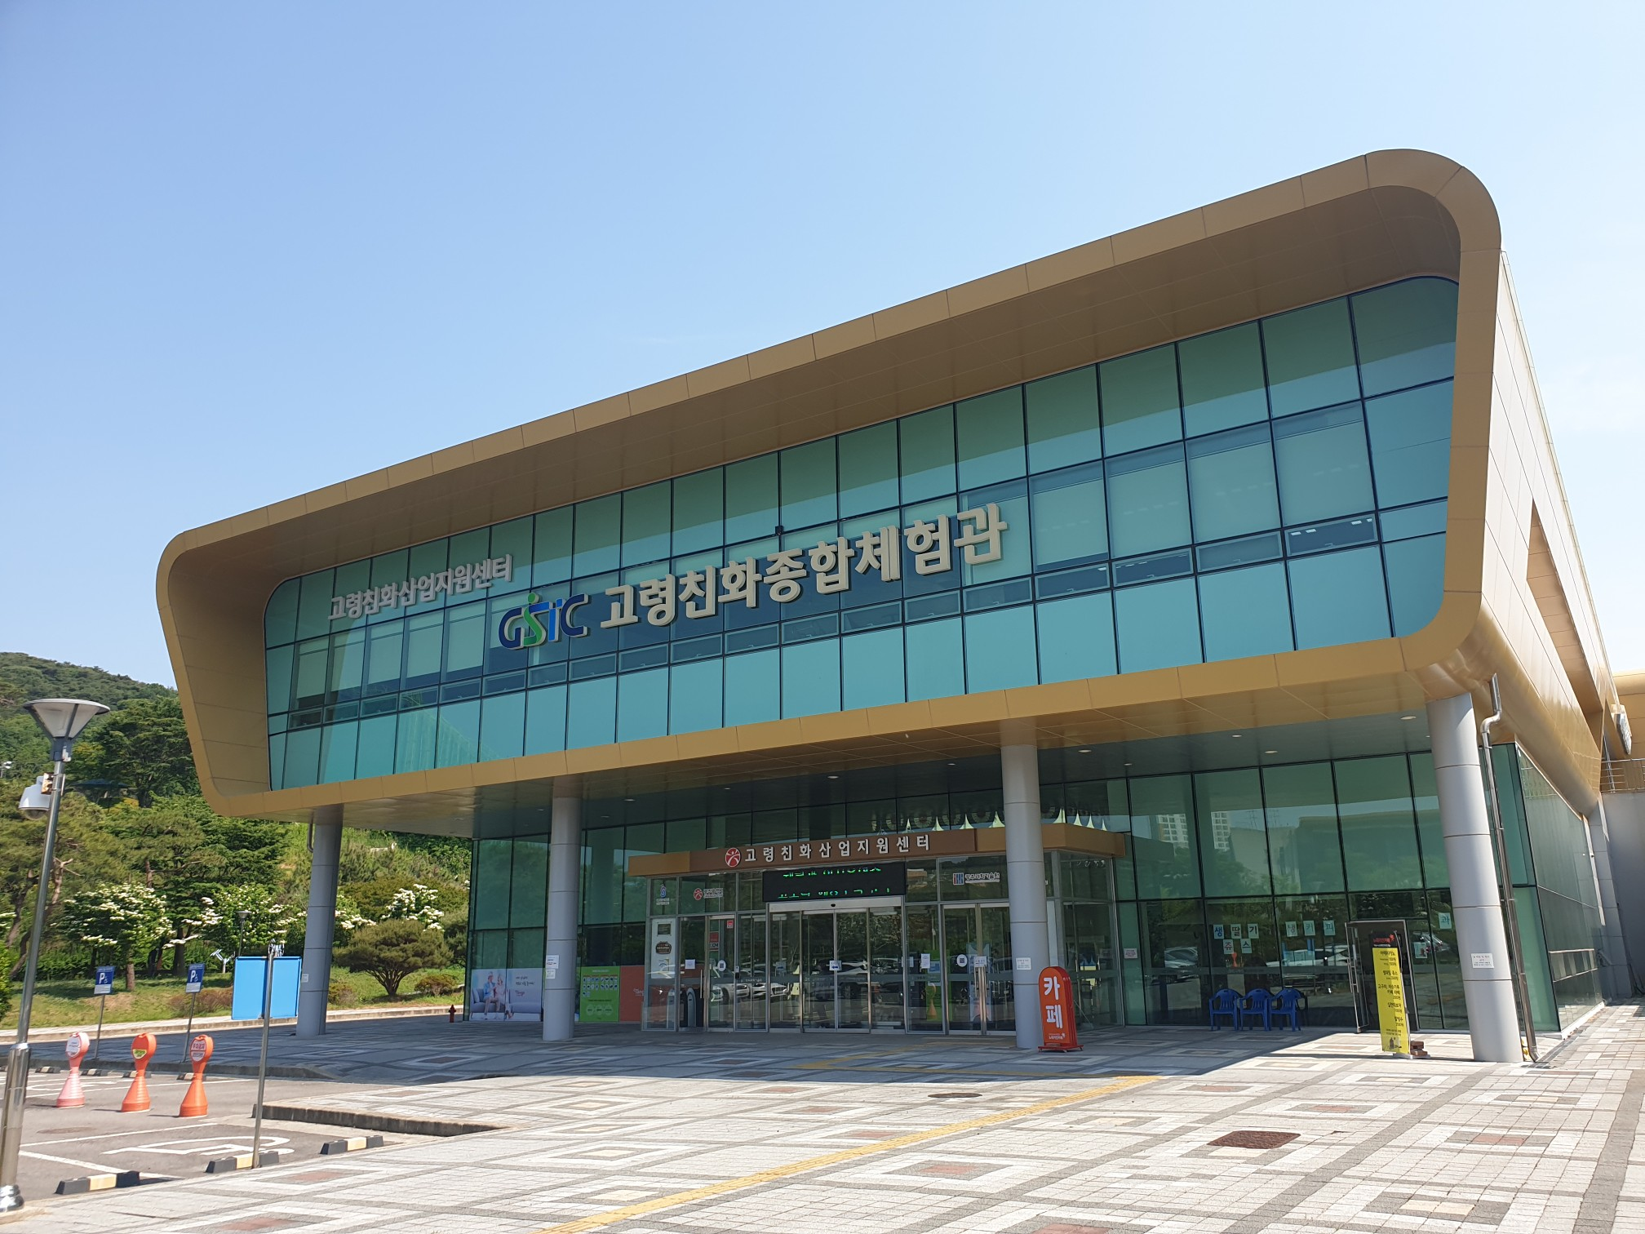
▲ Front view of Gwangju Aging-Friendly Industrial Support Center

GIST (Gwangju Institute of Science and Technology, Acting President Raekil Park) Aging-Friendly Industrial Support Center (hereafter Center, Center Director Chang-Myung Oh) is promoting support for senior-friendly specialized companies in earnest.

In order to revitalize the elderly-friendly industry in the region, which has been stagnant since COVID-19, the Center announced that it will recruit companies related to the elderly-friendly industry in Gwangju Metropolitan City by the 19th (Wednesday) of this month.

This project, with the support of Gwangju City, involved a total of 11 companies with a scale of KRW 63 million: ▴ customized marketing (6 companies) ▴ prototype production (2 companies) ▴ acquisition of intellectual property rights (2 companies) ▴ development of senior-friendly products converging with the 4th Industrial Revolution (1 company) will be supported.

After the announcement deadline at 18:00 on April 19th, the selection evaluation (evaluation of presentation) will be conducted through external selection committee members on April 25th. After the notification of the selection results and the signing of the agreement by April 28, the project will be carried out for three months from May 1 to August 1.

Recruitment target can apply if it is a company with a head office or main business place in Gwangju Metropolitan City as of the deadline for application submission.

For more information, you can check the Gwangju Aging-Friendly Industry Support Center website (www.gstc.or.kr) Center News, 'Announcement of Support Projects and Events', or the websites of various related organizations such as Gwangju Metropolitan City and Gwangju Techno Park. Other inquiries Matters can be addressed to the consignment business operation team (070-7710-2415).

The Aging-Friendly Industry Support Center expects the possibility of gradual development of the senior-friendly industry through the convergence of the 4th Industrial Revolution by adding support for the development of senior-friendly products for the 4th Industrial Revolution from last year's business support project.

Center Director Chang-Myung Oh said, "Through this support project, we expect to discover joint technology development tasks between the center and companies as well as increase sales and corporate competitiveness of beneficiaries. We will do our best to provide preemptive and active corporate support in cooperation with excellent GIST researchers in various fields."

Meanwhile, the Aging-Friendly Industry Support Center was established in 2013 for the purpose of developing local senior-friendly industries and improving the quality of life for the elderly, and is operated by GIST under the consignment of Gwangju Metropolitan City. The main business is ▴ supporting projects to discover senior-friendly service models and market development of various products and services ▴ as a regional senior-friendly industry fostering base center and partner of senior-friendly industries through government-sponsored projects to discover regional focus and specialized industries making a substantial contribution.

