AI treatment solution development for pain-mental health

- Gliopathic Pain Research Center signs business agreement with AI startup ‘Count Mind’
- Expected to present a new methodology for the treatment of pain and depression
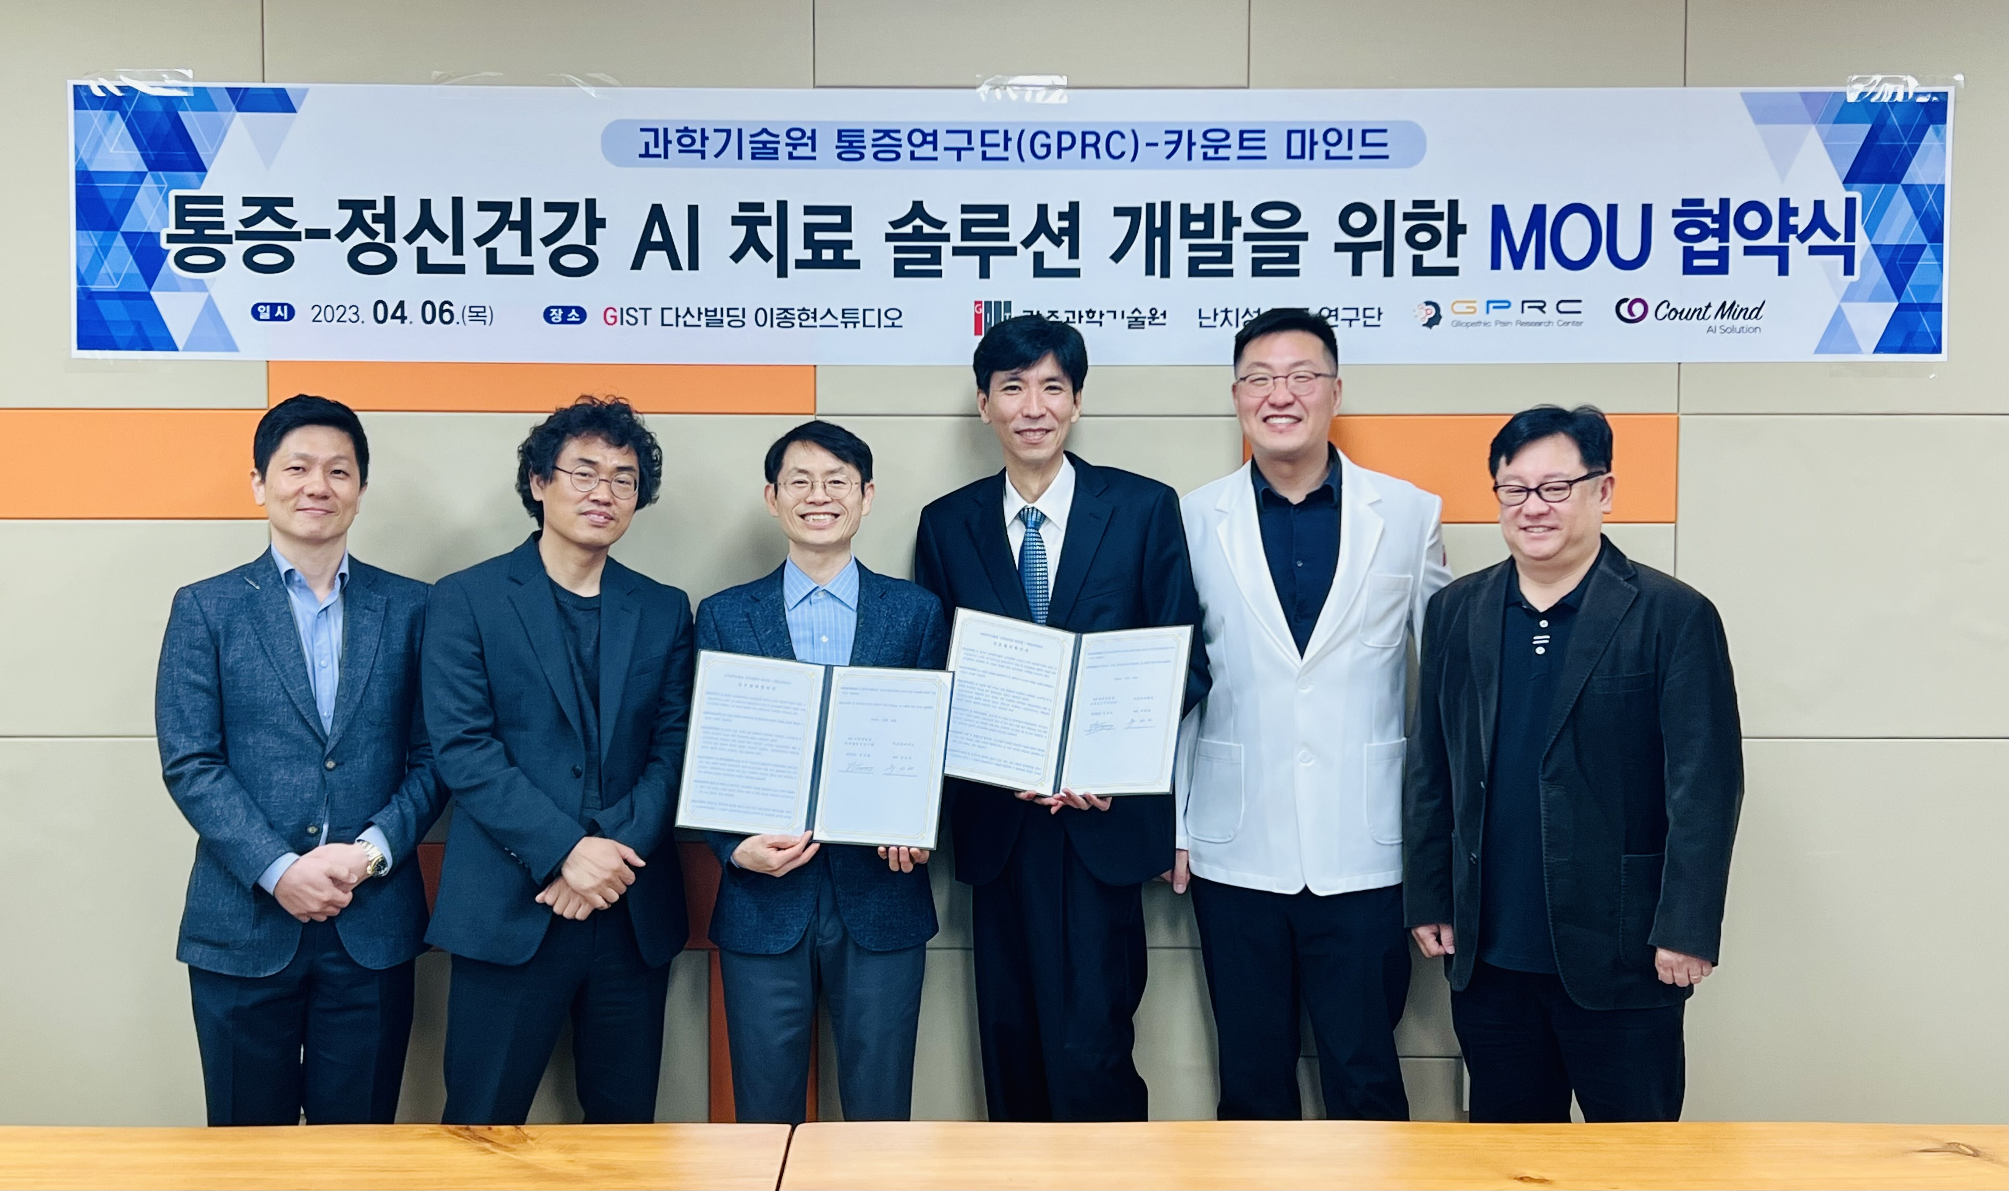
▲ On April 6 (Thursday) at the GIST Dasan Building, the Gliopathic Pain Research Center at and Count Mind held an agreement ceremony for joint research on pain-AI treatment solutions and took commemorative photos. (From left) Count Mind Dr. Jun-seok Choi and Dr. Ji-soo Kim, Gliopathic Pain Research Center Director Euiheon Chung (GIST Department of Biomedical Science and Engineering professor), Count Mind CEO Seong-kwon Choo, and Gliopathic Pain Research Center Manager Professor Hyuk Sang Kwon (GIST Department of Biomedical Science and Engineering professor), Gliopathic Pain Research Center Professor Tae Kim (GIST Department of Biomedical Science and Engineering)

GIST (Gwangju Institute of Science and Technology, Acting President Raekil Park) and the Gliopathic Pain Research Center (Director: GIST Department of Biomedical Science and Engineering Professor Euiheon Chung) signed a business agreement (MoU) with the startup Count Mind (CEO Seong-kwon Choo) to develop pain-mental health artificial intelligence treatment solutions.

The signing ceremony was held on April 6th (Thursday) at GIST Dasan Building Lee Jong-hyun Studio with researchers from the Gliopathic Pain Research Center and Count Mind CEO Seong-kwon Choo in attendance.

With this agreement, the AI motion recognition wearable device being developed by Count Mind in the Living Lab* of the Pain Research Center of the Institute of Science and Technology installed at the Gwangju Aging-Friendly Industrial Support Center. It is expected that clinical research will be conducted to present a new approach to the treatment of depression caused by pain.

* Living Lab: It means a laboratory of daily life such as a living laboratory or living research laboratory, where citizens (users) take the lead in discovering problems (urban problems) in daily life. It refers to a social innovation policy that designs solutions and even solves problems directly.

The Gliopathic Pain Research Center was launched in 2020 to develop non-pharmacological treatments based on objective diagnosis and precise neuromodulation by identifying the neurological mechanisms of intractable chronic pain. It consists of four major science and technology institutes including GIST, medical institutions such as Severance Hospital and Chonnam National University Hospital, and universities, hospitals, and companies such as Well Patent Law Firm.

Count Mind is a startup that develops a depression treatment system using artificial intelligence (AI) and was established in October 2020 and are developing a system solution that treats depression or anxiety disorders by maximizing the positive impact of skinship on mental health through motion recognition sensors mounted on smart watch-type wearable devices.

CEO Seong-kwon Choo said, "I want to share the effects of skinship treatment that I learned during the treatment of rare and intractable pain diseases with many people suffering from depression and help them. We hope to find the optimal treatment for pain and depression by collecting and analyzing behaviors that positively affect human pain and mental health as quantitative data."

Gliopathic Pain Research Center Director Euiheon Chung said, "As the population ages, the problem of chronic pain and depression caused by it has become an urgent task to be solved. Through this industry-academia cooperation with Count Mind, we will try to present a new methodology for pain and depression treatment by converging advanced neuroscience and AI technology."



