GIST invites ‘The Head of Turbo’ to give a special lecture on <Scientist’s Conversation Method>

- Jung-mo Lee, former director of Gwacheon National Science, was invited as a science communicator
- Developing the right skills as a scientist for new students in the bachelor's degree program

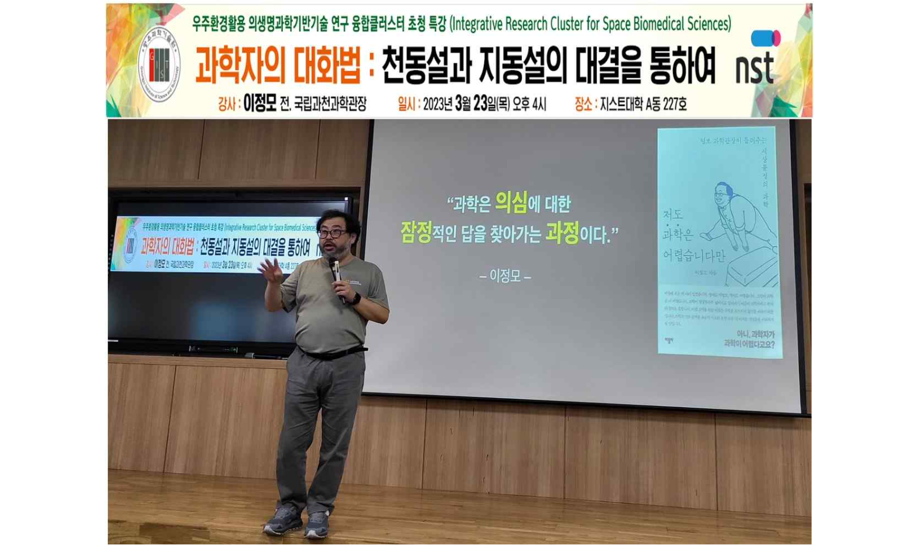▲ Jung-mo Lee, director of the Penguin Museum of Science (former director of the Gwacheon National Science Museum), is giving a special lecture to freshmen of the GIST undergraduate program on the subject of ‘Scientist’s Conversation Method.’

GIST (Gwangju Institute of Science and Technology, Acting President Raekil Park) invited science communicator Jung-mo Lee, director of Penguin Museum of Science (former director of Gwacheon National Science Museum), a well-known science communicator, to hold a special lecture on 'How Scientists Talk.'

Director Lee strives to popularize science by easily explaining difficult science through liberal arts science books and lectures.

The special lecture on this day was held on the 23rd (Thursday) hosted by the 'Integrative Research Cluster for Space Biomedical Sciences (Cluster Director School of Life Sciences Professor Steve K. Cho).'

This is a special lecture for GIST undergraduate freshmen who will lead Korea in the full-fledged space era, with the successful launch of the Nuri and Danuri and the opening of the control tower, the Space Aviation Administration, this year. It was designed to provide opportunities to develop and build logical problem-solving abilities as scientists and scientific thinking skills through liberal arts education*.

With the theme of <The Conversation Method of Scientists: Through the Confrontation between the Geocentric and Heliocentric Theories>, Director Lee starts with the question, ‘Is science easy?’ and explained that ‘science is a process of finding tentative answers while constantly doubting’, breaking away from ‘the conventional wisdom that all scientists experiment’.

In addition, it conveys the geocentric and heliocentric theories in an easy-to-understand way through various animations, emphasizing the 'importance of dialogue', emphasizing the importance of dialogue, which is essential for scientists, and the importance of logical thinking that checks whether there is any contradiction in the other's claims with quantitative data.

Professor Steve K. Cho, who prepared this lecture, said, "I would like to thank Director Jung-mo Lee for his great help so that the new students of the GIST undergraduate program, who are future scientists preparing for the wide open space age in various fields of research, can cultivate and develop their knowledge as scientists. Like the words introduced during the special lecture, we look forward to GIST students who will grow into mature scientists through humility and endless questions and conversations."

Meanwhile, the Integrative Research Cluster for Space Biomedical Sciencesent focuses on the GIST Integrated Institute of Biomedical Research (Director Zee Yong Park) to respond to life sciences in the space environment, such as microgravity and exposure to cosmic radiation, to prepare for the manned space age. We are conducting research on strategic base technology platforms. In particular, it is being operated with the goal of planning a next-generation space research personnel development protocol by strengthening STEM education* capabilities.

* Liberal arts education: Emphasis is placed on basic studies such as humanities and social sciences, natural sciences, engineering, and the arts, and discussion-oriented classes develop expressive skills through extensive reading and writing, as well as mathematics, science, history, literature, and philosophy. It is an educational method that focuses on cultivating critical thinking and creativity while acquiring knowledge in various fields by applying research and investigation methodology to liberal arts subjects. For example, when appreciating works of literature and art, students not only grasp the intention of the author, but also investigate the intention of creation or the situation of the times, induce them to have an independent point of view, and develop scientific thinking skills and logical problem-solving skills in the process.

* STEM Education: Science, Technology, Engineering, and Mathematics education, which is attracting attention as an education that develops problem-solving skills.



