For the 29th anniversary celebration, Mujin Service Co., Ltd. CEO Eun-mo Choi awarded the <1st GIST Oryong Grand Prize>

- The establishment ceremony on the 16th... This year's first award by selecting people who contributed to GIST and regional economic development
- President Kiseon Kim, “We will be reborn as an institution of integrity and contribute to science, technology, and industrial innovation by nurturing experts and starting businesses”

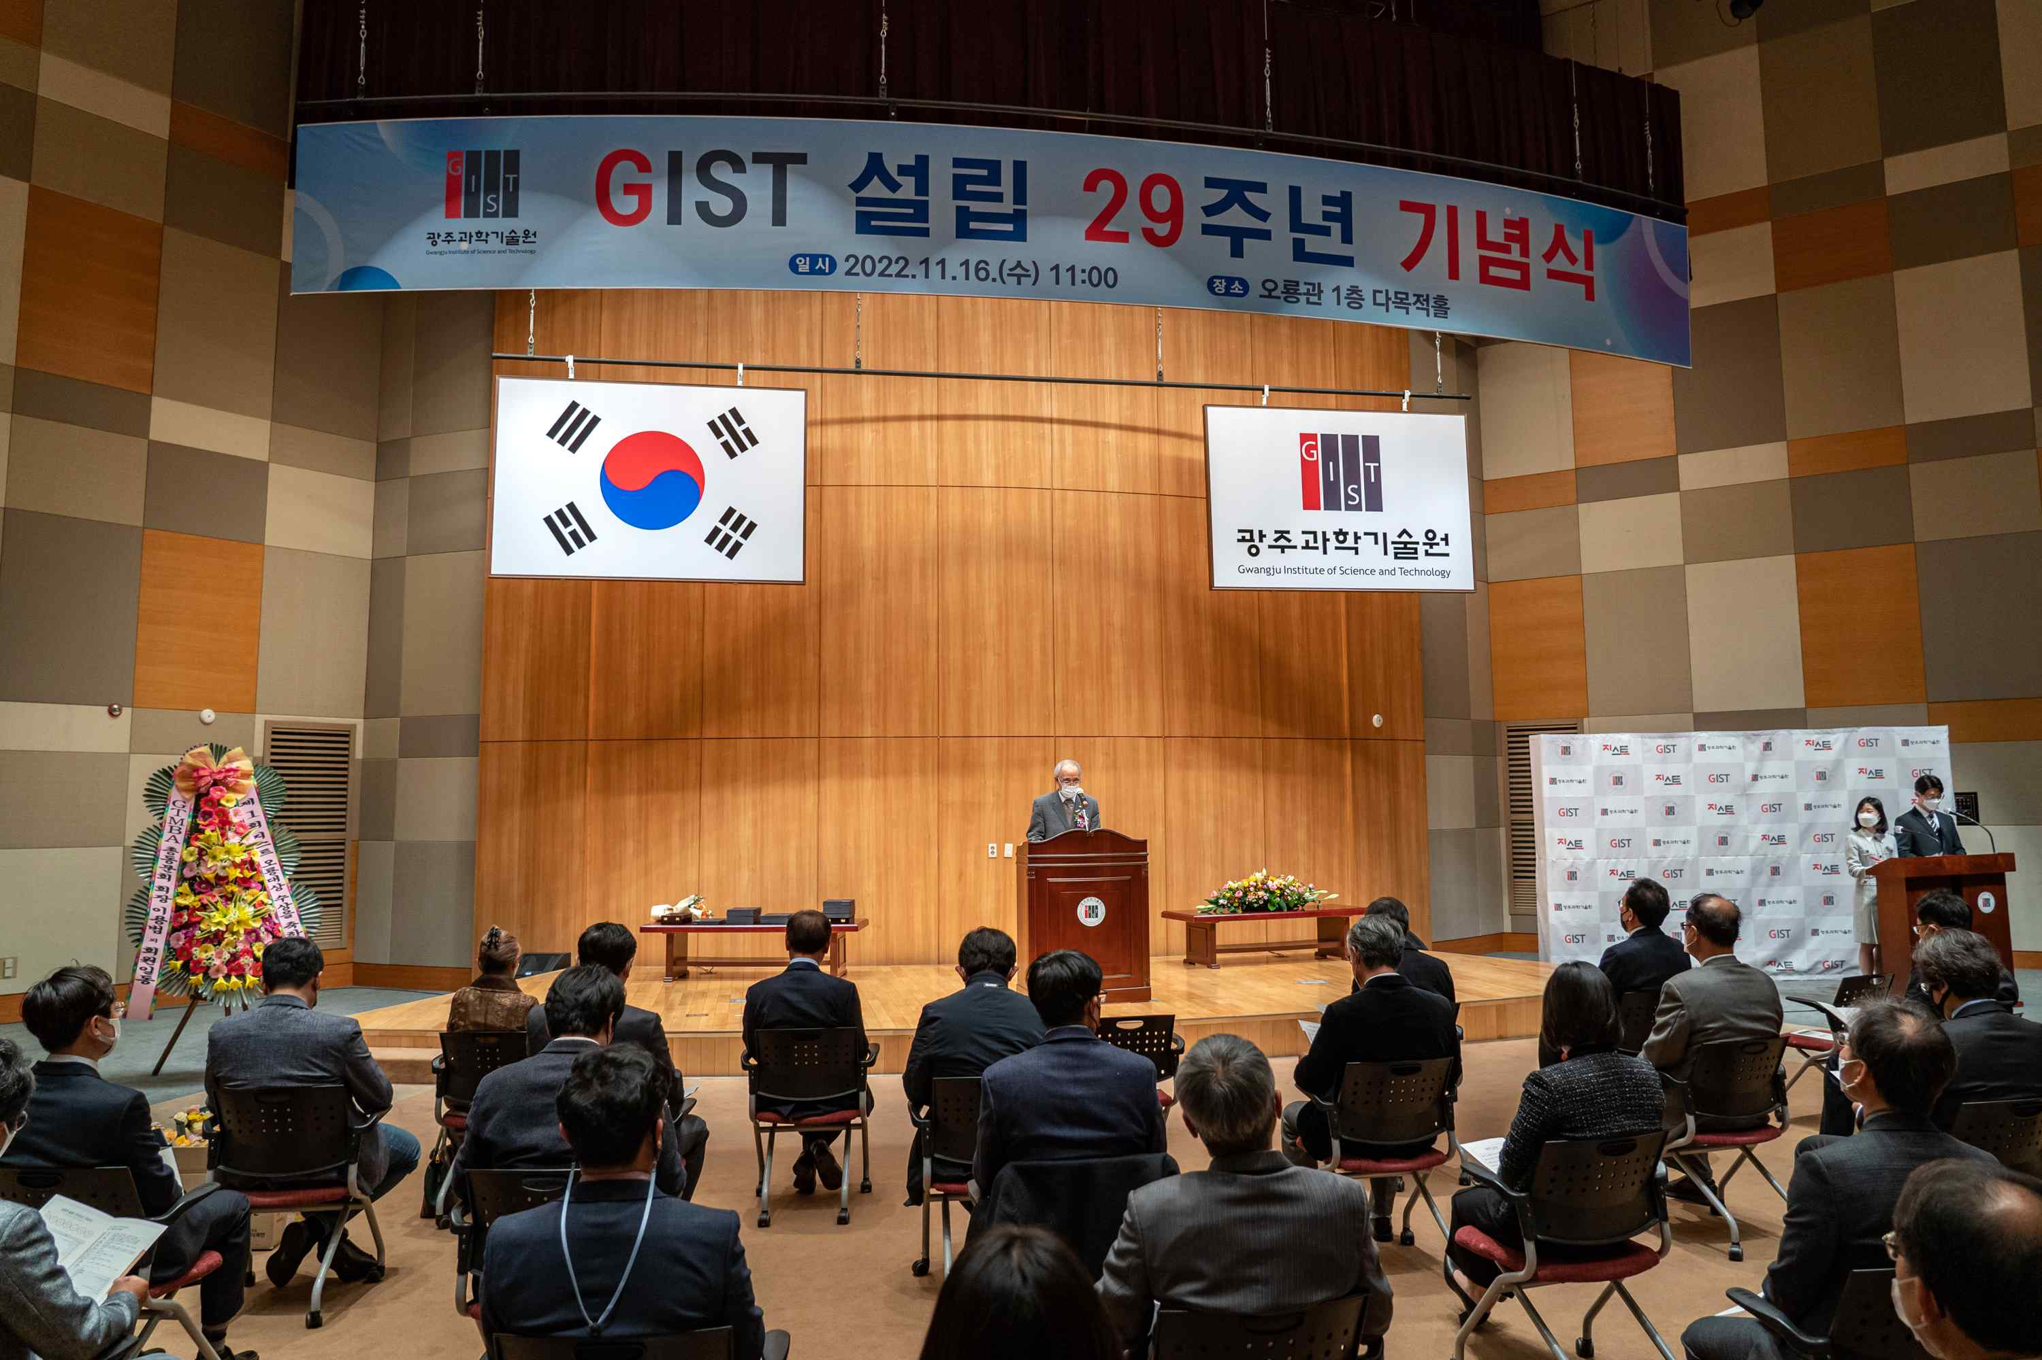
▲ To commemorate the 29th anniversary of the establishment of GIST on November 17th, on the morning of the 16th (Wednesday), a ceremony was held at Oryonggwan in the presence of 80 people including major officials, faculty, and students.

GIST (Gwangju Institute of Science and Technology, President Kiseon Kim) selected Mujin Service Co., Ltd. CEO Eun-mo Choi awarded the <1st GIST Oryong Grand Prize> and held an award ceremony at the 29th anniversary ceremony held on November 16 (Wednesday).

Inspired by the name of the administrative district where the GIST campus is located (Oryong-dong, Buk-gu, Gwangju), the <GIST Oryong Grand Prize> is an award for a person who has played a pivotal role in the development of GIST, raising the honor of the school and establishing correct corporate ethics and contributing to the development of the local economy. It was established for the first time this year.

After the establishment of Mujin Service in 1988, CEO Eun-mo Choi has grown domestic battery manufacturing equipment technology to the global TOP 3 level and ranked first in domestic market share in related equipment sales. Mujin Service has grown into a global company by ranking third in overseas market share.

In addition, based on excellent management skills and leadership, they are continuously sponsoring and investing to create jobs for local talent, and training to strengthen employee capabilities with the goal of becoming a "100-year company" and entrepreneurship that values talent the most while implementing various welfare policies and is working as a representative local entrepreneur trusted by internal and external sources.

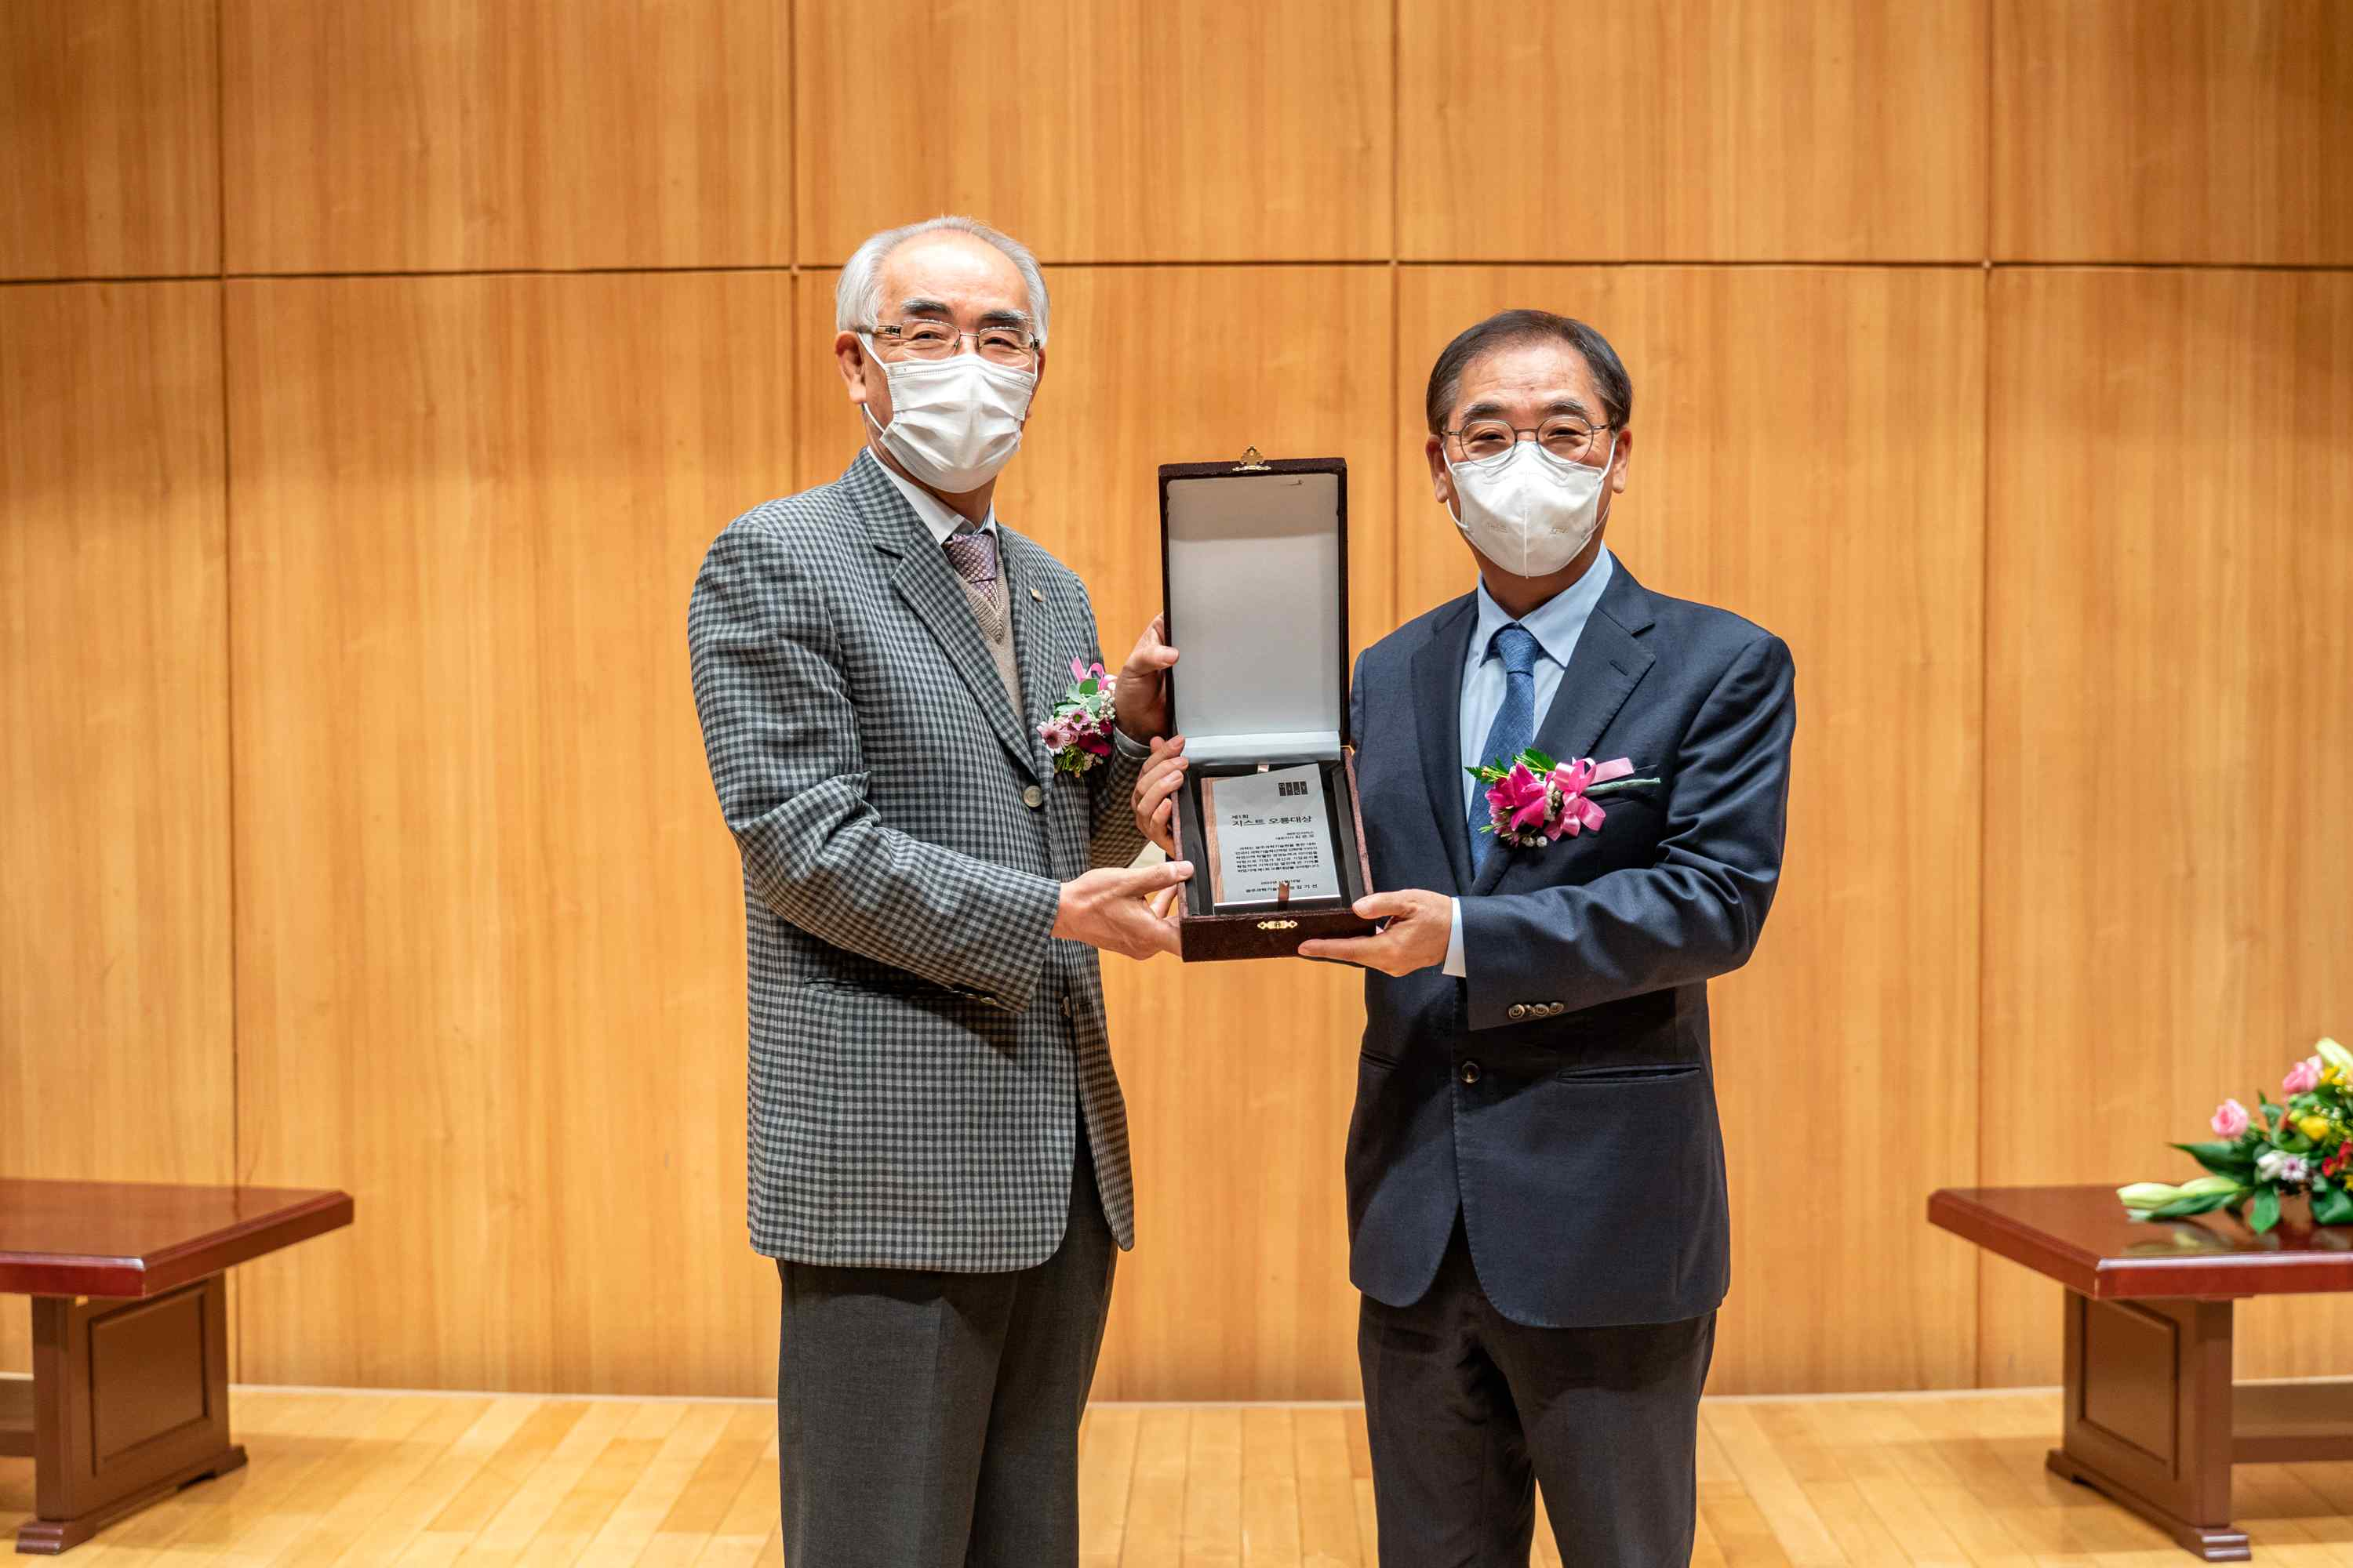
▲ Mujin Service Co., Ltd. CEO Eun-mo Choi was selected as the winner of the <1st GIST Oryong Awards> and an award ceremony was held at the 29th anniversary ceremony held on November 16 (Wednesday).

Mujin Service Co., Ltd. strengthens the capacity of excellent personnel by encouraging all employees to visit countries with overseas customers at least once a year and conduct overseas training with their families to understand the cultural characteristics of the country to support and to promote creative and stable work. In addition, it is famous for high job satisfaction among local manufacturers by implementing various welfare designation policies such as foreign language ability improvement education and support for acquiring various qualifications.

International and Public Affairs Dean Chang-Duk Jun said, "The <Oryong Grand Prize> is an award open to all, not just GIST members, and is given to those who have dedicated themselves to GIST and the region and who have achieved outstanding achievements. I sincerely hope that the meaning and weight of the first award of this <Oryong Awards> will become a momentum to announce a new beginning in the history of GIST."

The ceremony to commemorate the 29th anniversary of the establishment of GIST was held at the Oryonggwan this morning, with around 80 people in attendance, including CEO Eun-mo Choi, the winner of the <GIST Grand Prize>, President Kiseon Kim, key officials, faculty, and students.

As in last year, to prevent the spread of COVID-19, it was held with online real-time broadcasting and only major winners attending the ceremony. An award ceremony was also held for GIST members who have dedicated themselves to the development and operation of GIST in various fields such as research and education, COVID-19 response, and safety work.

President Kiseon Kim delivered the commemorative speech, saying, "Since its establishment, GIST has been swiftly responding to the diverse needs of regions and countries for Korea, a super-giant artificial intelligence powerhouse. We will do our best to create a successful model for Gwangju AI clustering by playing a key role in AI research and human resource training centered on the currently successfully operating AI Graduate School, Energy Convergence Graduate School, and AI Research Center."

In addition, he said, "Ahead of the 30th anniversary of its establishment next year, various efforts were made in 2022 to improve the integrity of GIST, including education on the integrity of its members centered on the ‘Integrity Improvement Special Committee’ and ‘Lunch Talk’ with students. We will continue to strive and communicate to become a GIST that fulfills its social responsibilities as an honest university and public institution, as well as fostering excellent scientific experts, economic and industrial innovation through startups, and job creation."

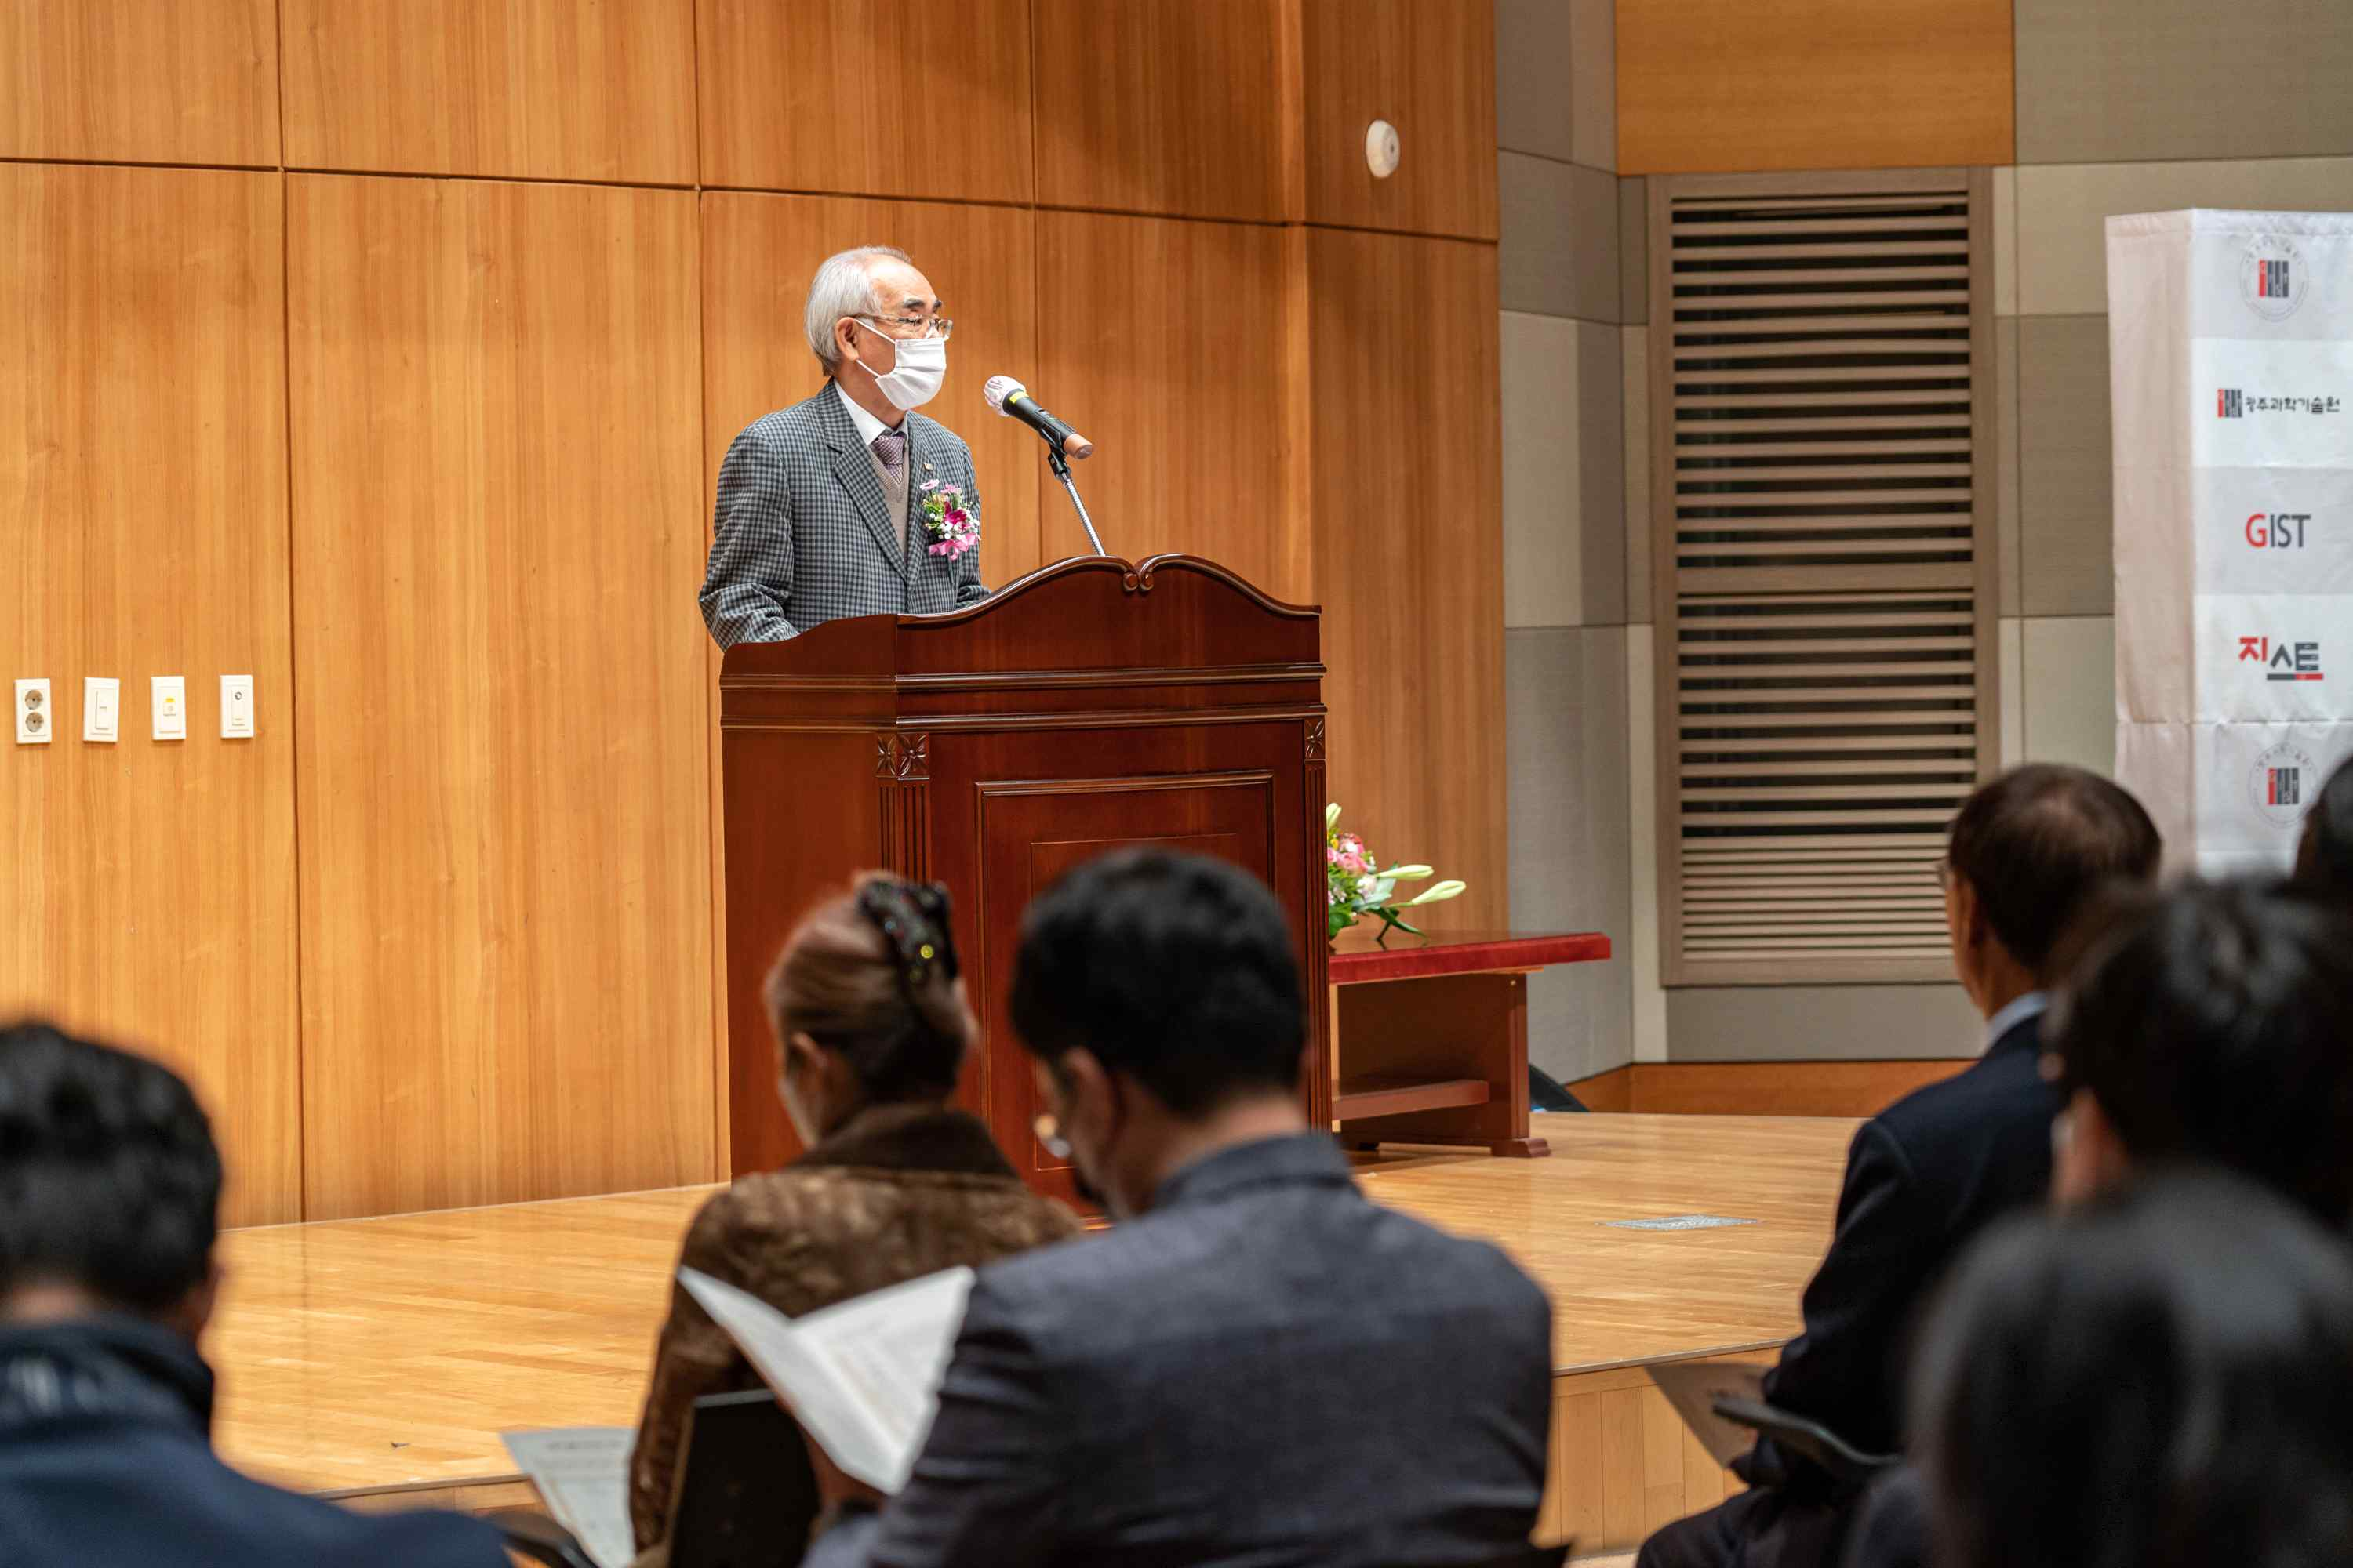
▲ GIST President Kiseon Kim gives the commemorative speech at the 29th anniversary ceremony.

GIST was established in 1993 for the purpose of nurturing advanced scientific and technological experts, conducting basic and applied research for national research and development, and revitalizing the Gwangju Advanced Science Industrial Base. It started as a master's and doctoral graduate program in 1995 and opened a bachelor's program in 2010, establishing itself as a successful model for innovative small-scale science and engineering education.

In particular, recently, based on the ‘High Performance Computing-Artificial Intelligence-based Public Infrastructure Data Center’, it has been contributing substantially to the AI industry convergence complex construction project. Through artificial intelligence, GIST is striving to innovate regionally, create jobs, and foster advanced AI experts.

