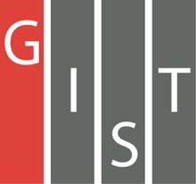
Gwangju Institute of Science and Technology

Official Press Release (https://www.gist.ac.kr/)

Section of Hyo Jung Kim Nayeong Lee
Public Affairs Section Chief Senior Administrator
(+82) 62-715-2061 (+82) 62-715-2062

Contact Person Dean Sung-Gyoo Park
for this Article Section of Public Affairs
(+82) 62-715-2022

Release Date 2019.08.19

President Kiseon Kim introduces the future vision of the Gwangju AI Innovation Cluster at the United States-Korea Conference on Science

□ GIST President Kiseon Kim participated as a panel speaker at the United States-Korea Conference on Science (UKC), the largest science and technology conference of Korean and American scientists, which was held in Chicago on August 16, 2019.

∘ The Korea-US Science and Technology Conference (UKC) was first held in Seoul in 1974 as a symposium for Korean American scientists. Since 2010, it has become the largest academic conference involving Korean universities, government-funded institutions, and companies. Under the leadership of Korean scientists in the U.S., hundreds of scientists from both countries have attended the conference to introduce the latest research achievements and trends and to attend symposiums and forums on various topics in science and technology.

□ The 2019 United States-Korea Conference on Science was held for three nights and four days from the 14th to the 17th. The conference was cosponsored by the Korean-American Scientists and Engineers Association (KSEA, President Jun-seok Oh), the Korean Federation of Science and Technology Societies (KOFST, President Myung-ja Kim), and the Korea-US Science Cooperation Center (KUSCO, Chairperson Jung-hye Noh). This year, more than 1,000 scientists from the two countries gathered under the theme "Smart Science, Engineering and Health for a Living Society" to discuss exchanges and cooperation in science and technology.

∘ The University Leadership Forum was on two themes (future-proofing and workforce) and was attended by Seoul National University, Ewha Womans University, and the president of the University of Illinois System. GIST President Kiseon Kim gave a presentation on "Creating an Ecosystem for Innovation and Entrepreneurship in Higher Education."

□ President Kiseon Kim explained the creation of the Gwangju AI Innovation Cluster, which is being developed as a new economic growth engine and to develop core technologies for the future, saying that "the Gwangju 'AI Innovation Cluster' is a model for interdisciplinary and open research, which will have a positive impact on the country and the community."

□ GIST has participated in the annually in UKC to contribute to promoting friendship between scientists of both countries and to introduce GIST's outstanding research achievements as a specialized science and engineering university representing Korea to foreign countries as well as to raise the status and awareness of Korean universities.

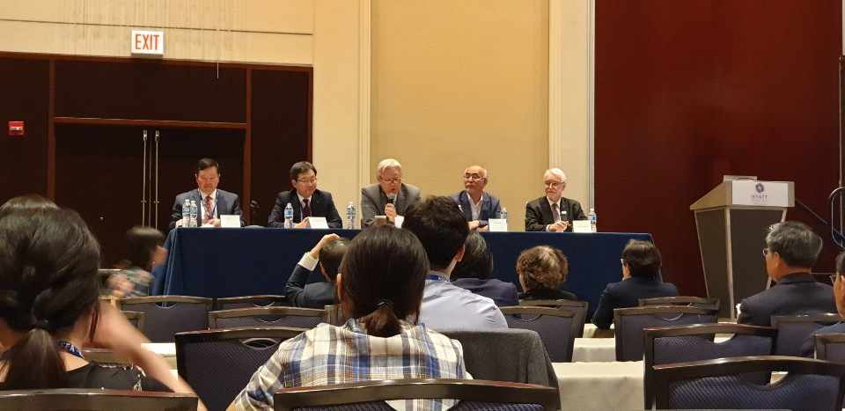
▲ GIST President Kiseon Kim is fourth from left

