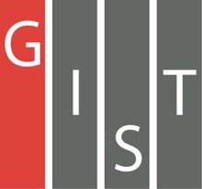
Gwangju Institute of Science and Technology

Official Press Release (https://www.gist.ac.kr/)

Section of Mi-Yeon Kim Nayeong Lee
Public Affairs Section Chief Senior Administrator
(+82) 62-715-2020 (+82) 62-715-2024

Contact Person Man-jae Kim, MS Student
for this Article School of Electrical Engineering
and Computer Science
(+82) 62-715-3169

Release Date 2018.11.30

GIST students Man-jae Kim and Dong-hyun Lee won third prize in the CIG 2018 Fighting Game AI Competition hosted by IEEE

□ GIST (President Seung Hyeon Moon) Man-jae Kim, a master's student in the School of Electrical Engineering and Computer Science, and Dong-hyun Lee, a GIST College senior, won third prize in the CIG 2018 Fighting Game AI Competition hosted by IEEE, the world's largest technical organization for electrical and electronics engineering.

∘ Fighting game AI Competition is one of the competitions organized by the Computational Intelligence Society (CIS), a professional association dealing with Neural Network, Evolutionary Programming, Fuzzy System and Hybrid Intelligence at the IEEE. Every year they host competitions for such games as StarCraft and Doom as well as general video games.

□ This year's competition was held in the Netherlands from August 1 to 10, and the results were released on August 15. Man-jae Kim participated in the competition by forming a team with Dong-hyun Lee called JayBot_GM (GIST MEMI).

∘ Fighting Game AI Competition is a field that competes with each other's latest artificial intelligence technologies by developing optimized artificial intelligence for three characters each capable of dozens of actions. JayBot_GM team developed artificial intelligence using Hybrid Method, which is a fusion of genetic algorithm and Monte Carlo tree search algorithm.

∘ The JayBot_GM team was the only team to win purely through algorithms rather than utilizing Domain Knowledge.

□ Man-jae Kim said, "Successful generalizations seem to work effectively so that they do not depend on specific circumstances. Although it was hard to integrate high-level artificial intelligence technologies, I was honored to participate in international competitions and win an award for excellence."

□ IEEE CIG AI Competition has hosted various AI competitions since 2010 under the auspices of the IEEE. Many of the world's leading institutes such as Intel, Facebook, UC Berkeley, Carnegie Mellon University, Nagoya University, and Tencent hve participated in the competition. The JayBot_GM team was the only winner from Korea this year.

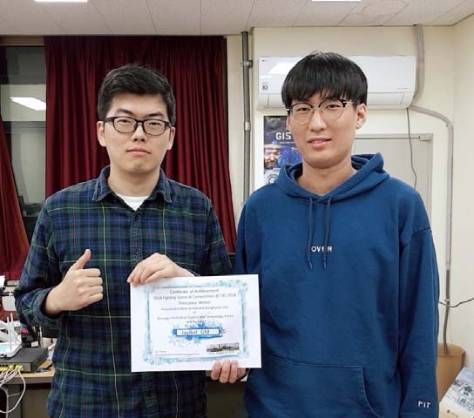
▲ GIST students Man-jae Kim and Dong-hyun Lee of team JayBot_GM

