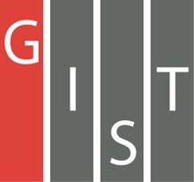
Gwangju Institute of Science and Technology

Official Press Release (https://www.gist.ac.kr/)

Section of Hyo Jung Kim Nayeong Lee
Public Affairs Section Chief Senior Administrator
(+82) 62-715-2061 (+82) 62-715-2062

Contact Person Professor Kayoung Lee
for this Article School of Materials Science and Engineering
(+82) 62-715-2368

Release Date 2019.10.02

School of Materials Science and Engineering Professor Kayoung Lee selected as a
Fellow POSCO Rising Professor

□ GIST (President Kiseon Kim) School of Materials Science and Engineering Professor Kayoung Lee was selected as a Fellow POSCO Rising Professor during the 11th POSCO Science Fellowship sponsored by the POSCO TJ Park Foundation.

∘ The POSCO TJ Park Foundation presented research certificates to 39 Korean scientists selected for the fellowships at the POSCO Center in Seoul on September 27, 2019. 55 people attended the event, including Sun-wook Kim, chairman of the foundation, 39 members of the 11th POSCO Science Fellowship, Sogang University Professor Beom-hoon Lee who was the chair of the selection committee, GIST Professor Do-Young Noh, Ewha Womans University Professor Yun-jin Lee, and Hanyang University Professor Chun-kyu Cho.

□ The POSCO Science Fellowship has been established as a 'new science award' to provide practical help and support to promising young researchers who may lack sufficient external funding.

∘ POSCO Science Fellowship provides 100 million won for two years to young professors who study basic science in four fields, including mathematics, physics, chemistry, and biochemistry. In particular, new categories for new metals, new materials, and energy were established this year, and Professor Kayoung Lee was selected for the new materials category.

∘ The 11th POSCO Science Fellowship received 492 applications during a one-month period from June 1, ending with a fierce competition ratio of 12 to 1. There were 42 applicants in mathematics, 68 in physics, 56 in chemistry, 176 in life sciences, 31 in new metals, 71 in new materials, and 48 in energy.

□ GIST Professor Kayoung Lee said, "I will actively carry out risky but challenging research, such as the implementation of solid equilibrium exciton coagulation, which has not yet been discovered despite the theory having been established decades ago."

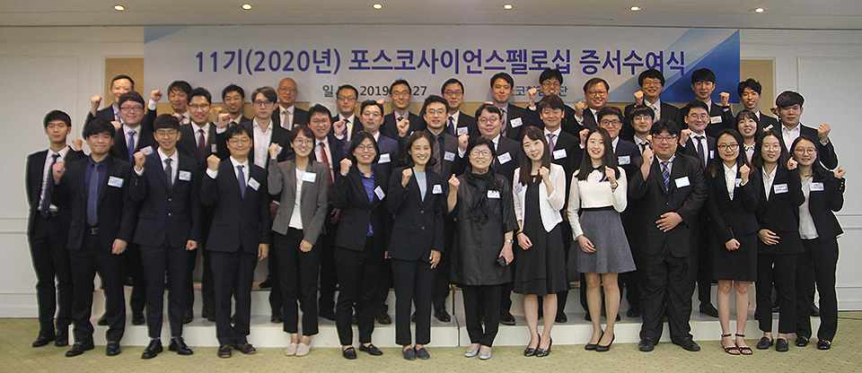
▲ The POSCO TJ Park Foundation awarded the research certificate to scientists selected as the 11th POSCO Science Fellows at the POSCO Center on September 27, 2019. 39 people took part in this commemorative photo, including President Sun-wook Kim (seventh from the left in the front row) and GIST Professor Kayoung Lee (fourth from the left in the front row).

