

**Gwangju Institute of Science and Technology**

**Official Press Release (https://www.gist.ac.kr/)**

**Section of** Hyo Jung Kim Nayeong Lee

**Public Relations** Section Chief Senior Administrator

(+82) 62-715-2061 (+82) 62-715-2062

**Contact Person** Professor Hyo-Sung Ahn

**for this Article** School of Mechanical Engineering

(+82) 62-715-2398

**Release Date** 2020.03.16

**Professor Hyo-Sung Ahn publishes a book entitled 'Formation Control' with Springer, a world-renowned science and technology publisher**

□ Gwangju Institute of Science and Technology (GIST, President Kiseon Kim) School of Mechanical Engineering Professor Hyo-Sung Ahn recently published the book *Formation Control: Approaches for Distributed Agents* with Springer, a well-known science and technology publisher.

∘ Springer is a prominent publisher established in Germany in 1842. It publishes scientific journals and books in the field of science and technology and publishes *Nature*, the world's best scientific journal.

□ *Formation Control*, written and published by Professor Hyo-Sung Ahn, is a book about information processing that established a new theory about using distributed control and distributed decision technology to define the motion of multi-agent systems according to the development of artificial intelligence technology.

∘ In the existing theory, control was handled only in a regional way without considering communication and computational perspectives, and observations were treated in a global way, but in this book, observations, controls, communications, and computations were all treated in a regional way to define the relative motion of the multidisciplinary system. Ultimately, the book was a celebration of the theory of presenting a global approach to control using regional and relative information, and provides prior mathematical and conceptual knowledge to build a decentralized one-sided control theory.

∘ Professor Hyo-Sung Ahn has been researching distributed formation control for a long time and has published this book as a result. He also previously published a paper called "A Survey of Multi-agent Formation Control (2015)" in the journal *Automatica*, which has been included as a top citation paper.

□ Professor Hyo-Sung Ahn said, "It took about 5 years for this book to be published, and I would like to express my gratitude to my family, my students, and the school for providing a good research environment. In the future, I would like to link the theory of distributed control to the theory of artificial intelligence."

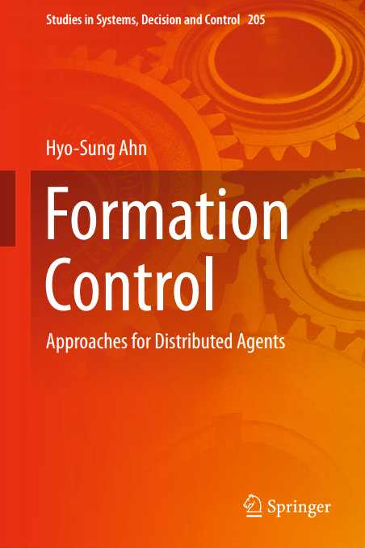

▲ <Formation Control> written by Professor Hyo-Sung Ahn