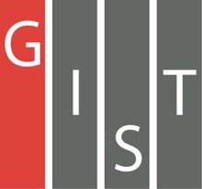

**Gwangju Institute of Science and Technology**

**Official Press Release (https://www.gist.ac.kr/)**

**Section of** Hyo Jung Kim Nayeong Lee

**Public Affairs** Section Chief Senior Administrator

(+82) 62-715-2061 (+82) 62-715-2062

**Contact Person** Hee-min Kwak, Ph.D. student

**for this Article** School of Electrical Engineering

and Computer Science

(+82) 62-715-2286

**Release Date** 2019.09.10

**Hee-min Kwak of the School of Electrical Engineering and Computer Science won the Grand Prize in the 2019 Korea Energy Start-up Contest**

□ GIST (President Kiseon Kim) School of Electrical Engineering and Computer Science graduate student Hee-min Kwak's (Advisor: Professor Dong-Seon Lee) "Light" (team member Moon-do Park, Ph.D. student) won the grand prize in the final round of the 2019 Korea Energy Start-up Contest.

∘ The 'Energy Start-up Contest' was launched in June by selecting 12 teams through a competition to utilize appropriate technologies in the energy sector, and the teams advanced to the finals after various customized programs to strengthen their corporate capabilities, including dedicated financial consulting.

□ The competition was held on September 4, 2019, at Hall 1 and 2 of the Ilsan KINTEX Exhibition Hall, and the final judging of the start-up product was conducted by the evaluators composed experts in each field and evaluated ▲ the excellence and differentiation of the idea ▲ necessity of commercialization ▲ the applicability of the site was evaluated.

∘ Among the winners were Reset Company, which came up with the idea of unmanned cleaning and snow-removal robots that improve solar power generation efficiency, and Tuxi which presented the idea of a small energy-saving refrigerator won a prize. The grand prize was awarded to the "Light" LED module idea.

□ GIST's preliminary start-up company 'Light' is an idea that complements the shortcomings of existing LED modules used in homes. It has been recognized at the competition with a history of winning awards and hopes to start its own business next year.

□ GIST School of Electrical Engineering and Computer Science student Hee-min Kwak said, "I became interested in starting a business during the first semester of this year. I was able to participate in this competition with the help of GIST Sprint for Start-up (GSS). In particular, I was able to achieve good results in this competition thanks to Professor Dong-Seon Lee and other students."

∘ The event was hosted by the Korea Energy Corporation, organized by the Ulsan Center for Creative Economy and Innovation and sponsored by KEB Hana Bank. The winners were awarded 10 million won for the first team, 5 million won for each of the best two teams, 2 million won for each of the best four teams, and 1 million won for each of the five creative teams.

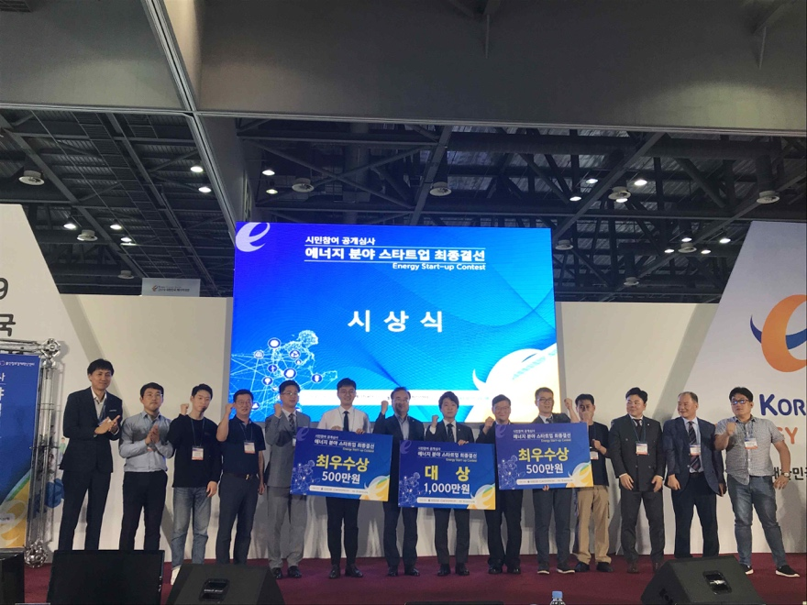

▲ 2019 Korea Energy Start-up Contest commemorative photo

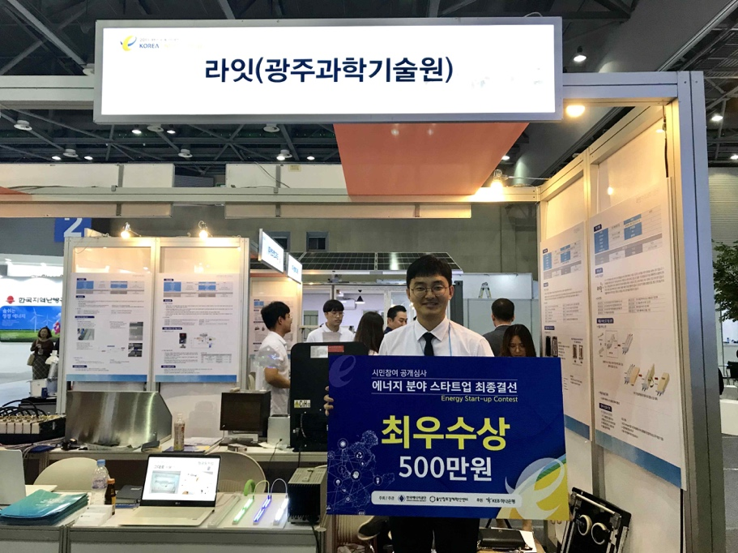

▲ GIST student Hee-min Kwak at his "Light" exhibition booth