

**Gwangju Institute of Science and Technology**

**Official Press Release (https://www.gist.ac.kr/)**

**Section of** Hyo Jung Kim Nayeong Lee

**Public Relations** Section Chief Senior Administrator

(+82) 62-715-2061 (+82) 62-715-2062

**Release Date** 2020.08.25

**School of Earth Sciences and Environmental Engineering graduate Dr. Tae-Yong Jeong becomes an assistant professor of environmental studies at Hankuk University of Foreign Studies**

□ GIST (Gwangju Institute of Science and Technology, President Kiseon Kim) School of Earth Sciences and Environmental Engineering graduate Dr. Tae-Yong Jeong will be appointed as an assistant professor of environmental studies at Hankuk University of Foreign Studies from September of this year.

∘ Dr. Tae-Yong Jeong is a graduate of the Environmental Toxicology & Chemistry Laboratory (ETCL) and completed his master's and doctoral degrees from September 2010 to August 2016 under the guidance of Professor Sang Don Kim. During his graduate program, he conducted research on the risk of hazardous chemicals and water quality monitoring using zooplankton.

□ After graduating from GIST graduate school, he served as a postdoctoral researcher at the University of Toronto from June 2017 to July 2020. During his post-doc, he conducted water quality monitoring studies utilizing changes in plankton biomolecules, contributing to enhancing the practicality of Omics* technology.

* Omics: the field of biology whose goal is the collective characterization and quantification of pools of biological molecules that translate into the structure, function, and dynamics of an organism or organisms

∘ The research results of Dr.Tae-Yong Jeong was published as research news at the University of Toronto in 2019 ([https://www.utoronto.ca/news/ut-researchers-develop-early-warning-system-water-pollution-using-tiny-water- fleas](https://www.utoronto.ca/news/ut-researchers-develop-early-warning-system-water-pollution-using-tiny-water-%20fleas)) where he was recognized for excellence. In addition, his proposed joint research with a team at the University of Oklahoma in the U.S. in 2020 was selected as the Globalink Research Award by Mitax (a science and technology support organization under the Canadian government) in Canada.

□ Dr.Tae-Yong Jeong said, "In the future, I will continue my research on water quality monitoring using Omics technology and will focus my efforts on training experts in the field. I would like to develop practical biomolecule monitoring techniques that can be applied to surface water and offshore areas instead of just at the laboratory-level of research."

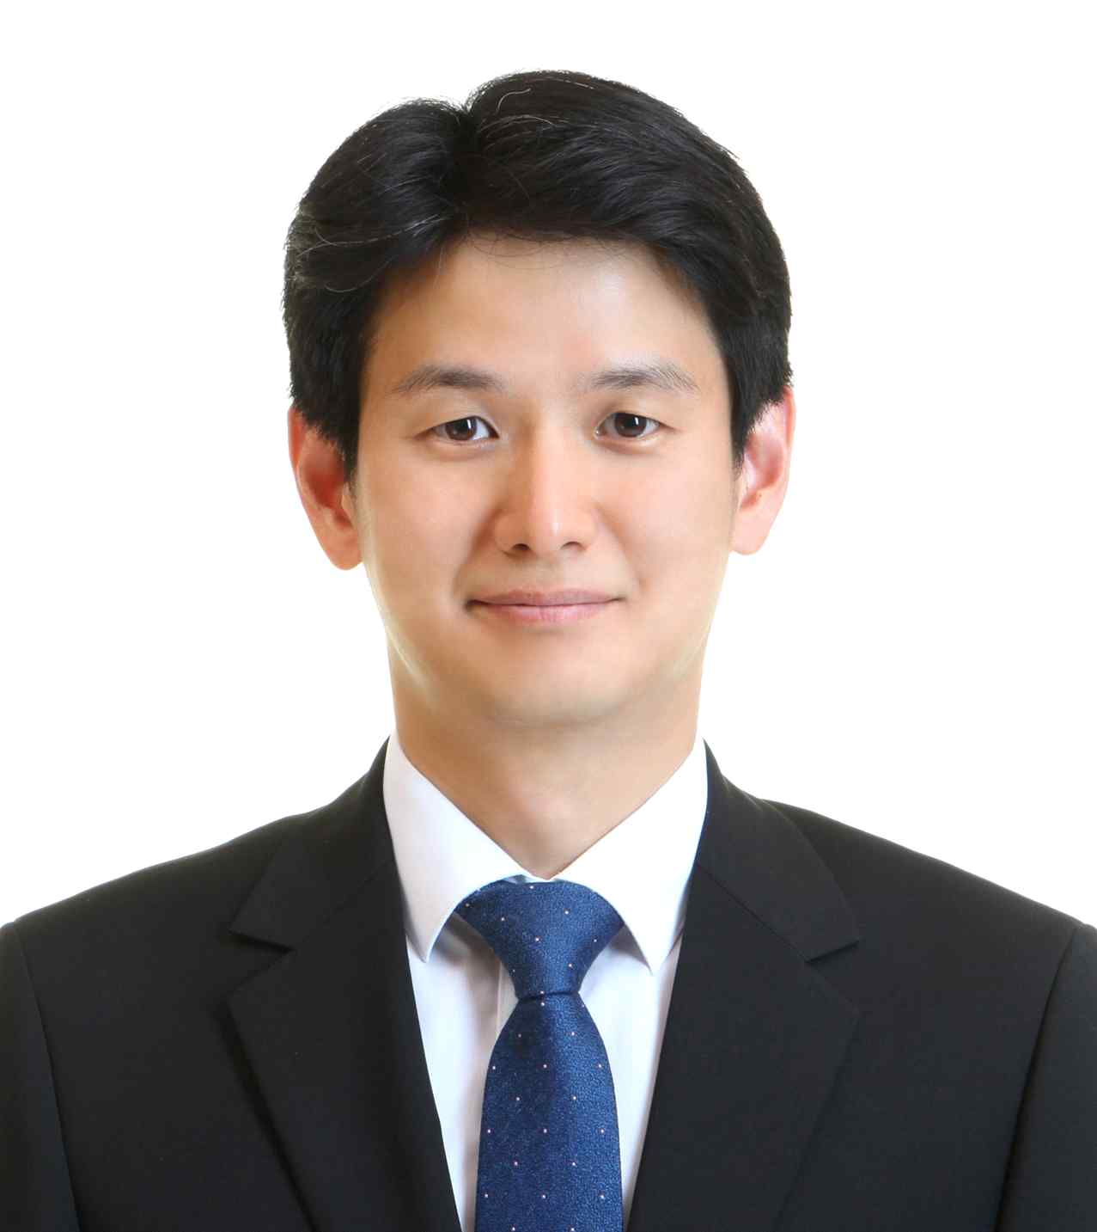

▲ School of Earth Sciences and Environmental Engineering graduate Dr. Tae-Yong Jeong