Hyunsu An of the School of Life Sciences was selected as a scholarship student by the Asan Social Welfare Foundation

– Scholarship students in the field of biomedical science... 10 million won scholarship per semester up to the next 5 semesters

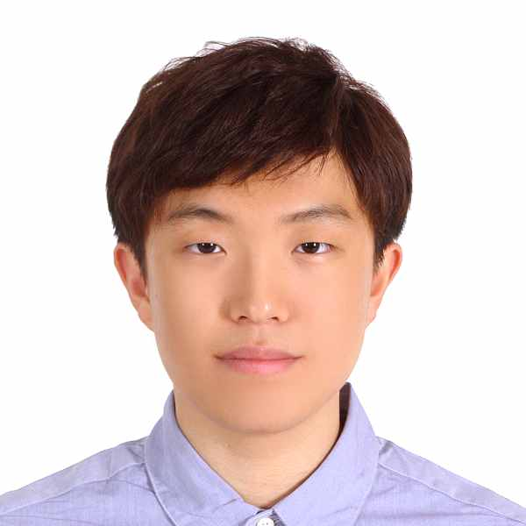
▲ Hyunsu An of the School of Life Sciences was selected for the 2023 Asan Social Welfare Foundation Graduate School of Biomedical Science Scholarship

GIST (Gwangju Institute of Science and Technology, Acting President Raekil Park) Hyunsu An (Functional Genomics Laboratory, Advisor: Jihwan Park) of the School of Life Sciences was selected for the 2023 Asan Social Welfare Foundation Graduate School of Biomedical Science Scholarship.

An will receive a scholarship of 10 million won per semester from the Asan Social Welfare Foundation for five semesters starting this year.

Last year at GIST, Kyung-dae Kim, an integrated master's and doctoral student in the same laboratory as An, and Young-joo Lee, an integrated biomedical engineering course, were selected as scholarship recipients by the Asan Social Welfare Foundation.

Hyunsu An aims to use bioinformatics data to look at life phenomena from a new perspective and is conducting research to effectively utilize the growing number of public bioinformatics databases.

Data analysis techniques developed as a result of these studies increase the accessibility of public bioinformatics data. It can directly help the application and development of the latest artificial intelligence technologies to shed light on life phenomena that have not been well studied in the past and can help to uncover the molecular biological pathology of rare diseases.

On February 28 last year, one of the research results was published in the international journal 'Briefings in Bioinformatics' in the field of bioinformatics (corona 19). The database was analyzed using artificial intelligence technology, and a protein candidate group that could be the cause of the sequelae of novel coronavirus infection was presented.

Hyunsu An said, "I am grateful to Professor Jihwan Park and my colleagues in the lab for guiding me well in conducting this research. In the future, I want to grow as a researcher who can use and develop various bioinformatics data and analysis techniques to present a direction for viewing life phenomena from a new perspective."

The Asan Social Welfare Foundation has been selecting and supporting graduate students every year since 2017 to foster talent in the field of biomedical science. Currently, there are a total of 63 scholarship students in the field of biomedical science graduate school, including 41 in Korea and 22 overseas.

The Asan Social Welfare Foundation held the 2023 scholarship award ceremony at the auditorium of the Asan Institute for Life Sciences in Songpa-gu, Seoul on February 23, and scholarships were delivered to a total of 502 people, including 69 graduate students and 433 college students.

The Asan Social Welfare Foundation has been continuously conducting scholarship projects since its foundation in 1977, and has provided a total of KRW 85 billion in scholarships to 36,000 students so far.

