Gwangju Institute of Science and Technology

Official Press Release (https://www.gist.ac.kr/)

Section of Mi-Yeon Kim Nayeong Lee
Public Affairs Section Chief Senior Administrator
(+82) 62-715-2020 (+82) 62-715-2024

Contact Person Se-mi Park, Administrator
for this Article GIST PRESS
(+82) 62-715-2960

Release Date 2019.04.25

GIST College Professor Siyeon Lee of the Division of Liberal Arts and Sciences has published a translation of the play 'Photograph 51'

□ GIST (President Kiseon Kim) College Professor Siyeon Lee of the Division of Liberal Arts and Sciences has published a translation of the play 'Photograph 51' by Anna Ziegler.

∘ Professor Siyeon Lee teaches English literature as well as major works of Western modern literature in the Division of Liberal Arts and Sciences, and she has developed and lectured on a number of convergence subjects through literary, historical, and philosophical texts that reflect diverse and critical issues in science and technology.

□ 'Photograph 51' is a play by the American playwright Anner Ziegler that dramatizes the events between the greatest biologists of the day who discovered the DNA double helix structure, which was one of the greatest scientific discoveries of the 20th century.

∘ One of the main themes of the play deals with the issue of discrimination against female scientists at the time, but the theme is not approached from a relatively simplistic perspective of "Rosalind Franklin as a tragic female scientist." Instead, Maurice Wilkins and Rosalind Franklin are treated as equal protagonist, dealing with the issues of competition, communication, and collaboration among researchers while portraying institutionalized discrimination and distortion.

□ As the translator, Professor Siyeon Lee said, "I am hopeful that a literary re-creation like 'Photography 51' of the controversial discovery of DNA will inspire others to think more about the lives and research of scientists, particularly Rosalind Franklin. I am also looking forward to seeing this play performed on stage."

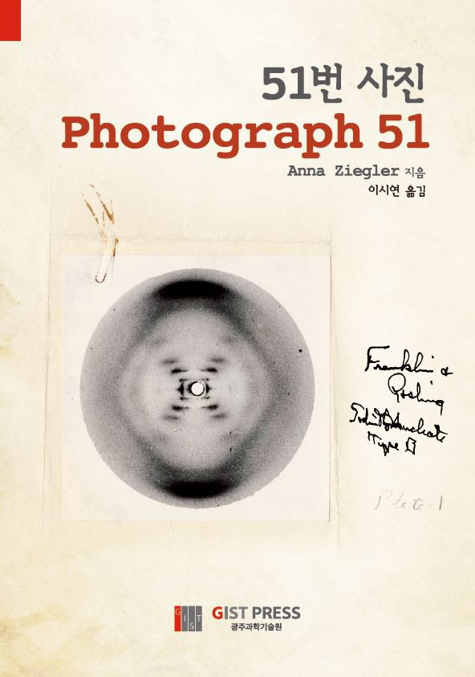
Book Cover: Photograph 51

