Gwangju Institute of Science and Technology

Official Press Release (https://www.gist.ac.kr/)

Section of Mi-Yeon Kim Nayeong Lee
Public Affairs Section Chief Senior Administrator
(+82) 62-715-2020 (+82) 62-715-2024

Contact Person Professor Seung Jun Kim
for this Article School of Integrated Technology
(+82) 62-715-5331

Release Date 2019.05.14

School of Integrated Technology Professor Seung Jun Kim selected for the Cultural Technology R&D Project

□ GIST (President Kiseon Kim) School of Integrated Technology Professor Seung Jun Kim is planning to develop virtual reality (VR) and augmented reality (AR) technologies utilizing self-driving simulation platforms over the next three years after being selected by the "Visibility Evaluation Method and Tools Development of Public Information Signals" project by the Korea Creative Content Agency's Cultural Technology R&D Project.

□ Professor Seung Jun Kim, an expert in convergence research on topics that incorporate human-computer interaction and artificial intelligence technology, plans to set up an AR/VR-based visual evaluation test bed with Professor Jin Hyuk Hong and Professor Ji Hyun Lee Ji-hyun School of Integrated Technology, and they will present new guidelines for the design of new signs and facilities in various situations, environments, and user scenarios.

□ Existing public information signs were designed mainly for readability and aesthetic purposes, making it difficult to maintain consistent visibility and safety in outdoor environments, including lighting/snow/rain/fog, day/night, installation location, visitor's age, and walking/vehicle driving conditions, and they often fail to function as intended.

∘ Because a lack of quantitative evaluation methods, it was difficult to systematically interpret or explain the success of signs after being improved or redesigned. Therefore, it was difficult to reproduce the successful cases in other regions or other places.

∘ Thus, Professor Seung Jun Kim's team developed a sensor fusion evaluation method that supports quantitative analysis of the contextual relationship between components of public facilities, information signs, and human elements, and provides local governments with on-site success performance and public guidance certification/evaluation services as well as a model for commercialization.

□ The results of the research are expected to be the first successful field demonstration by local governments, such as the Gwangju Metropolitan City, for supporting on-site verification and service commercialization models for efficient urban rehabilitation.

∘ Currently, the Gwangju Metropolitan City and the Gwangju Biennale Foundation are designated to provide a venue to demonstrate the evaluation technology developed by the research team in cooperation with the ACC/GSTC/GIST.

□ Professor Seung Jun Kim said, "This is the first attempt to utilize the VR/AR autonomous navigation platform based on the real vehicles, which is used indoors as well as outdoors, to design our urban spaces conveniently and safely. It is possible to support various kinds of design guidelines in advance and to evaluate and verify experimental user services beforehand without any damage to the site while reproducing and replaying various problem situations occurring in the urban space."

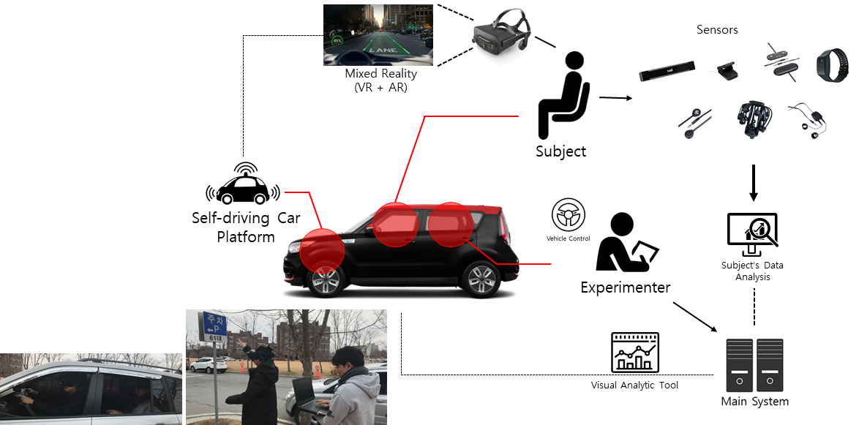
Conceptual diagram of the sensor-converged user evaluation test bed using virtual
self-driving platform based on actual vehicles and VR/AR technology

GIST School of Integrated Technology research team in front of
a motion system-based virtual self-driving platform

