Gwangju Institute of Science and Technology

Official Press Release (https://www.gist.ac.kr/)

Section of Hyo Jung Kim Nayeong Lee
Public Relations Section Chief Senior Administrator
(+82) 62-715-2061 (+82) 62-715-2062

Contact Person Professor Jae-Suk Lee
for this Article School of Materials Science and Engineering
062-715-2306

Release Date 2020.12.04

Professor Jae-Suk Lee inaugurated as the 2nd president of the Korean Society for Flexible
Printed Electronics

□ GIST (Gwangju Institute of Science and Technology, President Kiseon Kim) School of Materials Science and Engineering Professor Jae-Suk Lee was inaugurated as the second president of the Korean Society for Printed Electronics.

∘ The inauguration ceremony was held on December 2, 2020, at the regular general meeting of the Korean Society for Flexible Printed Electronics held at the El Tower in Seocho-gu, Seoul. The term of office is one year from January 1 to December 31, 2021.

□ Professor Lee received a bachelor's degree in chemical engineering from Chonnam National University, a master's degree in chemical engineering from the Korea Advanced Institute of Science and Technology, and a doctorate in molecular engineering from the Tokyo Institute of Technology. Currently serving as a visiting scholar at GIST, he is a full member of the Korean Academy of Science and Technology.

∘ He has served as director of the GIST Nanotechnology Research Center, vice director of the Grubbs Nobel Center, chairman of the Gwangju Jeonnam Nanotechnology Association, chairman of the Korea Chemical Society's Polymer Chemical Division, and vice chairman of the Korea Polymer Society.

□ Professor Lee said, "Flexible printed electronics is a convergence study that is essential in the era of super-connectedness, super-intelligence, and super-realism. I will actively work so that the academic society can contribute to solidifying and revitalizing the value of flexible printed electronics science."

□ The Korean Society for Flexible Printed Electronics was established in 2019 to contribute to the development of related studies by promoting domestic, foreign, academic, and industrial cooperation while promoting information exchange and academic activities related to flexible printing technology, which is leading the convergence technology between AI and the 4th Industrial Revolution in the post-corona era.

∘ The academic conference is held to share academic opinions through technical presentations and discussions among academic, research and industry experts, such as devices, materials, and equipment, which are key technologies for flexible printing electronics, and to provide high-quality related information such as the scent of research centers. In addition, various activities are carried out for the development of flexible printing electronics inquiries at home and abroad, including projects for publishing technical journals and overseas exchanges.

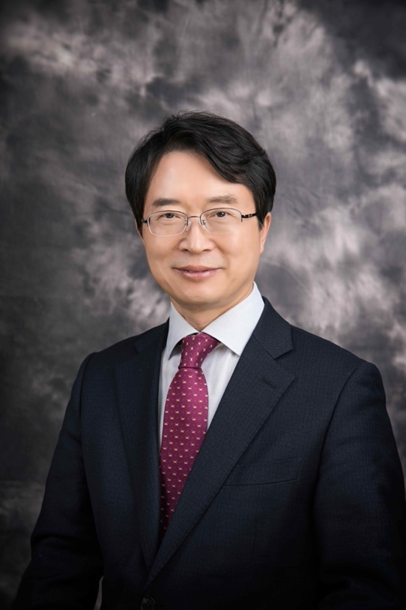
▲ GIST School of Materials Science and
Engineering Professor Jae-Suk Lee

