Gwangju Institute of Science and Technology

Official Press Release (https://www.gist.ac.kr/)

Section of Hyo Jung Kim Nayeong Lee
Public Relations Section Chief Senior Administrator
(+82) 62-715-2061 (+82) 62-715-2062

Contact Person Professor Eunji Lee
for this Article School of Materials Science and Engineering
(+82) 62-715-2730

Release Date 2020.03.25

School of Materials Science and Engineering Professor Eunji Lee is selected as a promising young researcher by the Chemical Society of Japan

□ Gwangju Institute of Science and Technology (GIST, President Kiseon Kim) School of Materials Science and Engineering Professor Eunji Lee received the 'Outstanding Asian Young Scientist, The distinguished Lectureship Award' from the Chemical Society of Japan for her achievements in polymer science and nanotechnology development based on supramolecular chemistry.

∘ The Chemical Society of Japan * , which celebrates its 100th anniversary this year, announced the award of March 24 and is given to outstanding young chemists under 40 years of age who are have been recognized for their international research achievements.

* Japan's largest chemical society has more than 5,000 members and is recognized as one of the most prestigious institutions for promoting global scientific development, along with the German, U.S., British, and Chinese societies.

∘ Professor Lee was invited by Professor Takahiro Seki of Nagoya University to give a lecture at an international symposium celebrating the 100th anniversary of the Chemical Society of Japan from March 22 to 25 at the Tokyo Institute of Technology in Noda, Japan, but this has been rescheduled to next year due to the international COVID-19 situation.

□ Professor Eunji Lee has made many contributions to polymer science and nanotechnology, especially in the field of 'polymer structure and properties' and has published over 140 research papers.

∘ She has also been recognized for her published research that has had a significant impact on the biomedical field, such as the self-assembly of molecules that respond to various external stimuli, a smart flexible nanomaterial that was developed, and the correlation between structure and physical properties that was identified by using state-of-the-art electron microscopy techniques.

□ Professor Eunji Lee said, "I am very pleased to be selected as a promising young researcher by the international academic society, and I would like to emphasize the importance of research on basic studies that can look into the future as well as application studies that respond to the times to enhance the competitiveness of the material industry."

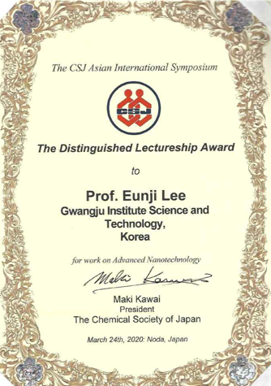

(left) Professor Eunji Lee, (right) Award

