Gwangju Institute of Science and Technology

Official Press Release (https://www.gist.ac.kr/)

Section of Hyo Jung Kim Nayeong Lee
Public Affairs Section Chief Senior Administrator
(+82) 62-715-2061 (+82) 62-715-2062

Contact Person Professor Kyung-Joong Kim
for this Article School of Integrated Technology
(+82) 62-715-5345
kjkim@gist.ac.kr

Release Date 2019.10.07

School of Integrated Technology Professor Kyung-Joong Kim received support for cultural
technology R&D projects

□ GIST (President Kiseon Kim) School of Integrated Technology Professor Kyung-Joong Kim's team was selected as a finalist for the "Development of Intelligent Tool-based Content Creation and Support Technology to improve Accessibility for the Socially Disadvantaged" of the Cultural Technology R&D Projects * by the Korea Creative Content Agency to develop over the next three years an interactive helper technology (AI Assistant) that will help people with developmental disabilities create paintings through voice and motion and share them on social networks.

* For this year, a total of 12 designated projects were conducted, and Professor Kim's team was finally selected after overcoming a competition ratio of 12:1 in the evaluation for culture and arts, signing an electronic agreement on October 2, 2019.

□ Professor Kyung-Joong Kim is an interdisciplinary research expert who combines entertainment and artificial intelligence technology and, along with Professor Jin Hyuk Hong, GIST School of Electrical Engineering and Computer Science Professor Jong Won Shin, GIST Korea Culture Technology Institute, Seoul National University Joint Research Institute, and the Solugate research company, plans to develop technology to support and help the socially vulnerable and disabled express their feelings by communicating with AI intelligence.

□ In Korea, there has been technology platforms that can soothe loneliness through emotional dialogue among the elderly who are socially marginalized or cope with emergency situations through AI speakers, but there is a lack of research on technology platforms that are specialized in expressing opinions and creativity of socially challenged people.

∘ Therefore, there is a need to provide practical help using technologies such as AI speakers, various sensors, and artificial intelligence for the socially disadvantaged who have difficulty in communicating and expressing creativity.

∘ Professor Kyung-Joong Kim's team 1). contributes to improving the quality of life of the socially disadvantaged by developing and utilizing social network technology platforms that can promote social participation through the creativity of the socially marginalized, and 2). find and develop new business models that have not been realized by creating social participation technologies that helps developmental and non-disabled people share their daily lives together.

□ The research team plans to develop three types of voice chatbot-based helpers, voice command-based helpers, and behavioral/sensor-based helpers in cooperation with professional groups specializing in developmental disabilities, providing an artificial intelligence drawing board and a platform linking social networks.

∘ On September 17, 2019, the research team signed a “Technology Development Work Agreement for Supporting the Cultural Enjoyment of the Socially Marginalized” with Cheonan Hospital and Nazarene University.

□ GIST Professor Kyung-Joong Kim said, "Social network services that are easily used by non-disabled people, such as KakaoTalk, Facebook, and Instagram, are often inaccessible to some of those with disabilities. The difficulty increases, especially if sophisticated mouse operations or keyboard input are required. This project aims to develop technologies to help disable people express their opinions through different channels such as conversations and actions."

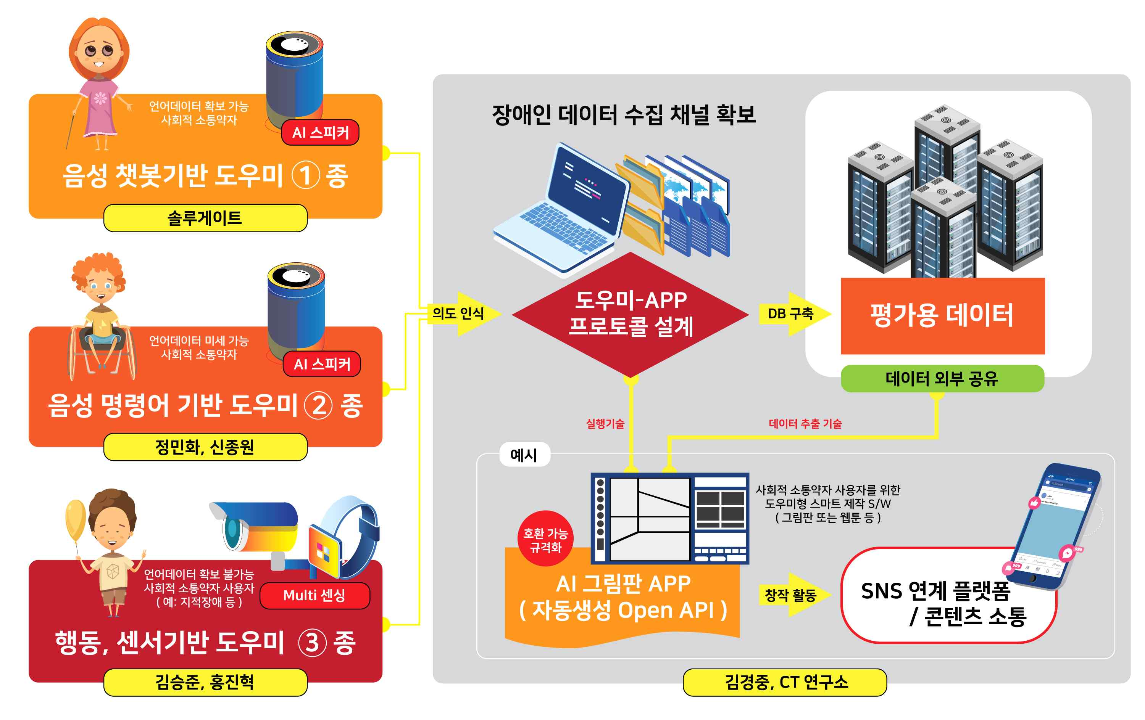
[Figure] Overview of the various ways AI assistants can help people communicate

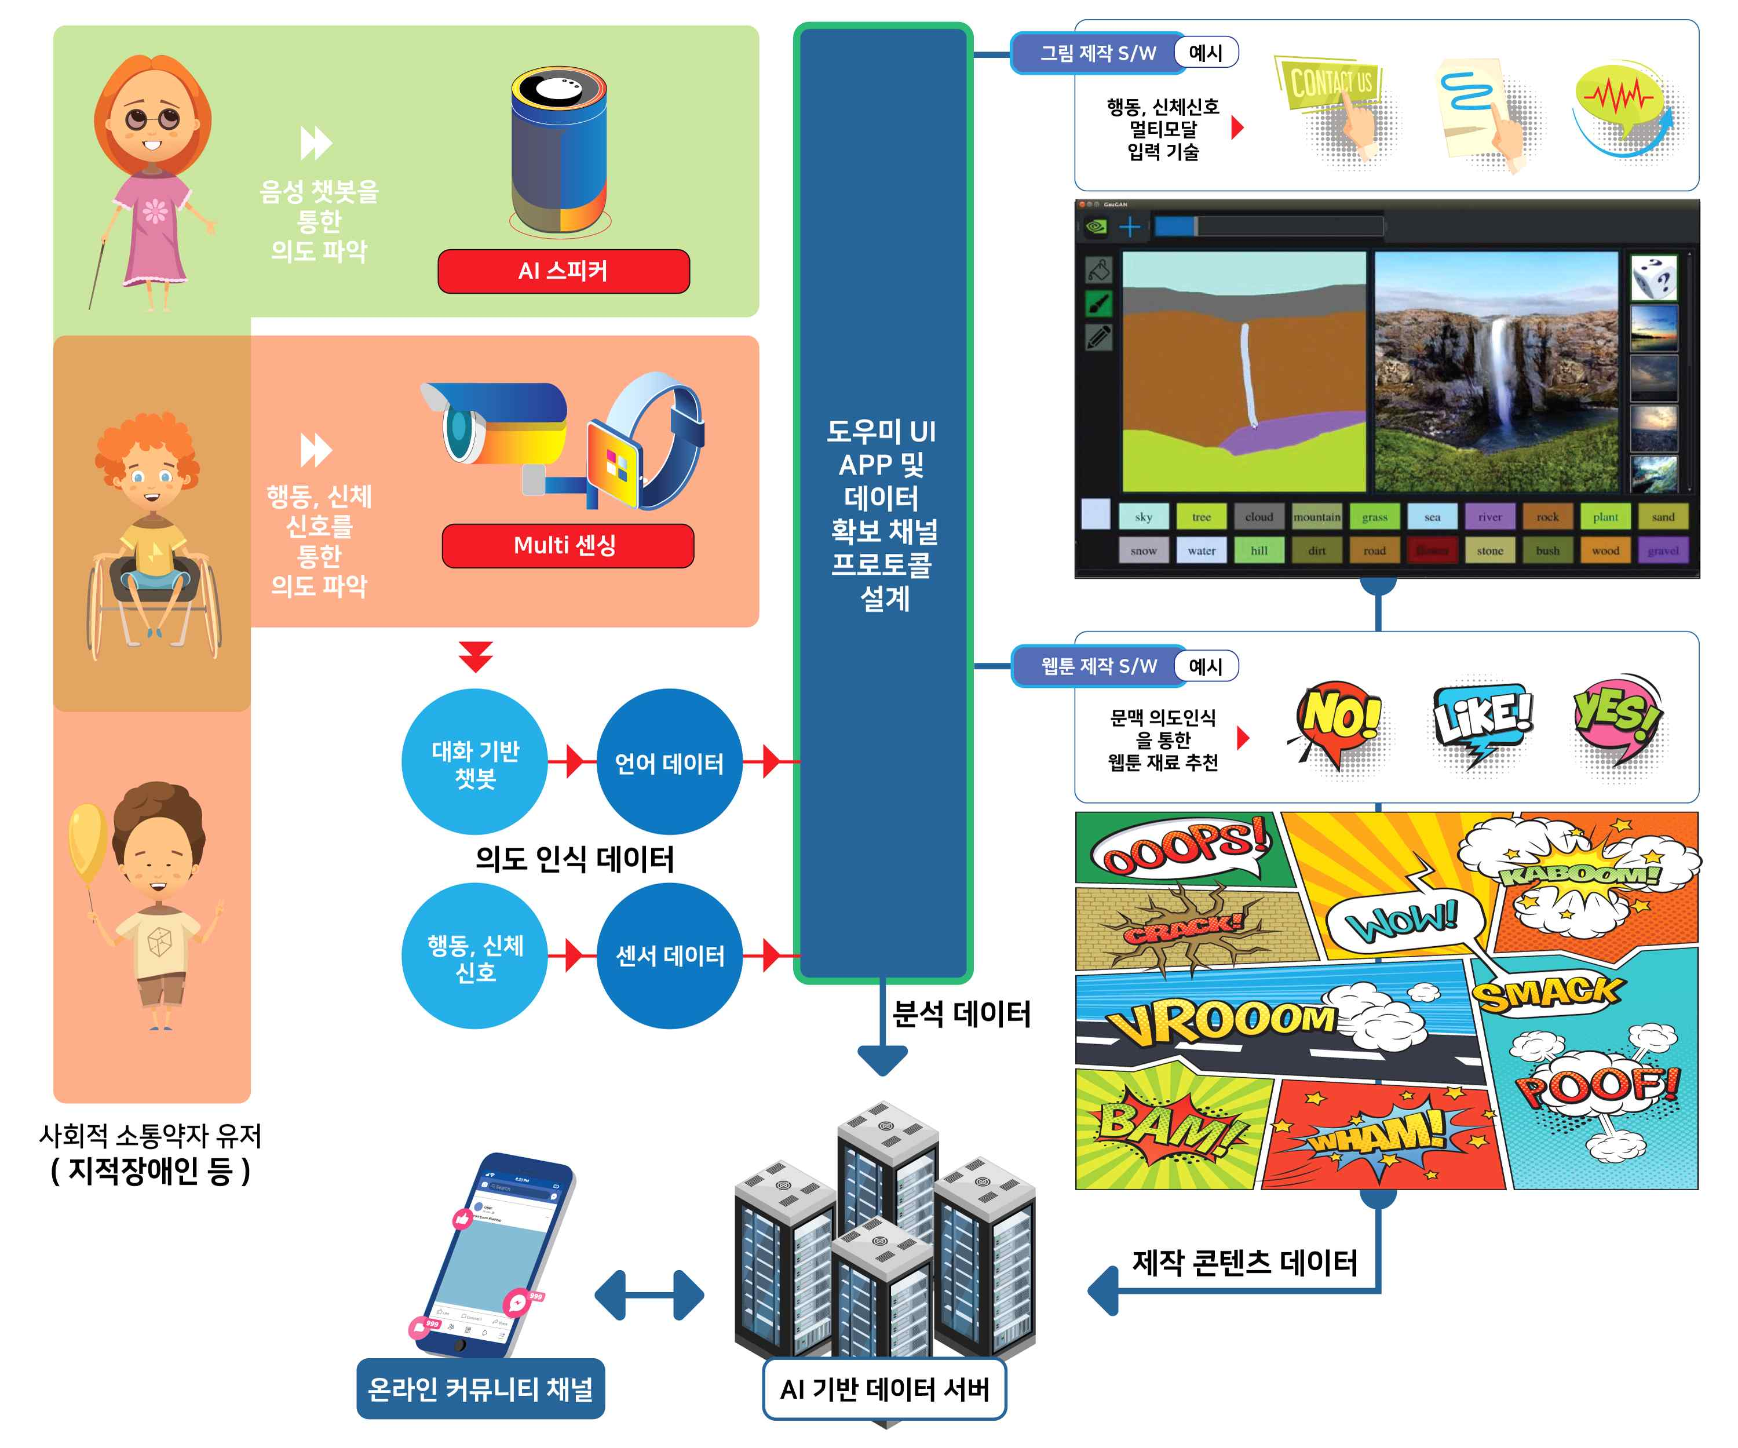
[Figure] Overview of the various ways AI assistants can help people communicate

