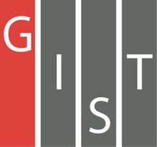
Gwangju Institute of Science and Technology

Official Press Release (https://www.gist.ac.kr/)

Section of Hyo Jung Kim Nayeong Lee
Public Affairs Section Chief Senior Administrator
(+82) 62-715-2061 (+82) 62-715-2062

Contact Person Dr. Won-young Kwak
for this Article School of Materials Science and Engineering
(+82) 62-715-2334

Release Date 2019.10.18

Professor Beongki Cho's research team is ranked in the top 12 in the field of physics by Scientific Reports

□ GIST (President Kiseon Kim) School of Materials Science and Engineering Professor Beongki Cho's research team was ranked in the top 12 in the field of physics by Scientific Reports.

∘ Scientific Reports is a sister journal of the world's leading scientific journal Nature, which covers all areas of natural science published by Nature Research and is a world-renowned and internationally acclaimed journal with an impact factor of 4.525 over the last five years.

□ In 2018 with more than 1,133 papers published by Scientific Reports in the field of physics, their paper recorded 1,768 article reviews, making it "One of the top 100 read physics papers for Scientific Reports in 2018."

□ The paper "Current-induced magnetic switching with spin-orbit torque in an interlayer-coupled junction with a Ta spacer layer" was led by Professor Beongki Cho (corresponding author) and conducted by Dr. Won-young Kwak (first author), which presented a method to remove the external magnetic field, which is an essential element for writing information on magnetic memory by using the orbital spin force by changing the internal structure of the device.

□ First author Dr. Won-young Kwak said, "This research seems to be in line with recent academic interests to find a way to solve the problem of applying orbital spin forces to actual devices. I will continue to make more efforts to carry out meaningful research."

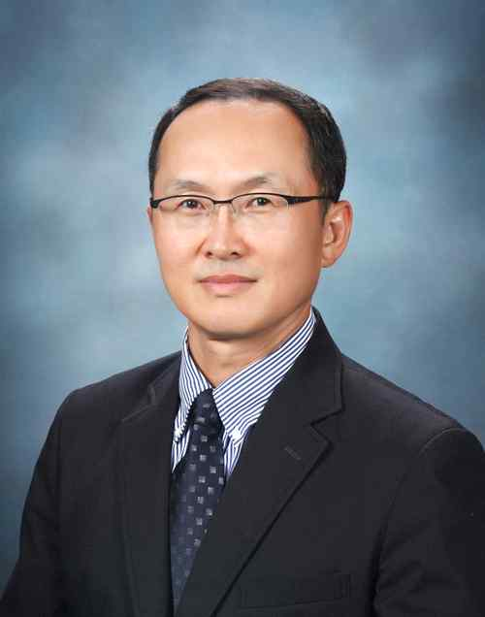
▲ Corresponding author, Professor Beongki Cho
(GIST School of Materials Science and Engineering)

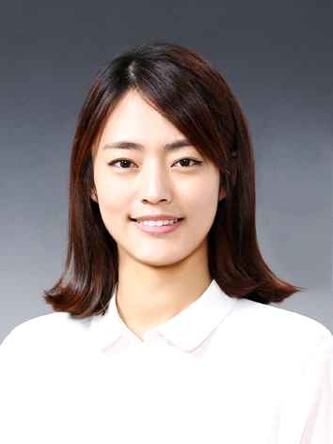
▲ First author, Dr. Won-young Kwak
(GIST School of Materials Science and Engineering)

