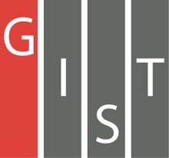
Gwangju Institute of Science and Technology

Official Press Release (https://www.gist.ac.kr/)

Section of Hyo Jung Kim Nayeong Lee
Public Relations Section Chief Senior Administrator
(+82) 62-715-2061 (+82) 62-715-2062

Contact Person Ho-jong Kang, Administrator
for this Article Auditor Office
062-715-2009

Release Date 2020.11.02

Auditor Kwang-sik Shin was awarded a commendation for his contribution to the development of police administration

□ GIST (Gwangju Institute of Science and Technology, President Kiseon Kim) Auditor Kwang-sik Shin received a commendation from the Ministry of Public Administration and Security on October 21, 2020, for Police Day.

∘ This award is given to those who contributed to the development of police administration, and Auditor Kwang-sik Shin received the award in recognition for his service as the chairman of the review committee of the investigation team of the Jeonnam Provincial Police Agency.

□ Auditor Shin, a lawyer from the 39th judicial examination, served as chairman of the investigation committee based on legal knowledge and abundant field experience, and he has contributed greatly to securing fairness in police investigations by operating the committee smoothly so that fair and in-depth deliberations on objections can be made.

∘ An 'Investigation Review Committee' is established at each local police station to deliberate and resolve the appropriateness of investigation results in cases along with possible investigation errors made by investigators, etc., and present the relevant opinions to the head of the local police agency.

□ Auditor Kwang-sik Shin said, "Once again, I felt a heavy sense of duty and responsibility to resolve the people's grievances and secure fairness in police investigations."

∘ Auditor Kwang-sik Shin is also actively participating in local public interest activities as a legal expert, including free legal support as a member of the Koryo Village Legal Support Group in Gwangju Metropolitan City.

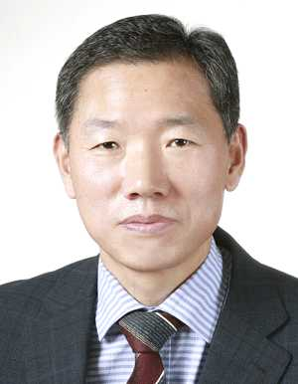
▲ GIST Auditor Kwang-sik Shin

