Gwangju Institute of Science and Technology

Official Press Release (https://www.gist.ac.kr/)

Section of Mi-Yeon Kim Nayeong Lee
Public Affairs Section Chief Senior Administrator
(+82) 62-715-2020 (+82) 62-715-2024

Contact Person Joo Young Park, Administrator
for this Article General Studies Division
(+82) 62-715-3604

Release Date 2018.07.19

GIST College Professor Soo Jong Lee
publishes a collection of personal poems
as well as a book about poetry

□ GIST (President Seung Hyeon Moon) – GIST College Professor Soo Jong Lee of the General Studies Division has published a collection of poems entitled I have Memories of Being Born Four Times and a book entitled Understanding Poetry.

∘ Professor Soo Jong Lee made her debut as a 'modern poet' in 2001. After joining the GIST faculty in 2013, she is currently teaching undergraduates about the basics of writing and understanding poetry. In her work I have Memories of Being Born Four Times, Professor Lee expresses life in a static world by using her own unique imagery and expressions.

□ Understanding Poetry is a non-literary work for a general audience to help them easily understand and appreciate poetry in an intellectually-stimulating manner by conveying various poetic concepts and theories. By covering poetic concepts and theories, Professor Lee's book is not only useful just for university students studying poetry but it is also useful for those who want to read an in-depth introduction to poetry.

□ Professor Soo Jong Lee said, "In Understanding Poetry, I hope that students and others who are interested in poetry will be able to realize their own innate abilities to think and express themselves in a poetic fashion."
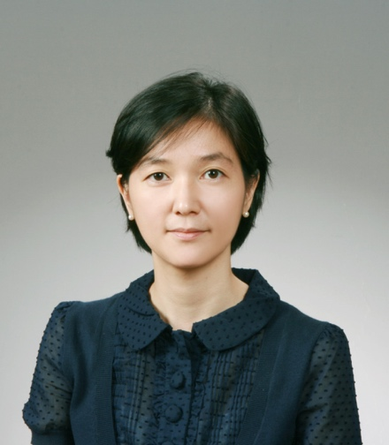
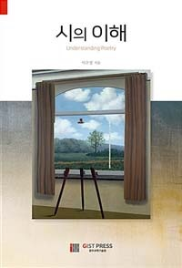

▲ Professor Soo Jong Lee and her books:
I have Memories of Being Born Four Times and Understanding Poetry

