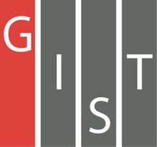
Gwangju Institute of Science and Technology

Official Press Release (https://www.gist.ac.kr/)

Section of Mi-Yeon Kim Nayeong Lee
Public Affairs Section Chief Senior Administrator
(+82) 62-715-2020 (+82) 62-715-2024

Contact Person Professor Sung-Min Hong
for this Article School of Electrical Engineering
and Computer Science
(+82) 62-715-2640

Release Date 2019.02.18

Professor Sung-Min Hong's research team won the Best Paper Award at the Korean Conference
on Semiconductors

□ GIST (President Seung Hyeon Moon) The research team of Professor Hong Sung Min of the School of Electrical Engineering and Computer Science won the Best Paper Award at the Korean Conference on Semiconductors.

∘ This year's 26th Korean Conference is the largest conference related to semiconductors. It was co-hosted by DB Hi-tech, Korea Semiconductor Industry Association, and Korea Semiconductor Research Association and was held at Hoengseong-gun in Gangwon Province from February 13-15, 2019.

□ A total of 815 outstanding papers were presented on the theme of "Smart Semiconductor in IoT and 4th Industrial Revolution," including invited announcements, oral presentations, and poster presentations. The award ceremony was held on February 14, 2019.

□ The paper "First principles approach to analyze defect-induced multiphonon transition at the Si-SiO2 interface" by Professor Sung-Min Hong (corresponding author) and Joon-sung Park (integrated MS/PhD student as first author) calculated the size of the hole trapping cross section of the defect state at the silicon-oxide interface by using the first principles approach.

□ Professor Sung-Min Hong said, "In-depth discussions and research about cutting-edge semiconductor technology trends in are more important than ever for the 4th Industrial Revolution. It is very meaningful to have a good understanding of the fault condition through the first principle calculation method, as the fault condition of silicon-oxidized membrane interface is the cause of the various degradation problems occurring in transistors."

□ First author and graduate student Joon-sung Park said, "Applying defect analysis methodology to the silicon-oxide interface through the first principle calculation methos, which has been actively studied recently, the Best Paper Award at the Korean Conference on Semiconductors. This award is very meaningful and honorable, and I will devote myself to further research."

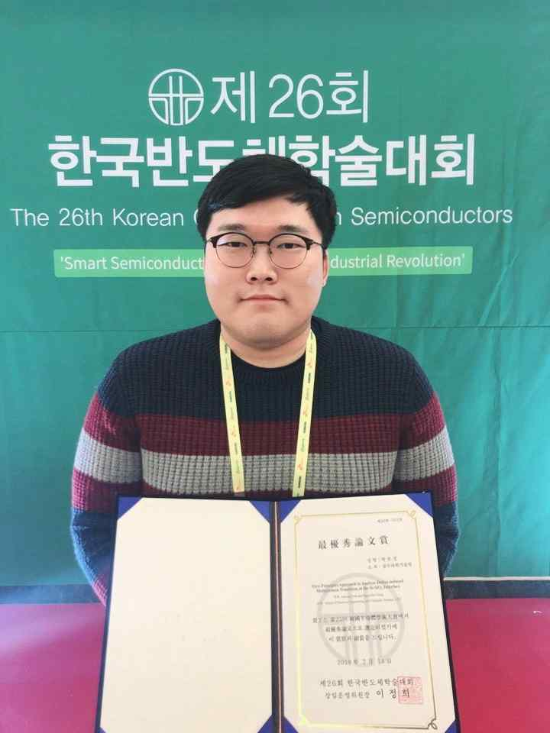
▲ Graduate student Joon-sung Park of the School of Electrical Engineering and Computer Science receives the Best Paper Award at the Korean Conference on Semiconductors

