Gwangju Institute of Science and Technology

Official Press Release (https://www.gist.ac.kr/)

Section of Hyo Jung Kim Nayeong Lee
Public Relations Section Chief Senior Administrator
(+82) 62-715-2061 (+82) 62-715-2062

Contact Person Moon-seop Yoon, Administrator
for this Article Section of Public Affairs
(+82) 62-715-2021

Release Date 2020.03.24

IMEDISON donates hand sanitizer to GIST

□ Gwangju Institute of Science and Technology (GIST, President Kiseon Kim) recently received portable hand sanitizes to prevent COVID-19 infections from IMEDISON (CEO Dong-pil Lee).

∘ IMEDISON was established in November 2015 as a company that manufactures medical products such as contact lens preservatives and hand sanitizers and is located in Sochon-dong, Gwangsan-gu, Gwangju. GIST Alumni Jong-seop Lee received his Ph.D. from the School of Life Sciences in 2017 and is a director.

□ IMEDISON Director Jong-seop Lee said, "Although it is a difficult time for everyone, we hope that the use of our hand sanitizer will prevent the spread COVID-19 so that GIST members can continue with their research activities."

∘ The donated hand sanitizer will be distributed to each department through the infirmary, and all GIST members will be able to receive one hand sanitizer from their departments between March 24 to March 25, 2020.

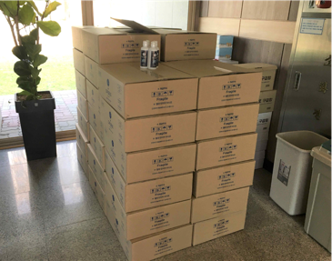
▲ Hand sanitizers delivered to GIST

