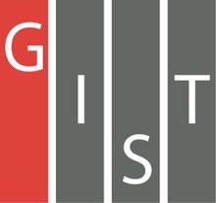
Gwangju Institute of Science and Technology

Official Press Release (https://www.gist.ac.kr/)

Section of Mi-Yeon Kim Nayeong Lee
Public Affairs Section Chief Senior Administrator
(+82) 62-715-2020 (+82) 62-715-2024

Contact Person Joo Young Park, Administrator
for this Article Section of Undergraduate Administration Services
(+82) 62-715-3604

Release Date 2018.08.13

Professor Hisam Kim publishes KDI Research Report entitled 'The Role and Policy Direction of Education on Social Capital'

□ GIST (President Seung Hyeon Moon) – Professor Hisam Kim of the Division of Liberal Arts and Sciences, published a research report on the role and policy direction of education on social capital fo the Korea Development Institute (KDI).

□ In the report, Professor Hisam Kim focused on the lack of social capital is the reason why Koreans' quality of life and happiness is lower than their economic strength and explored how education can contribute to raising social capital.

◦ Social capital is intangible capital such as trust, network, and norm derived from the relationship among people, and its importance is confirmed in various aspects such as economic growth, social integration and happiness. However, the social capital of Korea is lower than the physical capital and human capital, and it is gradually declining. Schools can build trust, cooperation, public mind, and compliance spirit, which is the basis of social capital. However, the study shows that Korean education has a very low effect of raising social capital. In a survey of university students from four countries including Korea, China, Japan and the United States, Korean university students showed the lowest social capital in many respects.

◦ Professor Hisam Kim has focused on the importance of teaching methods as a way to cultivate social capital through education and conducted educational experiments at GIST University's first semester in 2017. This compares how the social capital of the students varies over a semester in the horizontal and vertical classes centered on professors' lectures. As a result, it was found that the friendship network among the students in the horizontal class was wider and deeper, and that the expansion of the friendship positively changed the perception and attitude related to social capital.

□ Professor Hisam Kim said, "Since the role of education is crucial in reversing the decline of patriarchal patterns in Korean society, which is becoming increasingly widespread, it is necessary to try changing the method of teaching. I hope that educators will be able to find ways to implement horizontal education that will nurture future talents that combine creativity and creativity as well as social capital."

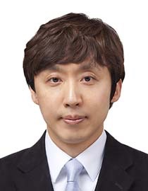  ▲ Professor Hisam Kim | 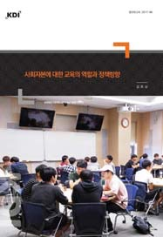  ▲ Cover of 'The Role and Policy Direction  of Education on Social Capital'

