Gwangju Institute of Science and Technology

Official Press Release (https://www.gist.ac.kr/)

Section of Mi-Yeon Kim Nayeong Lee
Public Affairs Section Chief Senior Administrator
(+82) 62-715-2020 (+82) 62-715-2024

Contact Person Ji-hoon Kim, Administrator
for this Article Section of Undergraduate Administration Services
(+82) 62-715-3603

Release Date 2018.12.18

GIST College students win gold, silver,
and bronze medals at a math competition

□ GIST (President Moon Seung Hyeon) College (Dean Do-Kyeong Ko) students won gold, silver, and bronze medals at the 37th College Mathematics Competition held on November 17, 2018.

∘ The awards ceremony was held at KAIST on December 17, 2018: ▲ GIST College students Dong-ha Lee (3rd year physics major) and Jong-hyun Lim (4th year physics major) received silver and bronze prizes ▲ Chung-eung Ahn (2nd year undeclared) won the gold medal in 2nd category ▲ Ju-hoon Kim (4th year physics major)and Chan-hyuk Sung (1st year undeclared) won the silver medal in the 2nd category.

∘ The National College Mathematics Competition was organized by the Mathematical Society and is divided into two categories. Dong-ha Lee and Jong-hyun Lim are not math majors, but they still won medals.

□ Out of the 39 universities that produced winners in the first and second categories of this year's 37th math competition, seven universities, including GIST, produced five or more winners.

∘ All five of the GIST College winners participate in the student math club "Pencil & Paper" (supervised by Professor Hyunsuk Kang). As members of the club, they prepared during the semester to participate in the college math competition.

∘ Among the students of the club, Jong-hyun Lim (36th gold medal, 37th gold medal) won again for the second consecutive year following the 36th competition held last year, Ju-hoon Kim (37th 2nd silver medal), Dong-ha Lee (36th silver medal, 37th silver medal).

□ GIST College student Dong-ha Lee said, "Last year, I was awarded a prize in the second category, but this year I looked higher and participated in the first category. The first category competition was much harder than the second category, but I was able to get good results thanks to my interest in mathematics and my active participation in the club."

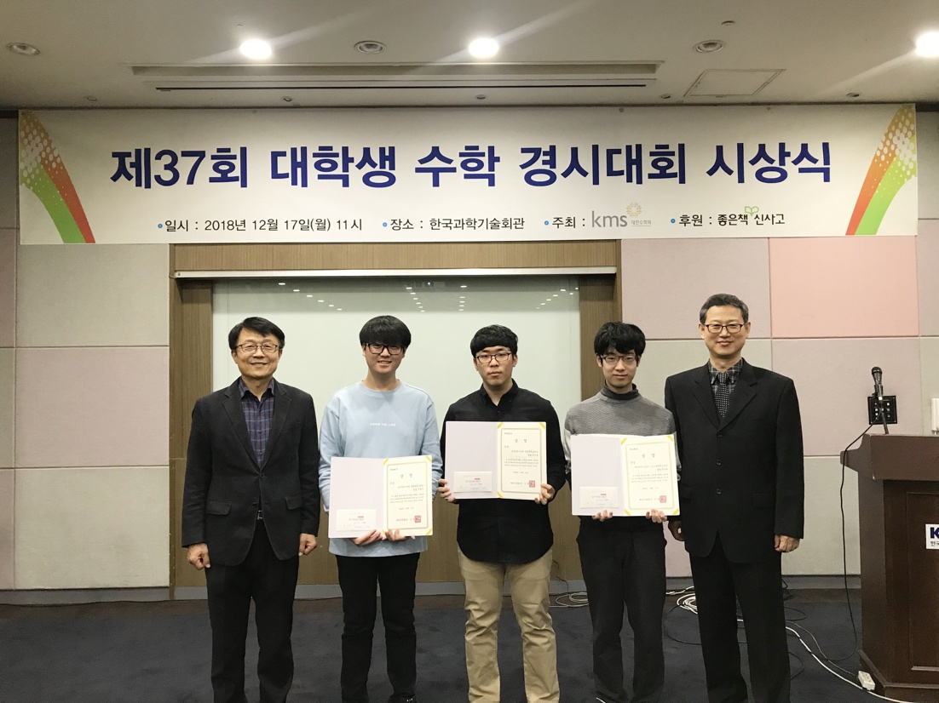
▲ From the left, GIST College students Dong-ha Lee, Ju-hoon Kim, and Chan-hyuk Sung

