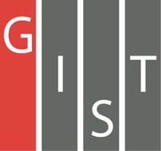
Gwangju Institute of Science and Technology

Official Press Release (https://www.gist.ac.kr/)

Section of Mi-Yeon Kim Nayeong Lee
Public Affairs Section Chief Senior Administrator
(+82) 62-715-2020 (+82) 62-715-2024

Contact Person Kyung-hwa Kim, Administrator
for this Article Section of Student Affairs
(+82) 62-715-2042

Ho-jung Kang, Administrator
Section of General Affairs
(+82) 62-715-2103

Release Date 2019.04.22

GIST professors and staff receive science and technology awards commemorating
the 52nd Science Day

□ GIST (President Kiseon Kim) – For the 52nd Science Day on April 21, six professors including Professor Jae-il Kim of the School of Life Sciences and one staff member received awards from the government for their contributions to science and technology.

∘ △ Professor Jae-il Kim of the School of Life Sciences received the Science and Technology Medal △ Professor Byeong Ha Lee of the School of Electrical Engineering and Computer Science received a Science Technology Citation △ Professor Sung Ho Jeong of the School of Mechanical Engineering received the Presidential Citation △ Professor Sang-Don Kim of the School of Earth Science and Environmental Engineering received the Prime Minister's Citation △ Professor Seunghee Han of the School of Earth Science and Environmental Engineering, Professor Myung-Han Yoon of the School of Material Science and Engineering, and Section 2 of Research Management Section Chief Younguk Cho received the received the Minister's Citation.

□ Professor Jae-il Kim, who received the Science and Technology Medal, founded Gwangju Jeonnam's first bio-venture company, Anygen Co., Ltd., and contributed to the development of the nation's education and industry, including the listing of his company on the KOSDAQ in February 2016.

∘ Professor Byeong Ha Lee, who received the Science Technology Citation, was the first Korean to implement advanced devices and systems based on fiber optics. He developed optics-based tomography and contributed to expanding optical technology, training professional researchers, and leading new innovation.

∘ Professor Sung Ho Jeong not only contributed to industrial development through the development and application of laser processing technology, but he also contributed to the achievement of excellent research results through creative research, popularizing laser processing technology, and training professional researchers.

∘ Professor Sang-Don Kim was credited with contributing to the development of national environmental policies for public safety in the field of environmental toxicity health monitoring and for the successful hosting of international academic conferences and the development of environmental academic groups based on outstanding academic achievements.

∘ Professor Seunghee Han has been operating a lab for trace metal biochemistry within GIST's School of Earth Science and Environmental Engineering, and she has been involved in a project for the long-term implementation of the national mercury monitoring system by pioneering the field of mercury biogeochemistry and has establish the national water measuring network with the Korea Environment Corporation.

∘ Professor Myung-Han Yoon runs GIST's Bio-Electronics Materials Lab and has published notable research results worldwide in the field of flexible printing electronics and biomechanical spheres, including the publication of 52 excellent international SCI journals, high h-index (8200/29; Google Scholar citation) and patents (7 domestic, 3 overseas).

∘ While working 24 years at GIST, Section Chief Younguk Cho made efforts to foster human resources in advanced science and technology to improve the institution. He also worked to solving problems through improved administrative support and has established various research collaboration.

□ To promote pride and honor among Korea's scientific community, the Ministry of Science and ICT commemorates Science Day every year by discovering and rewarding talented people who have contributed to the development of science and technology. The 52nd Science Day ceremony and awards ceremony was held on April 22, 2019.

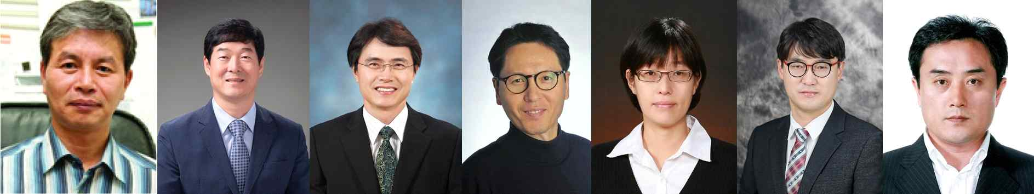
From left: Professors Jae-il Kim, Byeong Ha Lee, Sung Ho Jeong, Sang-Don Kim,
Seunghee Han, Myung-Han Yoon, and Section Chief Younguk Cho

