Gwangju Institute of Science and Technology

Official Press Release (https://www.gist.ac.kr/)

Section of Hyo Jung Kim Nayeong Lee
Public Relations Section Chief Senior Administrator
(+82) 62-715-2061 (+82) 62-715-2062

Contact Person Professor Jonghyun Choi
for this Article Artificial Intelligence Graduate School
062-715-2217

Release Date 2020.08.26

Artificial Intelligence Graduate School Professor Jonghyun Choi's team places 2nd in the AI Challenge for Robotic Tasks

□ GIST (Gwangju Institute of Science and Technology, President Kiseon Kim) Artificial Intelligence Graduate School Professor Jonghyun Choi's team achieved second place in the ALFRED Challenge, a robot AI development competition in a simulated environment that requires visual recognition and high-level semantic reasoning.

https://leaderboard.allenai.org/alfred/submissions/public

∘ The goal of this competition is for AI systems to use visual recognition modules and learn how to carry out high-level instructions (e.g., bring apples from the kitchen). By increasing the performance of the visual recognition module, the research team achieved an accuracy rate of 3.75 times higher than the previous best performance.

□ This study was presented earlier this week at the Embodied Vision, Action & Language Workshop (https://askforalfred.com/EVAL/) of the ECCV 2020 conference sponsored by Google and Alan Institute for Artificial Intelligence (AI2).

□ Professor Jonghyun Choi said, "Considering the gap in performance with the team that ranked first in the competition, more research is needed in the future. This is an emerging emerging field at the intersection of computer vision and natural language processing, which represents AI, and I plan to create more interesting research opportunities."

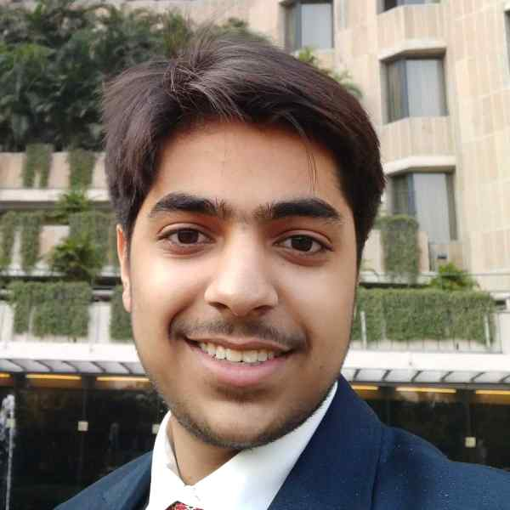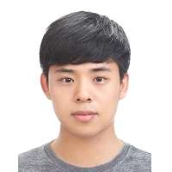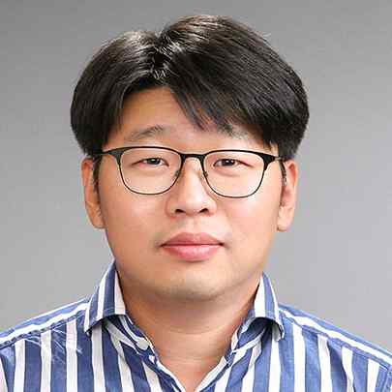

▲ Photo of the research team (from left): Kunal Pratap Singh (IIT Roorkee undergrad; GIST Computer Vision Lab intern), Suvaansh Bhambri (IIT Roorkee undergrad; GIST Computer Vision Lab intern), Byeonghwi Kim (GIST Artificial Intelligence Graduate School integrated program), and Artificial Intelligence Graduate School Professor Jonghyun Choi

