Gwangju Institute of Science and Technology

Official Press Release (https://www.gist.ac.kr/)

Section of Mi-Yeon Kim Nayeong Lee
Public Affairs Section Chief Senior Administrator
(+82) 62-715-2020 (+82) 62-715-2024

Contact Person Hee Won Jeong Administrator
for this Article School of Earth Sciences and
Environmental Engineering
(+82) 62-715-2461

Release Date 2018.08.20

Dr. Jangwon Seo of the School of Earth Sciences and Environmental Engineering becomes the first GIST College graduate to receive doctorate

□ GIST (President Seung Hyeon Moon) – Dr. Seon-won (advisor: professor Kim Jun-ha) of the School of Earth Sciences and Environmental Engineering has been the talk of the town as he entered GIST College as an undergraduate in 2010 and received a doctorate during the 2018 graduation ceremony * .

* During the GIST graduation ceremony, a total of 145 students graduated, including 40 with doctoral degrees, 74 with master's degrees, and 31 with bachelor's degrees.

□ Dr. Jangwon Seo conducted research to reduce the production cost of membrane distillation, which is a method for membrane-based seawater desalination. Through this, the arrangement and shape of the membrane spacer and the structure of the module are optimized, and the methodology of process optimization modeling was presented for the whole membrane distillation process. The related research has been recognized for its outstanding research achievements, including being published in Desalination (impact factor: 6.603), the most authoritative SCI journal in the field.

□ Professor Joon Ha Kim of the School of Earth Sciences and Environmental Engineering said, "Jangwon Seo is a student who has dedicated himself to research more than anyone else, and, thanks to his sincere approach to research, it was possible for him to finish the integrated doctorate course in only four years and six months. Since he was at GIST College from the beginning, his doctorate was more meaningful to me. After graduation, I hope he continues to study and become a brilliant scientist who can brighten up the school."

□ Dr. Jangwon Seo said, "I am proud to receive my Ph.D. from GIST, and I don't think that today's achievement could have been possible without having the steady encouragement and help of excellent professors and seniors. After graduation, I will continue to interact with my advisor and research lab and continue with research on modeling the seawater desalination process."

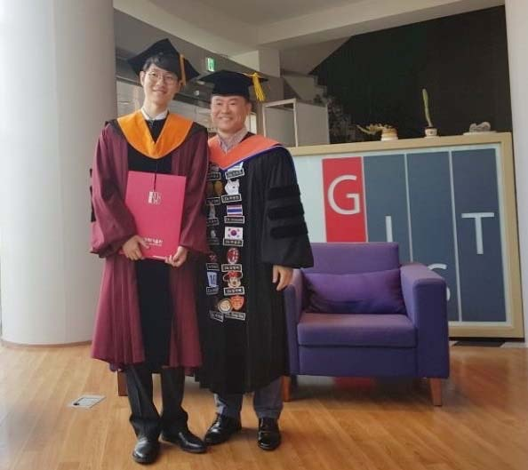

▲ Dr. Jangwon Seo (left) at Oryong Hall with his Professor Joon Ha Kim

