Dr. Inhyuk Nam, Department of Physics and Photon Science, appointed as Associate Professor, Department of Physics, UNIST

- Received a Ph.D. in plasma physics from the Department of Physics and Photon Science in 2015 under the guidance of Professor Hyyong Suk... After gaining postdoctoral experience at the Stanford Linear Accelerator Center, a renowned national research institute in the United States, he has worked as a senior researcher at the Pohang Accelerator Laboratory since 2017
- “I urge you to become the world’s best scholar, not just in Korea.”

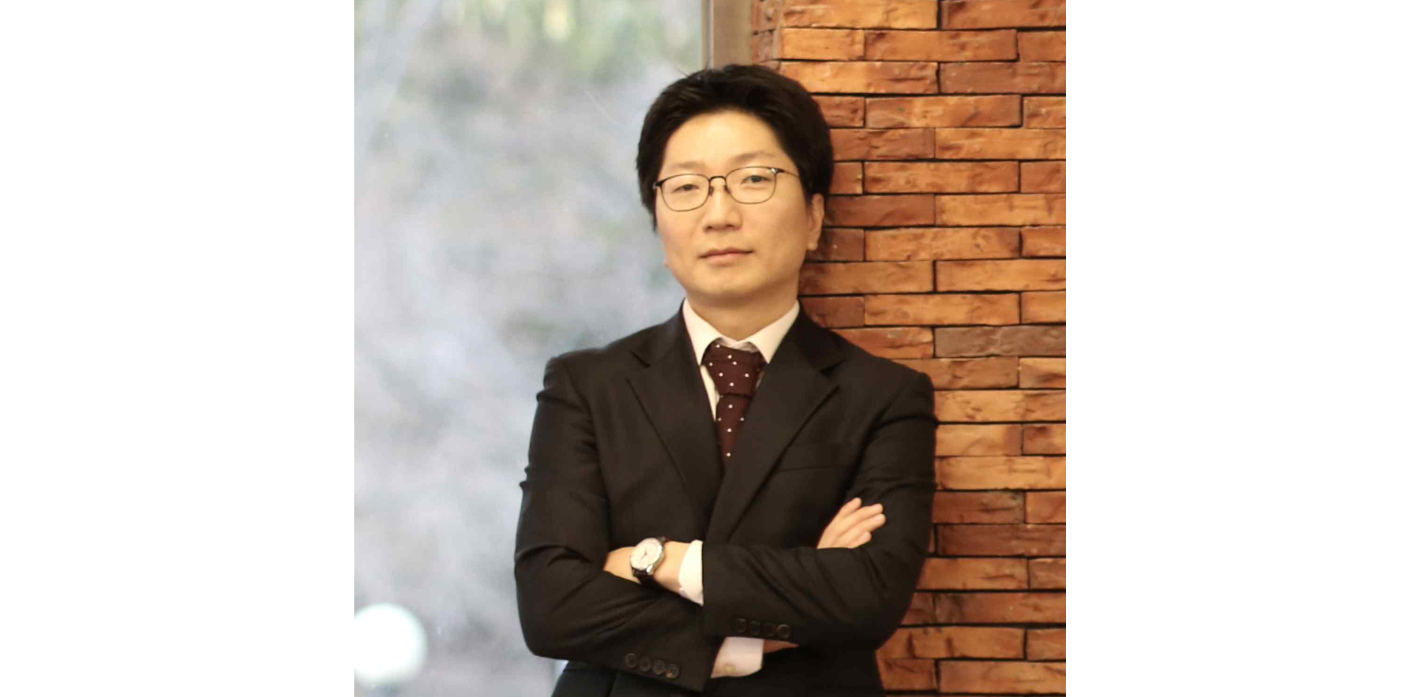▲ Dr. Inhyuk Nam was appointed as an associate professor in the Department of Physics at UNIST on September 1 of this year.

The Gwangju Institute of Science and Technology (GIST, President Lim Ki-cheol) announced that Dr. Inhyuk Nam (Advisor: Professor Hyyong Suk), a PhD graduate from the Department of Physics and Photonics, was appointed as an associate professor in the Department of Physics at Ulsan National Institute of Science and Technology (UNIST) as of September 1.

Dr. Inhyuk Nam received his Ph.D. in plasma physics from the Department of Physics and Photon Science in 2015. Afterwards, he worked as a postdoctoral researcher at the Stanford Linear Accelerator Center, a world-renowned national research institute in the United States. After returning to Korea, he has been working as a senior researcher at the Pohang Accelerator Laboratory since 2017.

In 2021, Dr. Nam published the results of a new free-electron laser oscillation method as the lead author in the international academic journal ‘Nature Photonics’, which has the highest impact index in the field of optics. It has also been recognized for its excellence, being selected as one of the ‘Top 10 Science and Technology News of the Year’ by the Korean Federation of Science and Technology Societies.

Professor Hyyong Suk, Dr. Nam's advisor, said, "I am proud of my student who always thinks positively and silently devotes himself to his research despite the difficult conditions in the early days of the lab. I hope that Professor Inhyuk Nam will become the best scholar in the world, not just in our country."



