GIST Students win startup competition for second consecutive year with traffic accident AI analysis solution

- Presenting a solution developed by applying the results of AI traffic accident prediction research conducted by the ‘Robot AI Reinforcement Learning Lab (Supervising Professor Je Ha Ryu)’ and achieving consecutive excellent results in startup competitions
- Rapidly analyzing traffic accident scene video data to identify the type of accident and responsibility and automatically generating analysis reports... Minimizing legal disputes by shortening the accident handling process and accurately calculating the percentage of fault

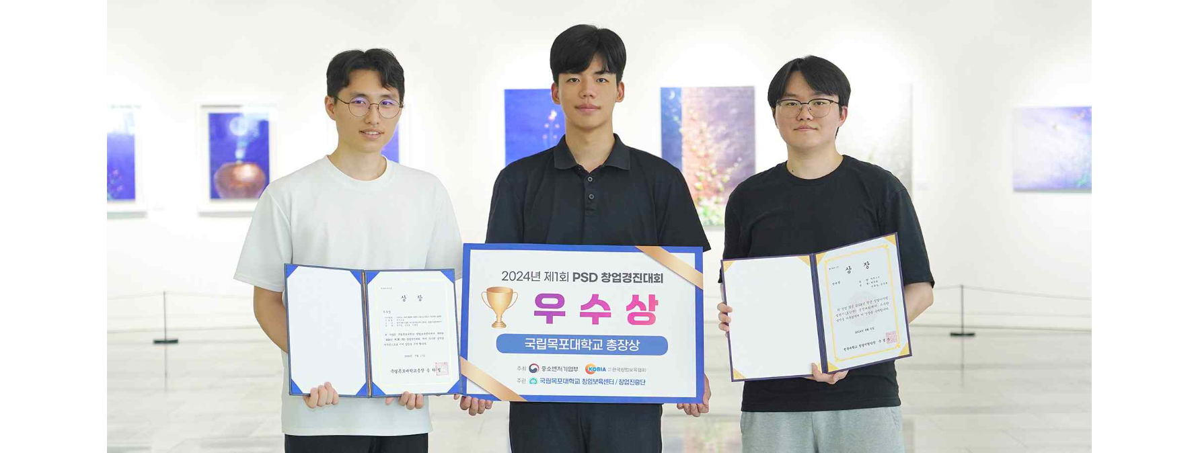▲ (From left) Hoosang Lee, a doctoral student in the School of Integrated Technology, and Joo-seong Park and Jun-ho Kim, undergraduate students in the DeparSchool of Electrical Engineering and Computer Science

The Gwangju Institute of Science and Technology (GIST) announced that the ‘Assist’ team (advised by Professor Je Ha Ryu), consisting of undergraduate students Joo-seong Park and Jun-ho Kim in the DeparSchool of Electrical Engineering and Computer Science PhD student Hoosang Lee from the School of Integrated Technology, recently achieved the feat of winning two consecutive awards at a startup competition.

The ‘Assist’ team, which introduced an automatic traffic accident report creation solution using artificial intelligence (AI), won the Excellence Award and Encouragement Award at the ‘1st PSD (Pre Startup Dream) Startup Competition’ and the ‘2024 Startup-centered University Youth Startup Item Challenge (Honam Region)’, respectively.

The solution they developed is an application of the results of AI traffic accident prediction research conducted by the ‘Robot AI Reinforcement Learning Lab’ led by Professor Je Ha Ryu of the School of Integrated Technology.

The startup item suggested by the ‘Assist’ team is ‘a system that automatically analyzes the accident type and fault ratio of a vehicle by analyzing black box footage using AI.’ When a traffic accident occurs, this solution quickly analyzes the video footage of the accident scene based on black box data to identify the type of accident and responsibility, and automatically creates a report (traffic accident analysis results report). This can shorten the accident handling process and minimize legal disputes by accurately calculating the fault ratio.

The ‘Assist’ team received a prize (Mokpo National University President’s Award) and a subsidy of 6 million won at the ‘2024 1st PSD Startup Competition’ held at Mokpo National University on July 17 to discover and support novel startup ideas from local university students.

On July 23, an agreement was signed with the Mokpo National University Startup Incubation Center, and follow-up programs such as consulting on improving business models and support for prototype production were provided.

The ‘Assist’ team also won an encouragement award and a prize of 2 million won at the ‘2024 Entrepreneurship-centered University Youth Entrepreneurship Item Challenge (Honam Region)’ held on August 6.

This competition is a regional preliminary round of the Challenge K-Startup, designed to discover promising startup teams with innovative technologies and ideas in the Honam region.

Undergraduate student Joo-seong Park said, "Professor Je Ha Ryu's continuous support and passionate guidance were of great help. The 'Assist' team will continue to work hard to advance solutions and achieve commercialization results through various startup support programs."



