GIST Planetary Exploration Research Institute (GPERI) won the Best Presentation Paper Award at the 2024 Korean Society of Propulsion Engineering Spring Conference

- GIST Planetary Exploration Research Institute (GPERI), a GIST aerospace engineering student research group (student club), successfully test-launched ‘GSLV-I’, a 500N thrust launch vehicle developed over two years
- A thesis was written on the system integration and performance test results of a 500N thrust launch vehicle that had been researched and developed over two years

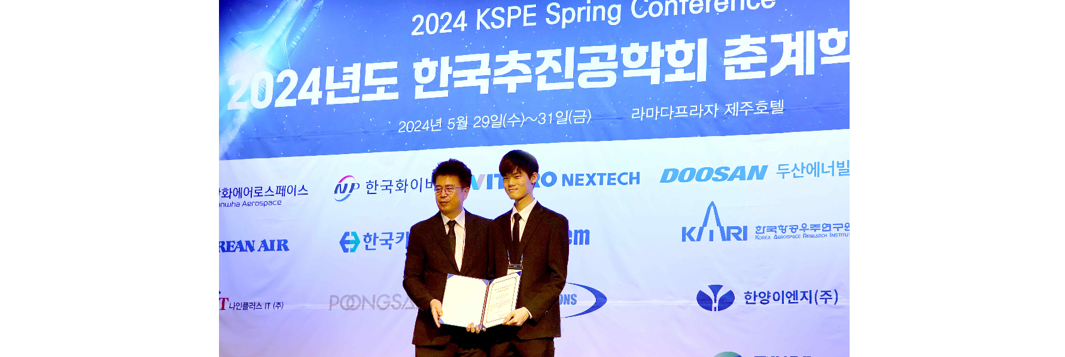▲ GIST space engineering student club GPERI is taking a commemorative photo after winning the ‘National University Rocketry Association Outstanding Paper Award’ at the 2024 Korea Society of Propulsion Engineering Spring Conference. (From left) Dr. Chang-gi Kim, president of the Korean Society of Propulsion Engineers, and Chang-hyeon Lee, a student at GIST’s Department of Mechanical Engineering.

The Gwangju Institute of Science and Technology (GIST, President Kichul Lim) announced that its space engineering student club, GIST Planetary Exploration Research Institute (GPERI), won the National University Rocketry Association Best Presentation Paper Award at the 2024 Korean Society of Propulsion Engineering Spring Conference.

GPERI, formed in September 2021, is a GIST student research group (club) that studies overall space science, including space launch vehicles, space robotics, satellites, and celestial dynamics, and is led by Professor Pyojin Kim of the School of Mechanical Engineering. As a member of NURA (National Universities’ Rocket Association), we participate in rocket launch competitions and various academic competitions hosted by NURA every year.

GPERI student Chang-hyeon Lee (Class of 23, Department of Mechanical Engineering) and 7 others (Jeong-hyeok Choi, Class of 21, Department of Physics and Photon Science, Ju-mong Jeong, Class of 20, School of Mechanical Engineering, Won-jae Cho, Class of 23, Division of Liberal Arts and Sciences, Ha-young Choi, Class of 23, School of Mechanical Engineering, Yi-jin Shim, Class of 23, School of Electrical Engineering and Computer Science, Lee-hyun Park, Class of 23, Department of Physics and Photon Science, and Ryun-gwan Yang, Class of 22, School of Mechanical Engineering) wrote a paper on the system integration and performance test results of GSLV-I developed by GPERI for two years (period: 2021. 9. ~ 2023. 8.) (Paper name: System design and basic experiment of GSLV-I ') was submitted to the 2023 Korean Society of Propulsion Engineering Fall Conference, which was selected as the ‘National University Rocketry Association Excellent Presentation Paper’ at the 2024 Spring Academic Conference.

This paper, which deals with the design and basic experiments of the rocket GSLV-I developed by GPERI, conducts mechanical analysis and design to ensure that the components and subsystems of GSLV-I can withstand the load and vibration applied during rocket motor propulsion. It contains verification of this through static combustion tests* and parachute ejection device tests.

* static fire test (SFT): Basically, a test that only burns the test spacecraft engine while fixed to the launch pad.

‘GSLV-I’ is a rocket equipped with a 500N KNSB engine (mixture of potassium nitrate and sorbitol) and was successfully test-launched at the Yeongsan River reservoir in Naju at around 4:30 pm on January 13, 2024. For reference, a 500N class engine has enough thrust to launch an object weighing about 50kg into the sky.

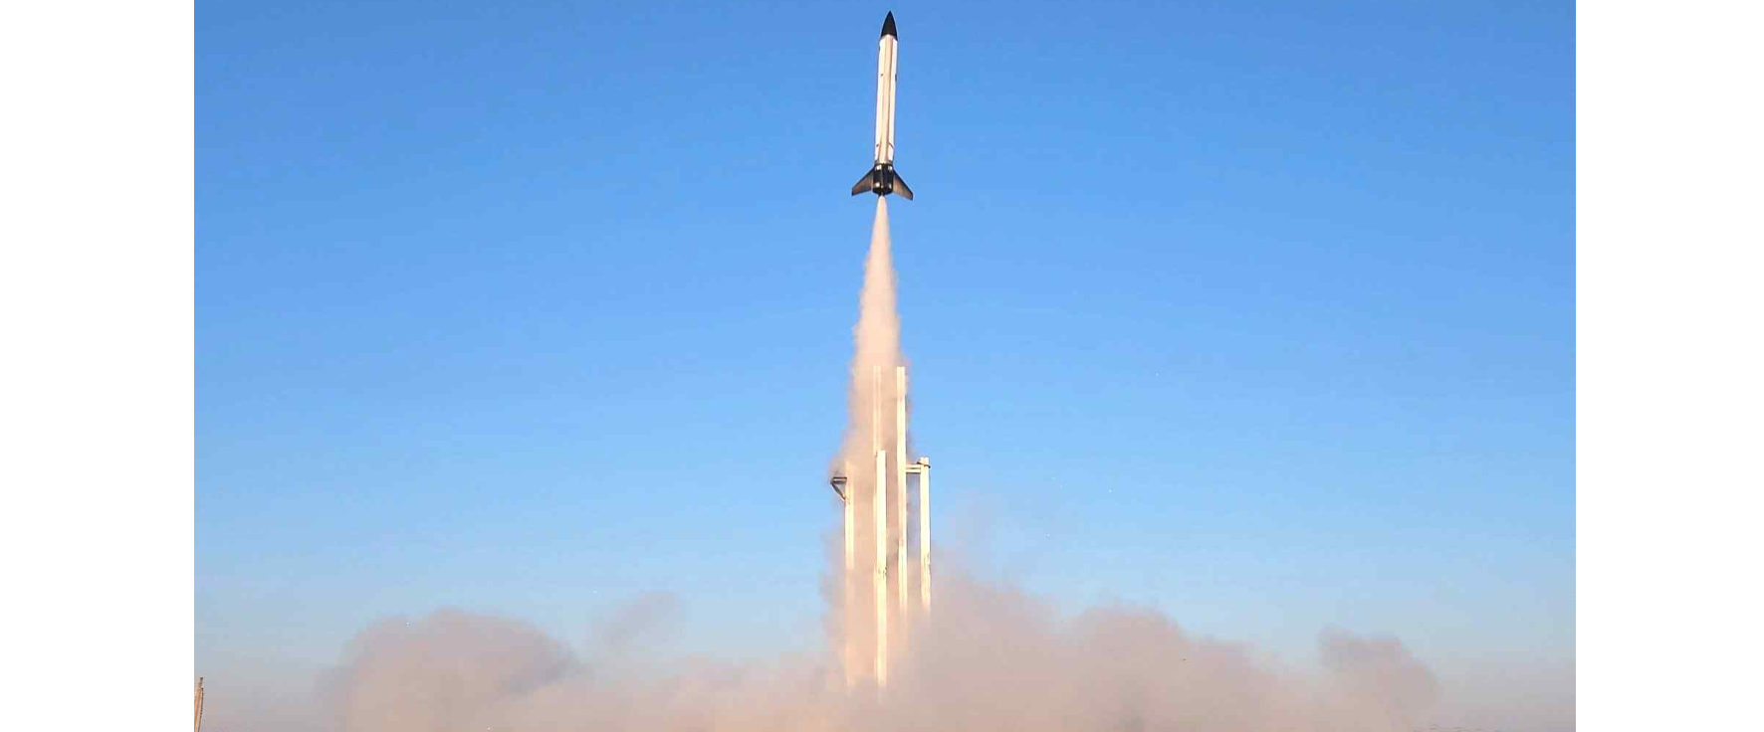▲ GSLV-I produced by GPERI successfully conducted a test launch at the Yeongsan River reservoir in Naju around 4:30 pm on January 13, 2024.

Chang-hyeon Lee, head of GPERI's launch vehicle research and development department and the first author of the paper, said, "I am very pleased that GPERI’s research capabilities have been recognized externally. In the future, we will focus on research to achieve good results in the national university rocket launch competition through continuous technology development."

GPERI research director Ryun-gwan Yang )Class of 22, School of Mechanical Engineering) said, "Currently, a solid fuel engine launch vehicle capable of stage separation and TVC (thrust vector control) is being developed within GPERI. We plan to develop our own liquid fuel engine launch vehicle in the near future."



