School of Materials Science and Engineering Professor Eunji Lee received the Academic Progress Award from the Polymer Chemistry Division of the Korean Chemical Society

- Contribute to the development of related fields by controlling the structure of self-assembled polymer nanoparticles and spatiotemporal transmission electron microscopy imaging

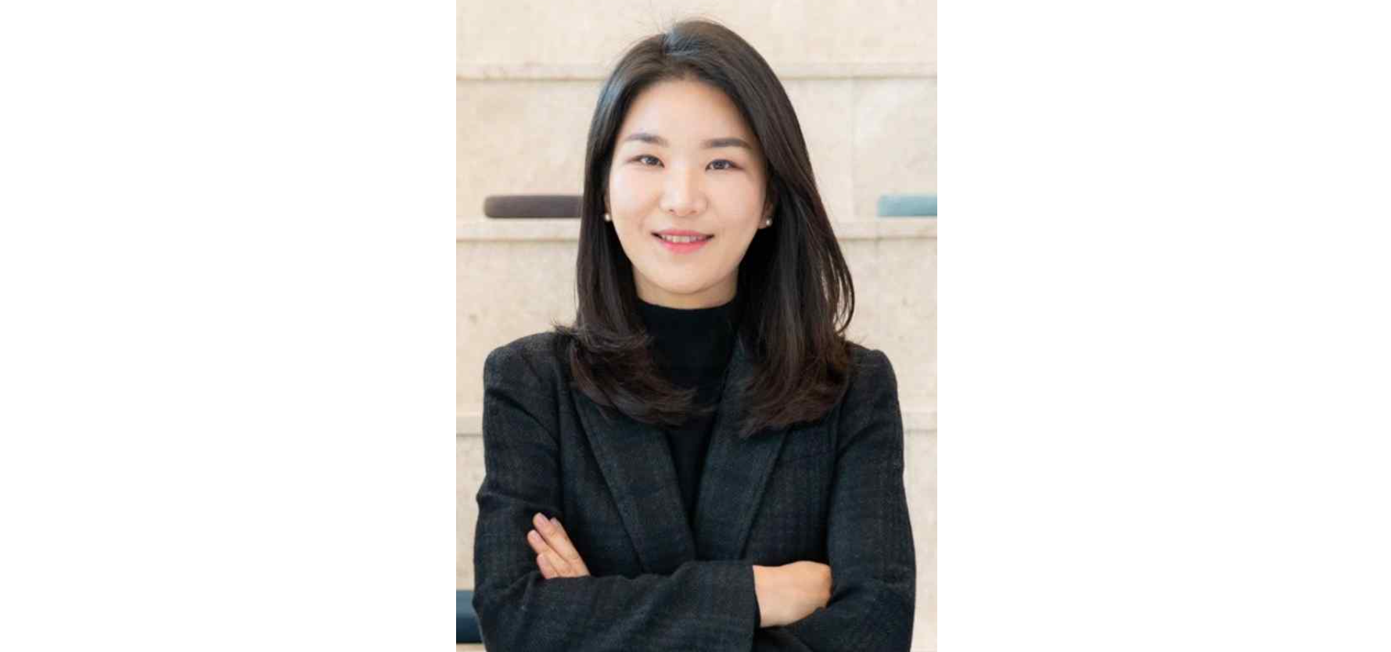▲ GIST School of Materials Science and Engineering Professor Eunji Lee

The Gwangju Institute of Science and Technology (GIST, President Kichul Lim) announced that Professor Eunji Lee of the School of Materials Science and Engineering won the ‘Polymer Chemistry Subcommittee Academic Progress Award’ at the 2024 Spring General Meeting of the Korean Chemical Society held at the Suwon Convention Center on Thursday, April 25.

Since 2008, the Korean Chemical Society* has awarded this award to one researcher each year who has published outstanding papers in the field of polymer chemistry and has contributed significantly to the development of polymer chemistry and its departments.

* Korean Chemical Society: A non-profit academic organization established in 1946, the purpose is to contribute to academic and technological development in the field of chemistry, education, and the spread of chemical knowledge. Currently, there are over 7,000 active members, and it is a representative academic organization comprised of over 140 organizations, 12 subcommittees, and management staff. It is a member of IUPAC and FACS, international chemistry-related organizations.

Professor Eunji Lee was selected as the winner in recognition of her contribution to the development of polymer chemistry by producing excellent thesis results through structural control of self-assembled polymer nanoparticles and spatiotemporal transmission electron microscopy imaging research.

