Two postdoctoral researchers from GIST's School of Materials Science and Engineering will stand on the podium at top overseas universities

- Researcher Mohammad Boshir Ahmed from Professor Myung-Han Yoon's lab and Professor Chang-Hyun Kim (currently an associate professor at Gachon University) were appointed as a senior lecturer at the University of Adelaide, Australia, and an associate professor at the University of Ottawa, Canada, starting in January of next year

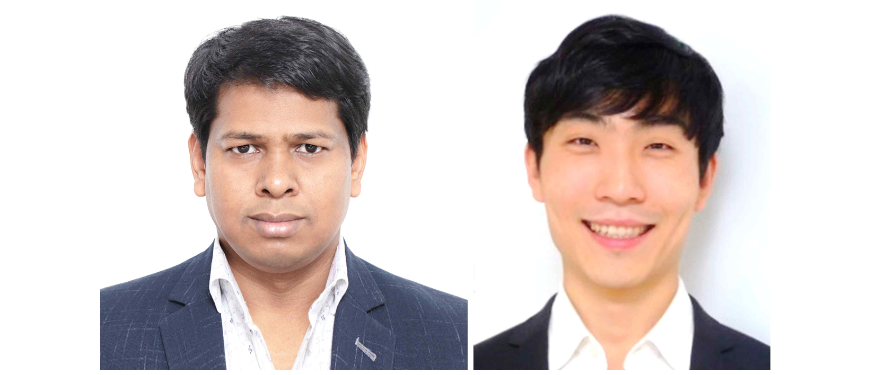▲ (From left) Researcher Mohammad Boshir Ahmed and Professor Chang-Hyun Kim (currently Associate Professor at Gachon University)

The Gwangju Institute of Science and Technology (GIST, President Kichul Kim) announced that researcher Mohammad Boshir Ahmed and Professor Chang-Hyun Kim, both from the laboratory of Professor Myung-Han Yoon in the School of Materials Science and Engineering, have been appointed as senior lecturer and associate professor, respectively, at the University of Adelaide, Australia, and the University of Ottawa, Canada.

Dr. Boshir received his doctoral degree from the Department of Environmental Engineering at the University of Technology Sydney (UTS), Australia, and worked as a Brain Pool Fellow in the Bio-Electronics Materials Laboratory of the School of Materials Science and Engineering at GIST from July 2019 to December 2023, studying plants and participating in the development of natural polymer-based hydrogel fibers to promote seed germination and carbon fiber-based composite materials to store electrical energy.

While working as a postdoctoral researcher at GIST, Dr. Boshir conducted joint research with the Korea Institute of Energy Technology (KENTECH) and Inha University, and his research results were published in many renowned overseas academic journals, including ‘Materials Science and Engineering R: Report’.

Dr. Boshir said, "I would like to thank GIST and Professor Myung-Han Yoon for their excellent research guidance and generous support that allowed me to conduct excellent research during the postdoctoral research period. In particular, Professor Yoon gave great support to the students in the lab, including me, in helping them grow into independent researchers."

Professor Chang-Hyun Kim graduated from the Department of Information Display at Kyunghee University and earned a master's degree in technology and innovation engineering and a doctorate in physics from Ecole Polytechnique in France.

From 2015 to 2018, he was selected for the Ministry of Education's Research Fellow Support Project and conducted research on organic and thin film semiconductor devices as part of the GIST School of Materials Science and Engineering Bio-Electronics Materials Laboratory and the Research Institute for Solar and Sustainable Energies.

In particular, he conducted research on the charge charging and transport characteristics of polymer electrochemical transistors and the analysis of the space charge effect suppression phenomenon by diode contact resistance, and he published the results in in numerous international journals such as Nature Communications, Applied Physics Reviews, etc. In recognition of his excellent research achievements, he was appointed as an assistant professor in the Department of Electronic Engineering at Gachon University since March 2018, and he is currently serving as an associate professor.

Professor Chang-Hyun Kim said, "I was able to grow as an independent researcher thanks to the guidance of professors who conducted world-class research at GIST with the use of excellent research infrastructure. I look forward to more opportunities to cooperate with GIST in the future, including international joint research."

Professor Myung-Han Yoon said, "We are proud that these two scholars, who performed postdoctoral research at GIST, have been appointed to excellent overseas universities starting next January. I hope this will be a great motivation not only for GIST students but also domestic researchers."



