A variety of support for female scientists and engineers... GIST, 2023 female scientist recruitment and employment target system ‘excellent’

- Achieving the target number of female faculty (25%)... Various efforts were made at the institutional level, such as appointing female faculty to major committees, increasing the number of female positions, improving the status of women, and creating a female-friendly culture
- Received the Excellence Award at the ‘2023 Women in Science and Technology Annual Conference’ on the 23rd (Thursday)

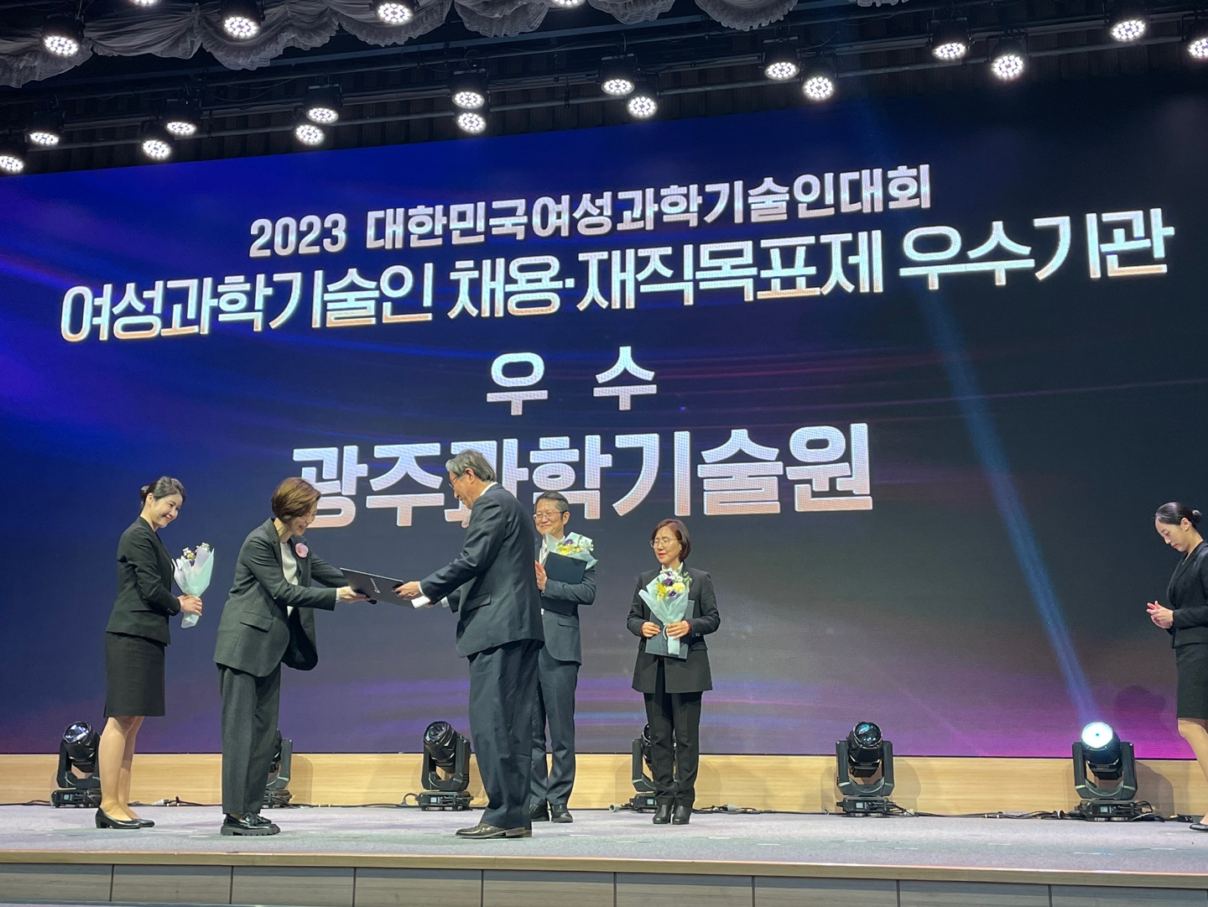▲ GIST (Gwangju Institute of Science and Technology) won the Minister of Science and ICT’s Institutional Excellence Award at the ‘2023 Korea Women in Science and Technology Competition’. First Vice Minister of Science and ICT Seong-kyung Cho (front row, left) is handing over the certificate to GIST President Kichul Lim (front row, right).

The Gwangju Institute of Science and Technology (GIST, President Kichul Lim) announced that it was selected as an ‘excellent institution in the recruitment and employment target system for women scientists and engineers’ and received an excellence award at the ‘2023 Korea Women in Science and Technology Conference (Women in Science and Technology Conference)’.

This event was hosted by the Ministry of Science and ICT, the Korea Women in Science and Technology Foundation, and the Korean Federation of Women in Science and Technology Societies. It was co-hosted for the first time by organizations of women scientists and engineers, including the Korean Association of Women Scientists and Engineers, and was held at the Korea Science and Technology Center on Thursday, November 23.

On this day, Prime Minister Deok-soo Han, First Vice Minister of Science and ICT Seong-kyung Cho, key figures from women's science and technology organizations, and about 300 scientists and engineers from industry, academia, and research attended. Regarding the recruitment and employment target system for female scientists and engineers, the recruitment of female scientists and engineers was excellent and women were promoted. Awards were given to organizations that made efforts to expand the use of scientists and engineers and improve their status.

GIST has been recognized for its excellence in efforts to recruit female research personnel, the rate of new female recruitment, and efforts to create a female-friendly culture.

In order to recruit female scientists and engineers, GIST implemented a female faculty target system (25%) when recruiting new faculty, and as a result of solidifying the policy at the institutional level, such as carrying over to the next year if the target is not achieved in the current year. The proportion of in-service female faculty increased significantly (10.2% in 2019 → 14.3% in 2023).

The recruitment performance of female faculty is increasing every year, with 14.3% in 2019 (1 female teacher out of 7 new teachers) and 25% in 2020 (2 female teachers out of 8 new teachers). In 2021, the organization's continued efforts to establish gender equality policies and foster excellent female faculty achieved 35% (7 female faculty out of a total of 20 newly appointed faculty).

These achievements are the result of continuous efforts at the institutional level to create a women-friendly culture. GIST operates a gender equality personnel system, including ▴ a 50% reduction in lecture hours for pregnant female teachers ▴ extending the retirement age for the same position within 1 year for each pregnancy or childbirth.

In addition, GIST has recently significantly expanded the number of female positions to improve the status of female faculty, and major committees (Faculty Personnel Committee, Planning Committee, etc.) also appointed female faculty.

Female faculty members were also appointed to major positions such as the Dean of Library and Information Resources and the Dean of Student Affairs and Admissions. In addition, GUST actively supports various activities of female faculty, such as invited lectures by female professors.

President Kichul Kim said, "GIST operates an on-site daycare center to ensure work-family balance and is selected every year as a ‘family-friendly certification institution.’ We will continue to strive to create a good environment for women to work in."

Meanwhile, this ‘2023 Korea Women Scientists and Engineers Conference’ shared the achievements of women scientists and engineers, as well as their future roles and directions, under the theme of ‘The future of Korea is opened by women scientists and engineers.’

