Yoon-geun Ko, president of the Ko Gwangju-Jeonnam Clan Association, generously offers scholarships to train prospective scientists

- In commemoration of the 25th anniversary of the establishment of the prestigious Ko Gwangju-Jeonnam Clan Association, scholarships have been donated according to the number of each year since 2018... Achieving a cumulative donation of KRW 121 million
- KRW 20.22 million donated as a scholarship fund to foster scientists for regional development

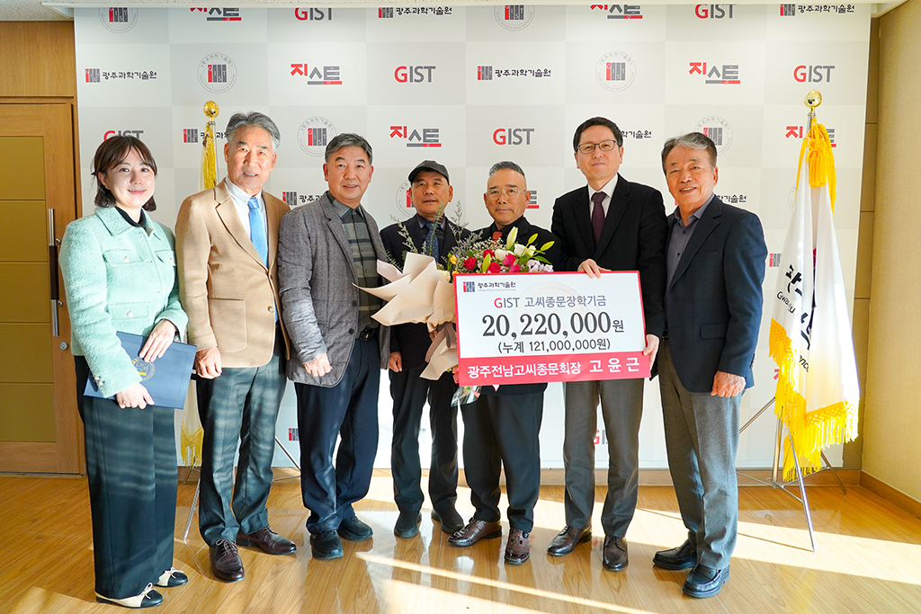▲ On the afternoon of Tuesday, November 21st, GIST held a scholarship donation ceremony for Ko Gwangju-Jeonnam Clan Association at the president's office and took a commemorative photo. (From left) GIST Development Fund Team Leader Ga-young Cha, GIST Development Foundation Chairman Hae-myeong Kim, Ko Gwangju-Jeonnam Clan Association Secretary General Hong-bae Ko, Ko Gwangju-Jeonnam Clan Association Chairman Dal-seok Ko, Ko Gwangju-Jeonnam Clan Association President Yoon-geun Ko, GIST Vice President for Academic Affairs Sang-Don Kim, KBI Hanam Chairman Jeong-ju Ko (Honorary Engineering Doctorate from GIST)

The Gwangju Institute of Science and Technology (GIST, President Kichul Lim) announced that Yoon-geun Ko, president of the Ko Gwangju-Jeonnam Clan Association, donated to the GIST Development Foundation for prospective scientists with the Ko surname in the Gwangju-Jeonnam region.

The donation ceremony was held in the president's office on the afternoon of Tuesday, November 21, with officials including Vice President for Academic Affairs Sang-Don Kim and Ko Gwangju-Jeonnam Clan Association President Yoon-geun Ko in attendance.

Starting with 20.18 million won in 2018, the 25th anniversary of the founding of GIST, President Yoon-geun Ko has been donating scholarships according to the number of each year. Last year, due to circumstances, the donation ceremony was postponed, and up to the 20.22 million won donated this time with the cumulative donation (20 million won donated in 2017) reaching 121 million won.

The GIST Development Foundation and the Ko Gwangju-Jeonnam Clan Association plan to discover and select outstanding scholarship students and award scholarships to students with the last name Goh in the Gwangju-Jeonnam region, including GIST students.

Ko Gwangju-Jeonnam Clan Association President Yoon-geun Ko said, "This year is a meaningful year as GIST celebrates its 30th anniversary, so we hope that the scholarship will be used for a more meaningful purpose. We will continue to show interest and donate to fostering scientific specialists for regional development."

President Kichul Lim said, "We are deeply grateful for the warm hearts of the region's prestigious Ko Gwangju-Jeonnam Clan Association, and will utilize the donation in meaningful ways to nurture future scientists not only in GIST but also in the region."



