GIST graduate Dr. Dong-hyun Kim receives commendation from the Minister of Science and Technology... Leading the development, certification, and commercialization of AI brain image analysis software

- Dr. Dong-hyun Kim, a graduate of the School of Electrical Engineering and Computer Science, served as CTO of Neurofit Co., Ltd., a company specializing in brain disease imaging artificial intelligence (AI) solutions... Contributed to the development of the bio industry
- Contribution to the development of brain neurodegeneration image analysis software and PET automatic image analysis solution

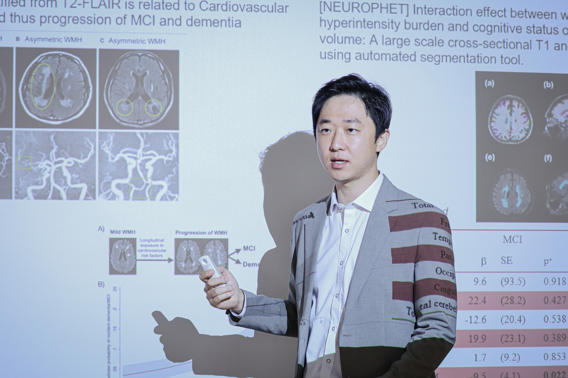▲ CTO Dong-hyun Kim of Neurofit Co., Ltd., who received a commendation from the Minister of Science and ICT at the ‘2023 Korea Science and Technology Exhibition’

The Gwangju Institute of Science and Technology (GIST, President Kichul Lim) announced that Dong-hyun Kim, Chief Technology Officer (CTO) of Neurofit (CEO Jun-gil Bin), an alumnus of the School of Electrical Engineering and Computer Science (Master's program in August 2012, Doctoral program in August 2016 / advisor Professor Sung Chan Jun), was selected as a contributor to the development of the bio industry at the 2023 Korea Science and Technology Fair and received a commendation from the Minister of Science and ICT.

Dong-hyun Kim, CTO of NeuroFit Co., Ltd., a brain disease imaging AI solution specialist, was recognized for his work in developing cranial nerve degeneration image analysis software and PET (positron emission tomography) automatic image analysis solution.

Dr. Dong-hyunf Kim has been involved in domestic and international medical device certification since the initial research of Neurofit Co., Ltd.'s flagship products, 'Neurophet AQUA', a cranial nerve degeneration image analysis software, and 'Neurophet SCALE PET', a PET automatic image analysis software and even led the commercialization of the product.

Neurofit Co., Ltd., a compound word of ‘Neuro’ and ‘Prophet,’ is a company that develops brain image analysis solutions that cover the entire cycle of ‘diagnosis, treatment guide, and treatment’ based on AI. It was founded in 2016 by CEO Jun-gil Bin (GIST School of Electrical Engineering and Computer Science master's degree) and Dr. Dong-hyun Kim (GIST School of Electrical Engineering and Computer Science Ph.D.), who have been conducting research based on electrical brain stimulation simulation for the treatment of brain diseases.

While attending GIST, CEO Jun-gil Bin and Dr. Dong-hyun Kim participated in the Entrepreneurship Promotion Center's mock startup program and received education such as startup consulting and mentoring. They were recognized by the government for their software development and technology to increase the success rate of brain disease treatment through the school's various startup support. It also attracted investment from TIPS, a private investment-led technology startup support program.

In particular, Neurofit Aqua, an AI brain image analysis software, received pre-market approval (510(k) Clearance) from the U.S. FDA in May this year, and was selected as the first Korean company to be selected for the global startup innovation program Startup Crispers APAC 2023. The company recently secured KRW 20 billion in Series C investment from 10 investors, bringing its cumulative investment total to KRW 50 billion.

CTO Dong-hyun Kim said, "Based on the research that started in the GIST laboratory, we were able to build the foundational technology of NeuroFit Co., Ltd., and I believe this is an achievement that has led to the commercialization of the current NeuroFit products. We will focus on developing technology and products so that patients suffering from various brain diseases can receive help with NeuroFit solutions."



