GIST achieves world's highest efficiency organic solar cell module <halogen-free solvent module field> and takes first step toward commercialization with first official certification from KOLAS

- The team of Senior Researcher Hongkyu Kang and Professor Kwanghee Lee secured technology for mass production of modules using non-halogen solvents and received certification for the world's highest module efficiency
- The organic solar cell modules received Korea’s first KOLAS (Korea Laboratory Accreditation Scheme) certification

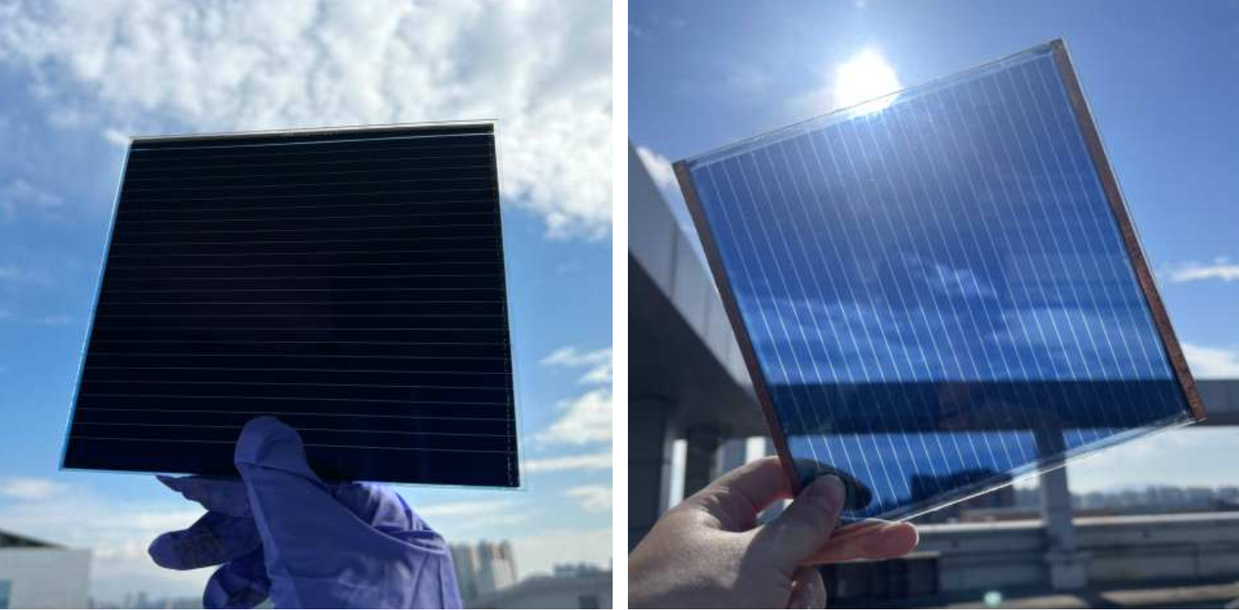▲ Representative photos of large-area organic solar cell opaque (left) and transparent (right) modules produced using non-halogen solvents.

The Gwangju Institute of Science and Technology (GIST, President Kichul Lim) announced that the large-area organic solar cell developed by the Research Institute for Solar and Sustainable Energies has achieved the world's highest efficiency for non-halogen solvent modules and received official certification from KOLAS* (Korea Laboratory Accreditation Scheme), the only company in Korea to measure solar cell efficiency.

KOLAS certification can be equally recognized overseas, making it easy for companies to enter overseas markets.

* KOLAS (Korea Laboratory Accreditation Scheme): An organization under the National Institute of Technology and Standards of the Ministry of Trade, Industry and Energy established to establish a national standards system, KOLAS evaluates and accredits calibration and testing laboratories in accordance with the provisions of the Basic Act on National Standards and ISO/IEC 17025, and it operates a system to certify that test reports issued by accredited laboratories have international credibility.

The joint research team of Hongkyu Kang, senior researcher at the Research Institute for Solar and Sustainable Energies, and Professor Kwanghee Lee achieved 12% efficiency in an organic solar cell module of approximately 200 cm2 in size through module manufacturing technology that used non-halogen solvents instead of existing halogen solvents, which are harmful to the human body and the environment.

Organic solar cells have the advantage of being lightweight, flexible, and transparent as well as being cheaper to manufacture than existing silicon solar cells.

In particular, it can generate power (convert sunlight into electricity) even in low-light environments, allowing it to generate power for longer (about 5 hours) than the average daily maximum power generation time of conventional silicon solar cells (about 3.5 hours), resulting in annual power generation similar to that of commercially available silicon solar cells with only about 13% efficiency.

Existing organic solar cell modules have lower efficiency as they grow in size, and the use of toxic halogen organic solvents such as chlorobenzene and dichlorobenzene adversely affects the health of workers as well as pollute the environment with generated vapors and byproducts.

Organic solar cells made with non-halogenated solvents are expected to contribute significantly to the utilization of photovoltaics and technological advancement in the future, as they have the advantages of low manufacturing cost, which is about 1/10 of that of conventional silicon solar cells, and the ability to be installed in various places in the form of flexible films.

Meanwhile, the research team plans to pursue additional certification procedures by achieving a module efficiency of over 14% through process optimization with non-halogen solvents.

Senior Researcher Hongkyu Kang said, "In Germany, through continuous R&D support and investment by the government, even though the efficiency is less than 10%, it is being commercialized and demonstrated on large domestic buildings. Korea needs to review its commercialization R&D investment and related support policies for large-area organic solar module manufacturing before it is too late."



