GIST wins excellence award at international automobile conference

- Professor SeungJun Kim’s research team won the Honorable Mention Award (Excellence Award) at the international conference ‘AutomotiveUI 2023’
- Design of a virtual agent interface that mimics autonomous vehicle and driver behavior for pedestrian safety... Verification in an environment similar to reality

▲ (From the left) Professor SeungJun Kim and master’s student Yumin Kang

The Gwangju Institute of Science and Technology (GIST, President Kichul Lim) announced on the 5th (Thursday) that Professor SeungJun Kim's team from the School of Integrated Technology won the Honorable Mention Award in October at the international academic competition 'ACM AutomotiveUI (Automotive User Interfaces and Interactive Vehicular Applications) 2023'.

The paper (title: Designing Virtual Agent Human–Machine Interfaces Depending on the Communication and Anthropomorphism Levels in Augmented Reality) in which master's student Yumin Kang participated as the first author was selected as an excellent paper within the top 5% of papers submitted to this conference and received an award.

The ACM AutomotiveUI conference is a major forum for automotive UI (User Interface) research and is an international conference that introduces research on the technical and human aspects of in-vehicle user interfaces and applications. Marking its 15th anniversary this year, it was held for four days from September 18 to 21 in Ingolstadt, Germany.

Professor SeungJun Kim's research team designed the external interface of a virtual agent vehicle and conducted research to verify the effectiveness of the interface through augmented reality (AR)-based user evaluation.

The research team designed a virtual agent interface that mimics driver behavior to aid the interaction between autonomous vehicles and pedestrians. By conducting user evaluations based on real vehicles and AR (Augmented Reality), they analyzed the impact of the interface on pedestrian safety and crossing times.

Master's student Yumin Kang, who gave an presentation about the paper, said, "I think it was well received because we not only tried to reduce the cognitive load and burden on pedestrians by applying the way drivers communicate with pedestrians to virtual agents, but we also conducted validation in a reality-like environment based on real vehicles and augmented reality."

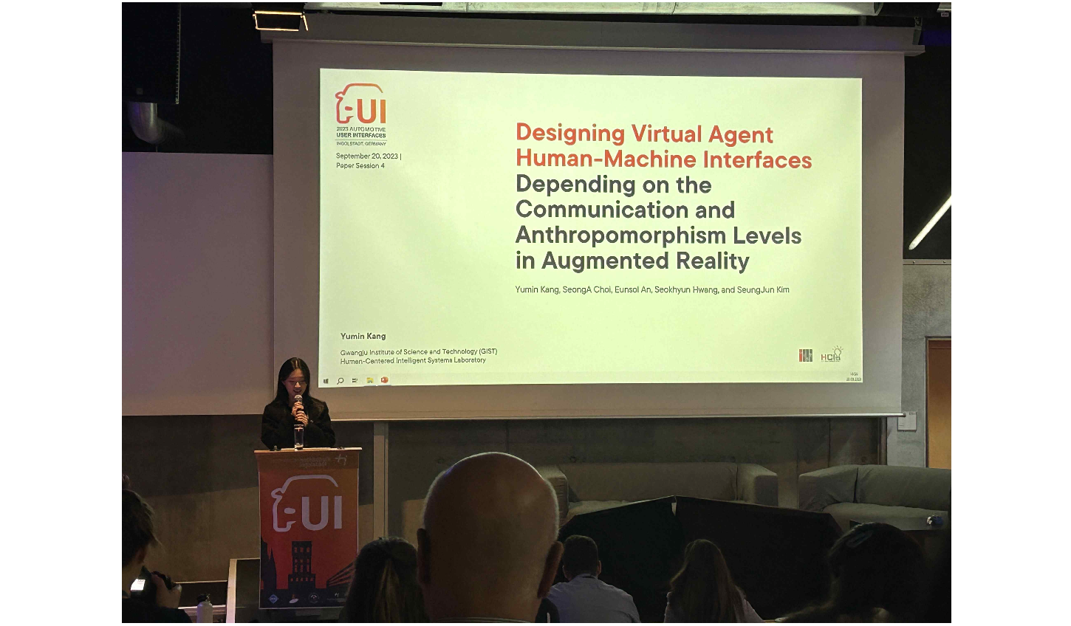▲ Student Yumin Kang, who won the Honorable Mention Award at the international academic conference ‘AutomotiveUI 2023’, is giving a presentation.

Professor SeungJun Kim said, "As autonomous driving technology develops day by day, the importance of research on interactions with road users such as pedestrians is growing. We will continue to conduct research to effectively communicate the status and intentions of autonomous vehicles to facilitate interaction with road users, including drivers.

Meanwhile, Professor SeungJun Kim's research team has been developing various interfaces and virtual reality (VR) technologies for self-driving vehicles as part of the future automobile core technology R&D professional manpower training project since last year. Research is being conducted with a focus on metamobility technology that expands ultra-realistic driving and walking experiences based on extended reality (XR) Twin.



