When you know what happiness is, you're closer to it! Happiness Class with GIST Professor Hisam Kim

- All about happiness! ‘Studying Happiness: Finding My Bluebird’ published on the 10th
- If you're interested in learning about happiness from an economist who wants ordinary people to be happy, check it out

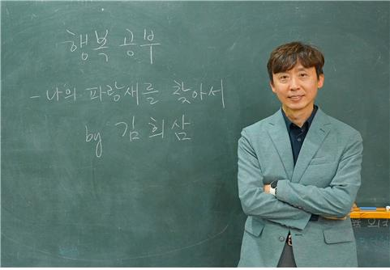
▲ GIST Division of Liberal Arts and Sciences Professor Hisam Kim published
‘Studying Happiness: In Search of My Bluebird’

Where is my ‘blue bird (happiness)’? People often reach a certain stage in their lives before they begin to find true happiness. However, sometimes we spend time wandering as we realize too late that we have been living without knowing much about the true nature of happiness.

GIST Division of Liberal Arts and Sciences Professor Hisam Kim (economist) at the Gwangju Institute of Science and Technology (GIST, President Kichul Lim) published ‘Studying Happiness: In Search of My Bluebird (published by The Power of Thought)’ on the 10th.

This book is based on the content covered in the ‘Conditions of Happiness’ class taught by GIST Division of Liberal Arts and Sciences Professor Hisam Kim for a total of 10 semesters from 2016 to 2021. ‘Conditions of Happiness’ was a popular class at GIST that closed on the first day of course registration.

In fact, in this book, not only are the impressive experiences and thoughts expressed by the ‘Conditions of Happiness’ students in class shared, but also Professor Kim’s personal experiences appear here and there. It delivers a lively feeling as if you are participating in a classroom centered on ‘discussion, sharing of texts, and presentations.’

'Studying Happiness: Finding My Bluebird' is organized into six parts, including the △ definition and determinants of happiness, △ the relationship between money, work, relationships, and △ specific practices for a happy life.

This book is full of interesting research results in various fields ranging from psychology to cognitive science and genetics as well as economics, which is the author's major, as well as 'happiness messages' extracted from Eastern and Western classics and mass media such as movies, TV, and YouTube. Professor Kim refers to it as ‘a kind of Bluebird Encyclopedia.’

As an economist who is interested in people's lives, Professor Hisam Kim focused on issues such as low birth rate, aging, education, and retirement security and social challenges such as coexistence between generations. He now embarks on a practical journey with readers to approach the reality of happiness to finally achieve a happy life.

Professor Hisam Kim said, "Studying happiness is necessary to find your own ‘blue bird’ and not to become distant from the ‘blue bird’ that turns out to be right by your side."

Professor Hisam Kim also said, "When students who were depressed, lost, anxious, stressed, and therefore unhappy see a difference at the end of the semester, I was always thrilled when I heard the confession that the secret to their happiness was due to a change in thinking and practice through ‘studying happiness.’"

Meanwhile, Professor Hisam Kim was appointed as a professor in the Division of Liberal Arts and Sciences at GIST in 2016 after serving as a research fellow at the Korea Development Institute (KDI), and he is currently serving as the dean of the Office of Planning. He served as a member of the Presidential Committee on Low Birth Rate and Aging Society, a member of the National Economic Advisory Council, and a member of the Future Talent Special Committee of the National Science and Technology Advisory Council. He is currently a member of the Mid- to Long-Term Strategy Committee of the Ministry of Strategy and Finance, a member of the Education Policy Empirical Research Committee of the Ministry of Education, and national statistics. He serves as an advisor on various national policies, including as a committee member.

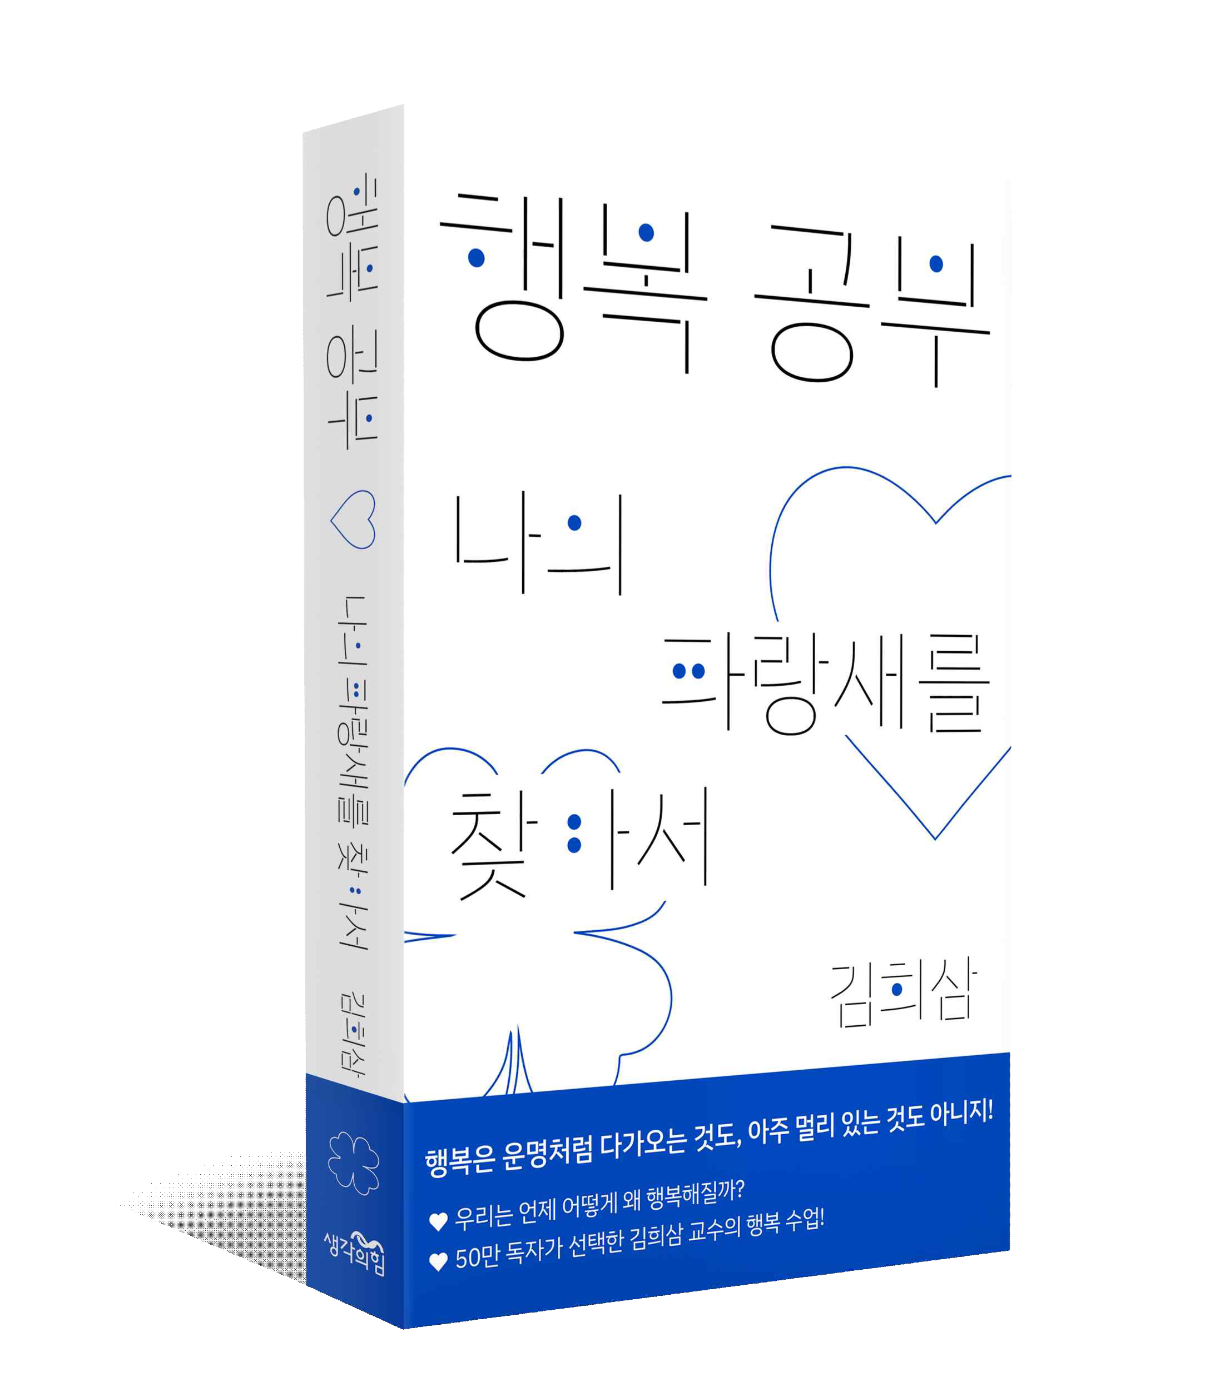
▲ Cover of ‘Studying Happiness: Finding My Bluebird’

