Dr. Hosu Lee of the School of Integrated Technology was appointed as an assistant professor at Gyeongsang National University

- Conduct research on the development of various rehabilitation robots and balance/gait assistance devices
- Hopes to lead by example and become a responsible educator

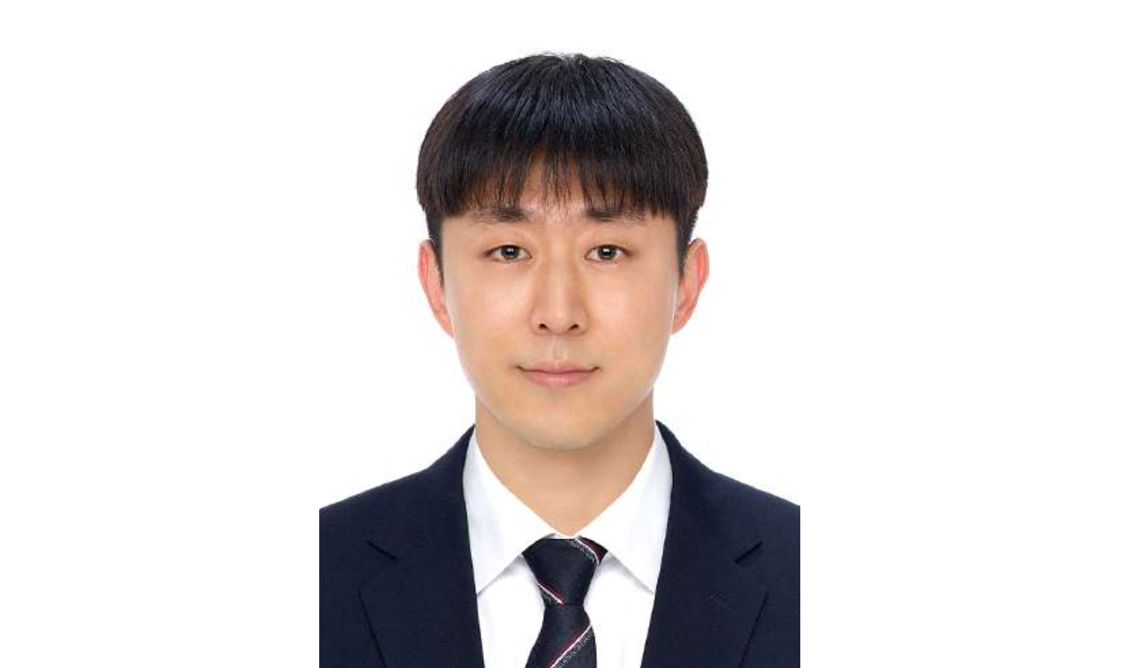▲ Dr. Hosu Lee, School of Integrated Technology (Intelligent Medical Robotics Laboratory), appointed assistant professor at Gyeongsang National University

Dr. Hosu Lee (advisor Professor Jung Won Yoon, graduated in February 2022), who received his doctoral degree from the School of Integrated Technology at the Gwangju Institute of Science and Technology (GIST, President Kichul Lim), will be appointed as an assistant professor in the Department of Control and Robot Engineering at Gyeongsang National University on September 1 of this year.

Dr. Lee received his master's degree from the Robots and Intelligent Systems Laboratory (RIS), Department of Mechanical and Aerospace Engineering, Gyeongsang National University (led by Sujeong Lee and Jung Won Yoon). From March 2018 to February 2022, he completed his doctoral degree under the guidance of Professor Jung Won Yoon at the Intelligent Medical Robotics Laboratory (IMR) as a GIST Presidential Scholar.

During his doctoral program, he conducted research on the development of various rehabilitation robots and balance/gait assistance devices, and wrote his graduation thesis on the topic of ‘Development and verification of haptic and tactile devices for gait rehabilitation of stroke patients.’ He also published a total of 11 papers in international academic journals, including ‘TNSRE (Transaction on Neural Systems and Rehabilitation Engineering)’, which were ranked within the top 10% in the field of rehabilitation engineering.

In recognition of his excellent research achievements, Dr. Lee received the Outstanding Researcher Award at the graduation ceremony and read the graduation speech as a representative of the graduates.

After graduation, he was selected for the National Research Foundation of Korea's postdoctoral researcher support project and conducted AI-based patient-customized vibration feedback gait research as a postdoctoral researcher at the GIST Brain and Nano Robot Research Center from September 2022 to August 2023.

During his postdoctoral research, he published a total of 6 international journal papers, including RA-L (Robotics and Automation Letter), and presented a paper at ICRA (International Conference on Robotics and Automation) and IROS (International Conference on Intelligent Robots and Systems) for two consecutive years (2022, 2023), where the top authorities in the field of robotics gather.

In particular, he was recognized for his research ability by publishing the development and verification results of a machine learning-based algorithm capable of automatically predicting the initial difficulty adjustment of trunk rehabilitation robots in IEEE TNSRE as the lead author. In 2022, he won the Encouragement Award (3rd place out of 23 teams) and the Medical Robotics Society Outstanding Paper Award at the performance presentation of the AI social problem-solving convergence talent training project.

In addition, while carrying out the GIST AI convergence talent training project (2022, 2023), we conducted joint research on AI and game convergence research to improve customized balance rehabilitation exercises with doctoral student Yun-Ho Choi (adviser Professor Kyung-Joong Kim) of the School of Integrated Technology.

Dr. Hosu Lee said, "Even in the face of many failures and frustrations, my life and research philosophy is to quietly strive for the best results rather than blaming the environment but instead changing it. We will lead by example and teach students with a responsible attitude to foster experts in the field of robotics and strive to become an educator respected by our students."



