GIST was the runner-up in the International Artificial Intelligence Badminton Competition

- Professor SeungJun Kim’s research team placed second in the badminton competition of the world’s top conference, ‘International AI Society’
- Introduced artificial intelligence badminton model with high accuracy... Presentation of research results at conference

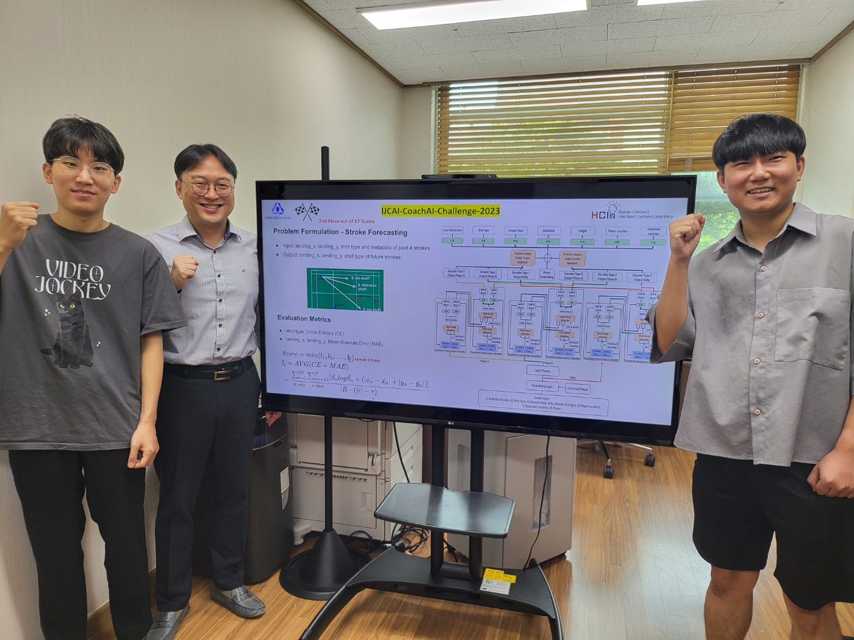▲ (From left) School of Integrated Technology integrated student Jungseok Oh, Professor SeungJun Kim, and master's student Minwoo Seong

GIST (Gwangju Institute of Science and Technology, President Kicheul Lim Gi-cheol) School of Integrated Technology Professor SeungJun Kim's research team was the runner-up at the 'AI Badminton Challenge 2023' hosted by the International Artificial Intelligence Society.

Founded in 1969, the International Joint Conference on Artificial Intelligence (IJCAI) is a world-leading conference on artificial intelligence research and is known as the world's best conference in terms of paper citations and influence.

The 'Badminseok' team, formed by master's student Minwoo Seong and integrated student Jungseok Oh, took second place out of a total of 17 teams in the competition held for about two months from April and presented its research results at the International Artificial Intelligence Society on the 19th.

The category where the research team won second place was 'Forecasting Future Turn-Based Strokes in Badminton Rallies'.

The goal is to accurately predict the future hitting method and the location of the ball based on rally data, such as the four hitting methods and the location of the ball, which were first observed in a single badminton rally.

The team said, "Based on the experience and data from participating in this competition, we plan to create a ‘badminton coaching system’ using artificial intelligence. We plan to build a sports training system in the metaverse by expanding not only to the real world but also to the virtual environment."

This research, led by Professor SeungJun Kim and conducted by master's student Minwoo Seong and integrated student Jungseok Oh, was supported by the GIST-MIT (Massachusetts Institute of Technology) International Cooperation Project and the Ministry of Science and ICT's Broadcasting and Communication Development Fund (Metabus Lab Support Project).

Meanwhile, the research team is conducting ‘HCI+AI convergence research for human-centered physical system design’ in the ‘AI International Cooperation Project’, which will be conducted for 5 years from 2021 to 2025 with MIT.



