[Personnel] GIST key positions

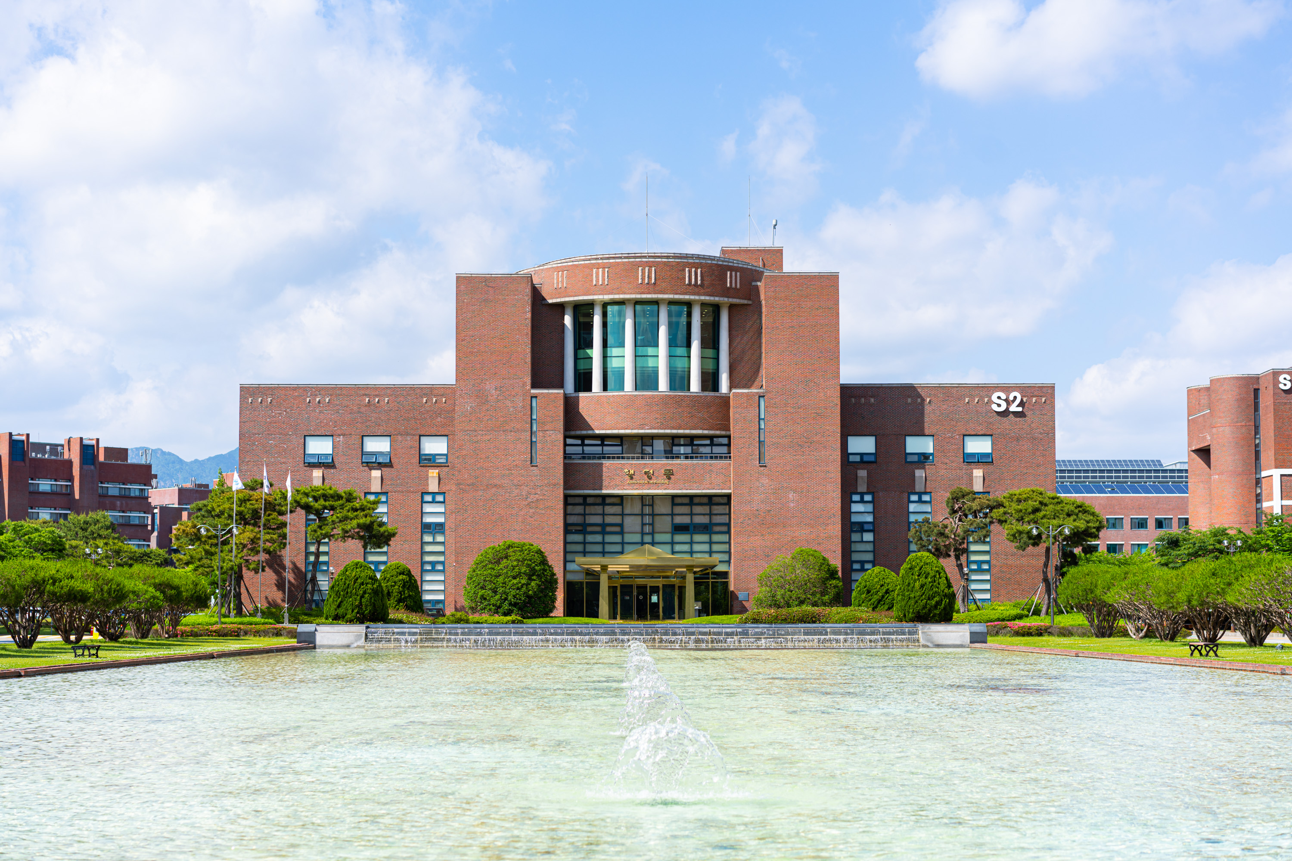▲ Panoramic view of GIST administrative building

▲ Vice President for Academic Affairs Sang-Don Kim ▲ Vice President for R&D Kwanghee Lee ▲ GIST College Dean Kwang Hee Ko ▲ Academic Affairs Dean Sukwon Hong ▲ Research Dean Jae Young Lee ▲ Planning Dean Hisam Kim ▲ International and Public Affairs Dean Jae Gwan Kim ▲ Library and Information Resources Dean Hyunju Lee ▲ Student Affairs and Admissions Dean Mi-Ryoung Song ▲ GIST Technology Institute Dean Min-Gon Kim



